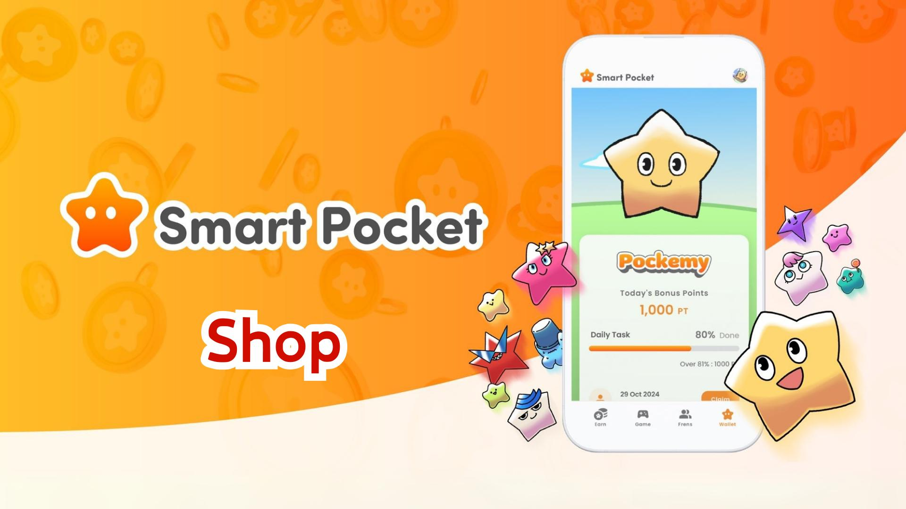

**Ẹya Tuntun ti Ìṣàkóso Smart Pocket! Itọsọna Pipe fun Shop**

# Atọka

1. 1. Kini Shop?  
   2. Ifihan Ibùdó Shop  
   3. Awọn ọna isanwo fun Awọn ohun Shop  
   Kini TON Coin?  
   Kini Stars ti Telegram?  
   4. Awọn ireti Lẹ́yìn Imuse Awọn ohun Shop  
   5. Awọn ireti Lẹ́yìn $SP  
   6. Akopọ

# 1. Kini Shop?

Shop jẹ ibi itaja inu-app nibiti awọn olumulo le ra awọn ohun elo ti a sanwo lati lo ninu ẹya 'Gacha'. Ni igba akọkọ, a le ra ohun elo 'Rocket', ti o fun laaye awọn olumulo lati yi Gacha ni ominira lai nilo lati kojọ awọn aaye!

# 2. Ifihan Ibùdó Shop

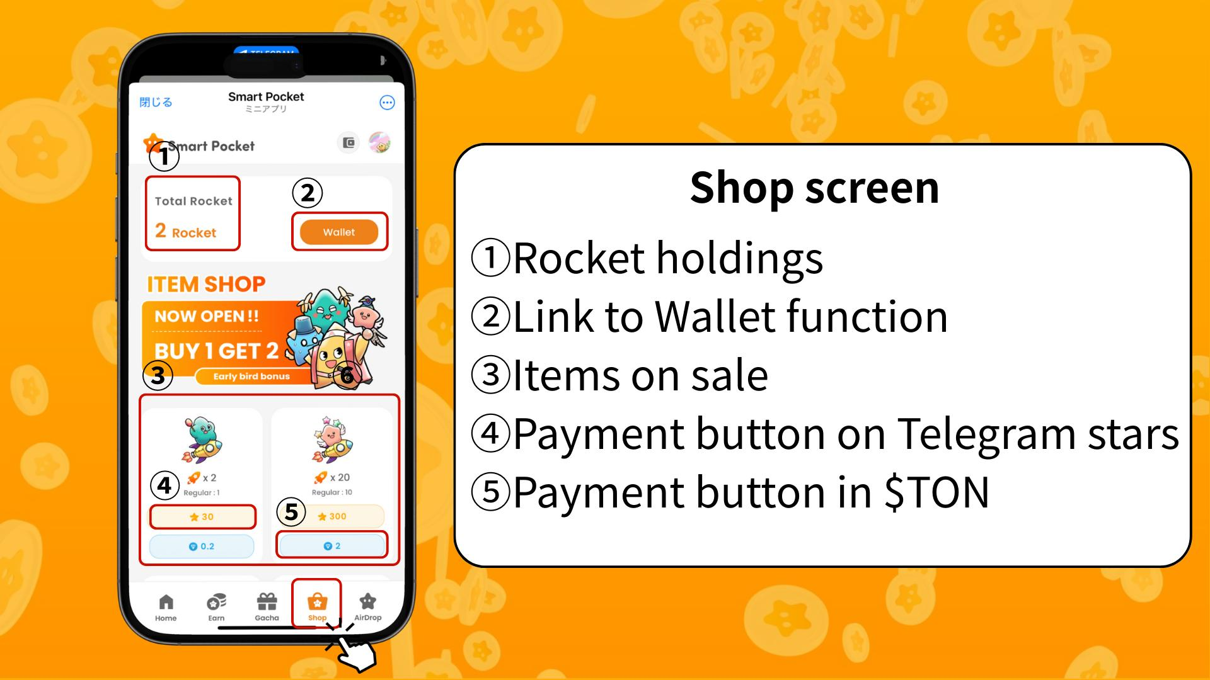  
  
① Iye Rocket to wa: Fihan nọmba ti Rocket ti olumulo ni.  
② Asopọ si Wallet: Wọle si iṣakoso awọn aaye, awọn tokẹni, ati awọn ohun-ini oni-nọmba bii Item/NFT/SBT.  
③ Awọn ohun ti o wa fun tita: Atokọ awọn ohun ti o wa fun rira.  
④ Bọtini isanwo pẹlu Telegram Stars: Lo bọtini yii lati ra pẹlu Stars.  
⑤ Bọtini isanwo pẹlu TON Coin: Lo bọtini yii lati ra pẹlu TON Coin nipasẹ apamọwọ Tonkeeper.

# 3. Awọn ọna isanwo fun Awọn ohun Shop

Ni bayi, ohun 'Rocket' le ṣee ra pẹlu TON Coin tabi Telegram Stars. Ni ọjọ iwaju, awọn tokẹni aladani bi $SP le tun jẹ ọna isanwo.

## Kini TON Coin?

TON (The Open Network) jẹ pẹpẹ blockchain ti Telegram ṣe agbekalẹ ni akọkọ. TON Coin jẹ owo inu eto ti a lo fun isanwo awọn idiyele iṣowo ati lilo iṣẹ inu nẹtiwọọki.

## Kini Stars ti Telegram?

Stars jẹ awọn aaye inu-app ti a lo ninu eto Telegram lati ṣe atilẹyin fun awọn onise akoonu, wọle si awọn akoonu aladani ati gba awọn ere. O le ra Stars taara lati bọtini rira Rocket.

# 4. Awọn ireti Lẹ́yìn Imuse Awọn ohun Shop

Botilẹjẹpe lilo app naa ṣi wa ni ọfẹ, afikun 'Rocket' n pese awọn anfani tuntun fun awọn olumulo lati dide ninu ipo, pataki fun ifọwọsi airdrop $SP ti n bọ.

# 5. Awọn ireti Lẹ́yìn $SP

Lẹ́yìn airdrop $SP, ọpọlọpọ awọn airdrop tokẹni miiran ti gbero. A nireti pe Smart Pocket yoo yipada si apamọwọ Web3 pẹlu ọpọlọpọ awọn iṣẹ bii staking, iṣowo NFT ati awọn ere inu-app.

# 6. Akopọ

Ẹya tuntun 'Shop' n gba awọn olumulo laaye lati gba awọn kikọ ẹlẹwa bi Pockemy ati Holy. Gbádùn ìrírí Smart Pocket rẹ ní ọna ti o ni iduro ati igbadun!

📢 Fun Awọn imudojuiwọn Tuntun 📢  
Aaye osise Smart Pocket: https://smapocke.com/  
Discord Osise Smart Pocket: https://discord.com/invite/smartpocket  
Akọọlẹ X Osise Smart Pocket: https://x.com/smapocke  
Akọọlẹ X Osise Pockemy: https://x.com/pockemys