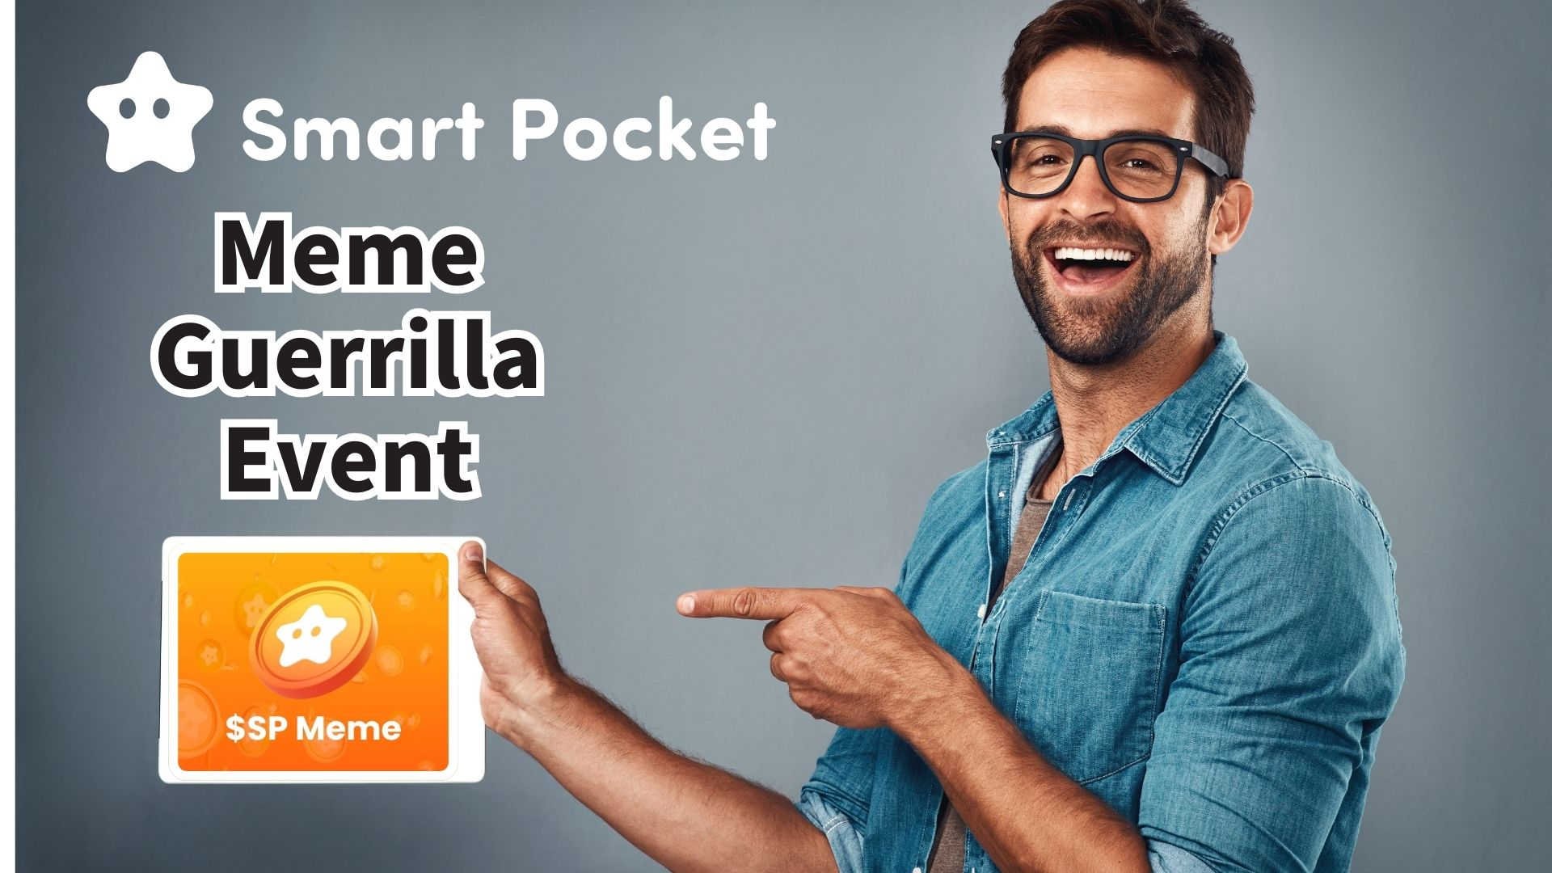

**$SP Meme Isẹlẹ Pajawiri! Aṣeyọri Lati Gba 1000PT!!**

**Ẹ ku ọjọ o gbogbo eniyan!  
  
Iroyin ayọ wa nibi!  
Daruman (@Daruman_EN), alakoso-ṣọpọ ti Smart Pocket, ti kede ifilọlẹ iṣẹlẹ $SP Meme!**

**Ninu iṣẹlẹ yii, o ni anfaani lati ṣẹgun 1000PT nipa ṣiṣẹda $SP meme tirẹ! Awọn eniyan 100 yoo ṣẹgun 1000PT kọọkan!**

**Alaye diẹ sii: https://x.com/Daruman_EN/status/1905922374350016710**

# Atokọ akoonu

* Awọn alaye iṣẹlẹ
* Awọn apẹẹrẹ meme
* Bii lati ṣe igbasilẹ ohun elo
* Awọn imọran fifi sori
* Ipari

# Awọn alaye iṣẹlẹ

Awọn ofin rọrun pupọ:  
  
- Kopa laarin wakati 72  
- Lilo AI gba laaye (pẹlu gbigbe aworan)  
- Firanṣẹ nipasẹ idahun tabi repost pẹlu asọye  
- To awọn ifiweranṣẹ 3 fun eniyan kọọkan  
  
Lo anfani yii lati fi ifẹ rẹ han ati ṣe ayẹwo nipasẹ Daruman lati ṣẹgun 1000PT!

# Awọn apẹẹrẹ meme

Ko daju kini iru meme lati ṣẹda? Wo awọn apẹẹrẹ nla wọnyi lati awọn iṣẹlẹ iṣaaju:  
  
Cristiane AnyaFer (@CristianeF9474)  
https://x.com/CristianeF9474/status/1901272621045416401  
  
annnnnne (@jinxsdf)  
https://x.com/jinxsdf/status/1901202970936770946  
  
Atiyya Tsun Tsun (@1988__atiyye)  
https://x.com/1988__atiyye/status/1901322439402881052  
  
hawaiisana (@hawaiisana2)  
https://x.com/hawaiisana2/status/1901355420654191009  
  
Gba iwuri lati ọdọ wọn ki o ṣẹda meme tirẹ!

# Bii lati ṣe igbasilẹ ohun elo

O le gba ohun elo ti o nilo lati oju opo wẹẹbu osise Smart Pocket:  
  
Oju opo wẹẹbu osise: https://sp-token.com/  
  
Fun awọn imọran lori lilo awọn ohun elo ọfẹ, ka nkan yii:  
https://note.com/japan_dao/n/ndfd476d81179

# Awọn imọran fifi sori

Nigbati o ba n fi meme $SP rẹ ranṣẹ, rii daju pe o repost ifiweranṣẹ Daruman ati fi hashtag “$SP” kun lati mu akiyesi rẹ.

# Ipari

Iru awọn iṣẹlẹ pajawiri wọnyi maa n waye laileto, nitorina ma ṣe gbagbe lati tẹle agbegbe naa fun imudojuiwọn.  
  
Iṣẹlẹ yii jẹ fun wakati 72 nikan, nitorinaa kopa yarayara!  
  
Fi awọn meme rẹ han, jẹ ki agbegbe naa dun, ki o si gba awọn ere! A n duro de awọn ẹda iyalẹnu rẹ!

# 📢 Awọn imudojuiwọn tuntun Smart Pocket

* Oju opo wẹẹbu osise: https://sp-token.com/
* Discord osise: https://discord.com/invite/smartpocket
* Iroyin X osise: https://x.com/smapocke
* Telegram osise: https://t.me/smartpocketjp