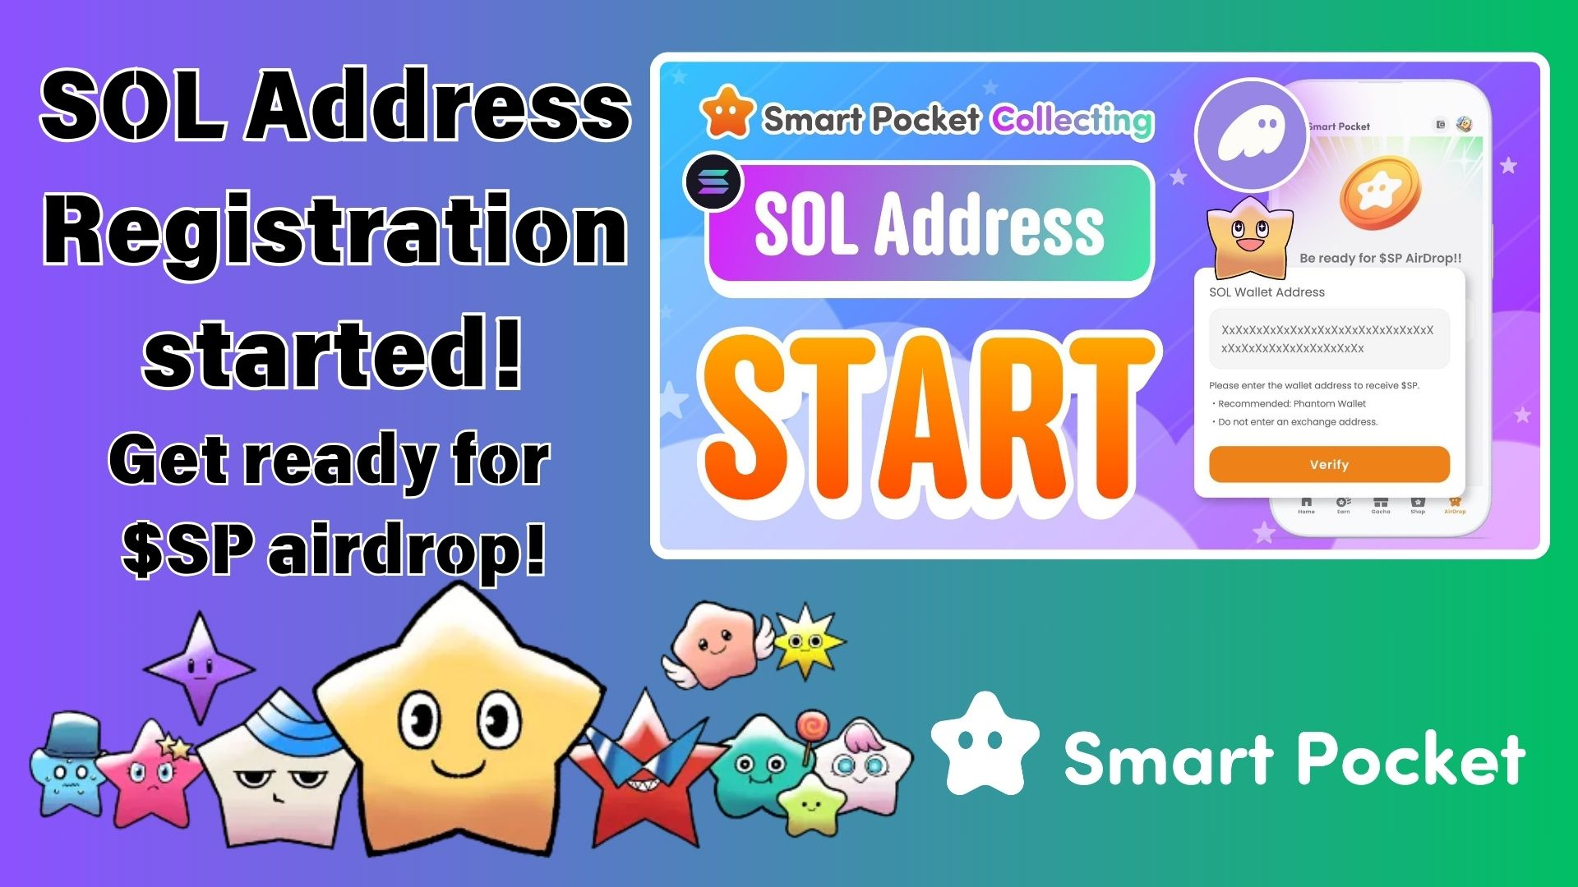

**Forukọsilẹ Bayi! Gba Airdrop Token $SP Nipa Iforukọsilẹ Adirẹsi SOL Rẹ Ninu Ohun elo Smart Pocket!**

# Iroyin Nla!

Ilana fun airdrop $SP token ninu ohun elo Smart Pocket ti bẹrẹ ni kikun! Iforukọsilẹ adirẹsi SOL ti bẹrẹ ni ifowosi. Nipa ipari iforukọsilẹ yii, iwọ yoo ni ẹtọ lati gba pinpin token $SP ni ọjọ iwaju.  
  
Ninu àpilẹ̀kọ yìí, a yoo ṣàlàyé pataki iforukọsilẹ adirẹsi SOL ati ṣe itọsọna fun ọ nipasẹ awọn igbesẹ. Maṣe padanu aye yii—forukọsilẹ bayi!

https://x.com/smapocke/status/1899403141432701277?s=46&t=XlW8lQKS8obTGhETug4PNA

# Iforukọsilẹ Adirẹsi SOL Ti Bẹrẹ!

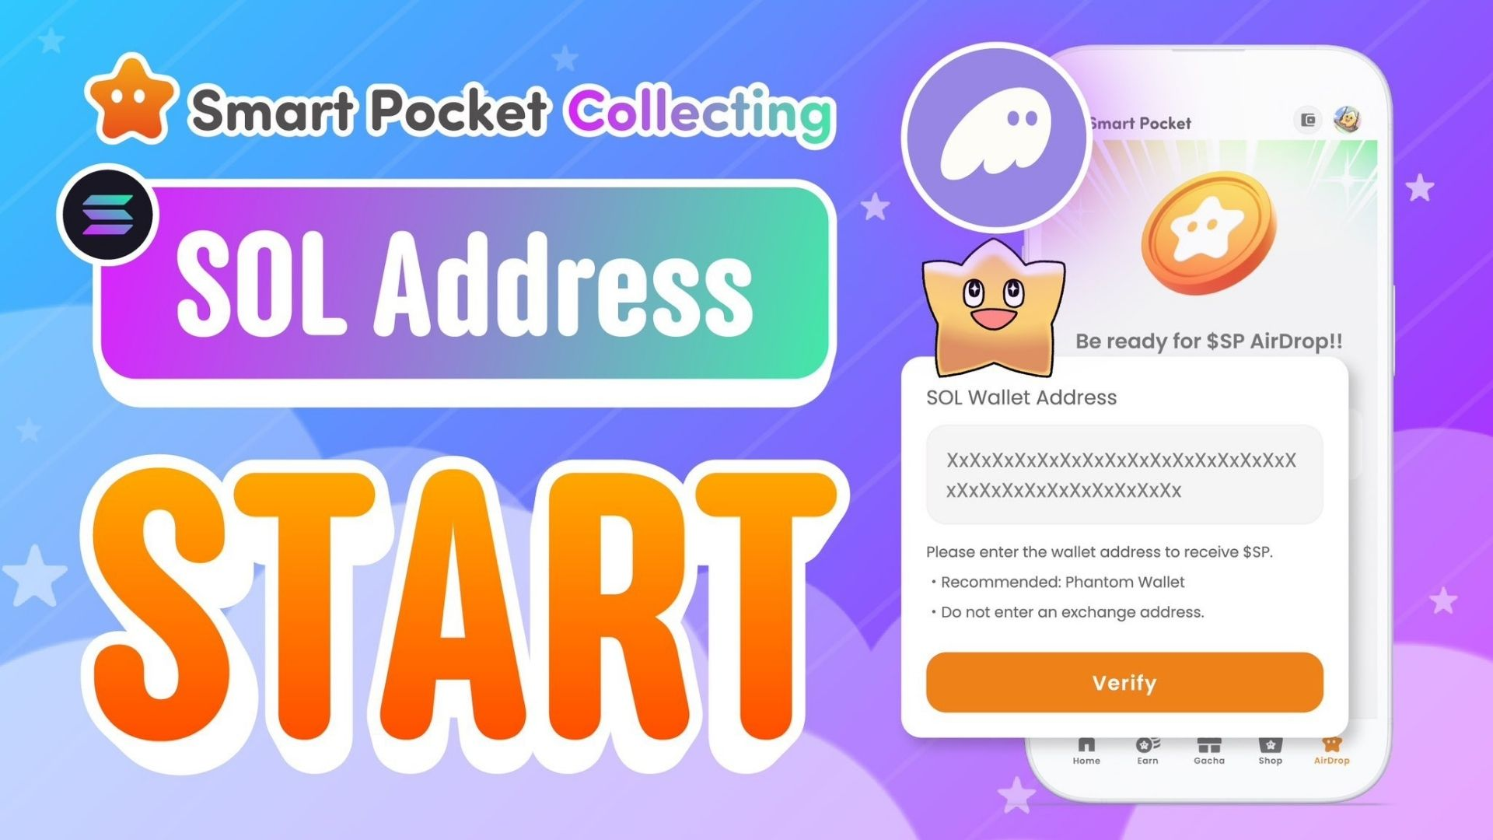  
  
Ohun elo Smart Pocket bayi gba laaye iforukọsilẹ adirẹsi apamọwọ SOL! Eyi jẹ igbesẹ pataki fun ọpọlọpọ awọn olumulo ti n duro de airdrop $SP token.  
  
$SP tokens yoo ṣe ipa pataki ninu ilolupo Smart Pocket, fifun ọpọlọpọ awọn anfani ati awọn iṣẹ. Ni ọdun to kọja, 1% ti ipese lapapọ ti fi ranṣẹ si aaye lori SpaceX roketi, o si jẹ akọle ifọrọwanilẹnuwo. Airdrop yii jẹ anfaani ti ko yẹ ki o padanu!

https://note.com/japan_dao/n/n5c82a3ceaba2

# Kilode Ti Iforukọsilẹ Adirẹsi SOL Se Pataki?

* Gba awọn token $SP larọwọto nipasẹ airdrop.
* Gba wọle si awọn ẹbun token ninu awọn iṣẹlẹ ati ipolongo iwaju.
* Darapọ ni irọrun pẹlu DEX ati awọn iṣẹ miiran fun awọn ilọsiwaju ọjọ iwaju.

# Bawo Ni Lati Forukọsilẹ Adirẹsi SOL Rẹ

## Igbesẹ 1: Ṣeto Apamọwọ Solana

O nilo apamọwọ ti o ṣepọ SOL. Ti o ko ba ni ọkan sibẹsibẹ, ka itọsọna yii lori bii o ṣe le ṣẹda Phantom Wallet.

https://note.com/japan_dao/n/n1e51a2eb7ed2

## Igbesẹ 2: Daakọ Adirẹsi SOL Rẹ

* Ṣii ohun elo Phantom Wallet.
* Tẹ "Gba" (Receive).
* Daakọ adirẹsi Solana ti o han.  
    
  (Akiyesi: Rii daju pe o daakọ adirẹsi Solana ti o tọ.)

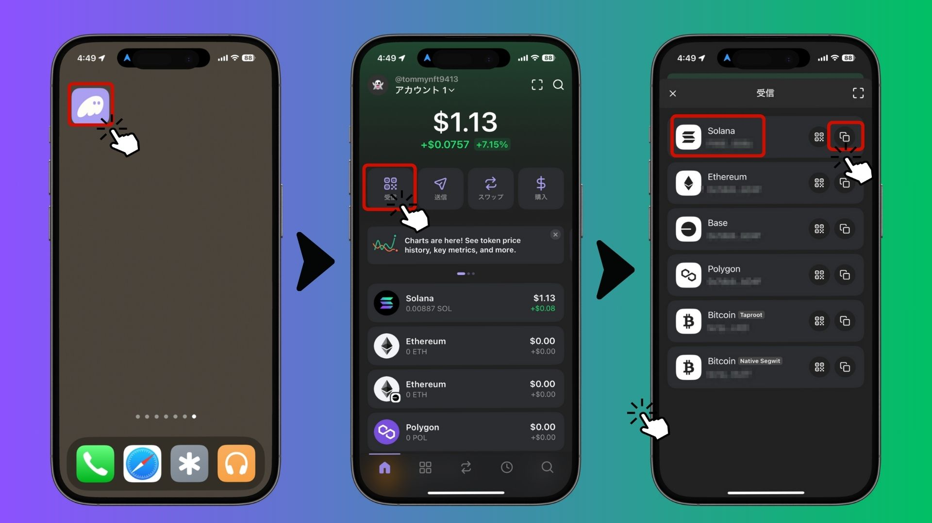

## Igbesẹ 3: Forukọsilẹ Adirẹsi Rẹ Ninu Ohun elo Smart Pocket

* Ṣii ohun elo Smart Pocket.
* Lọ si taabu "Airdrop".
* Lẹẹmọ adirẹsi Solana ti a daakọ sinu aaye "SOL Wallet Address".
* Tẹ "Verify" lati pari iforukọsilẹ.

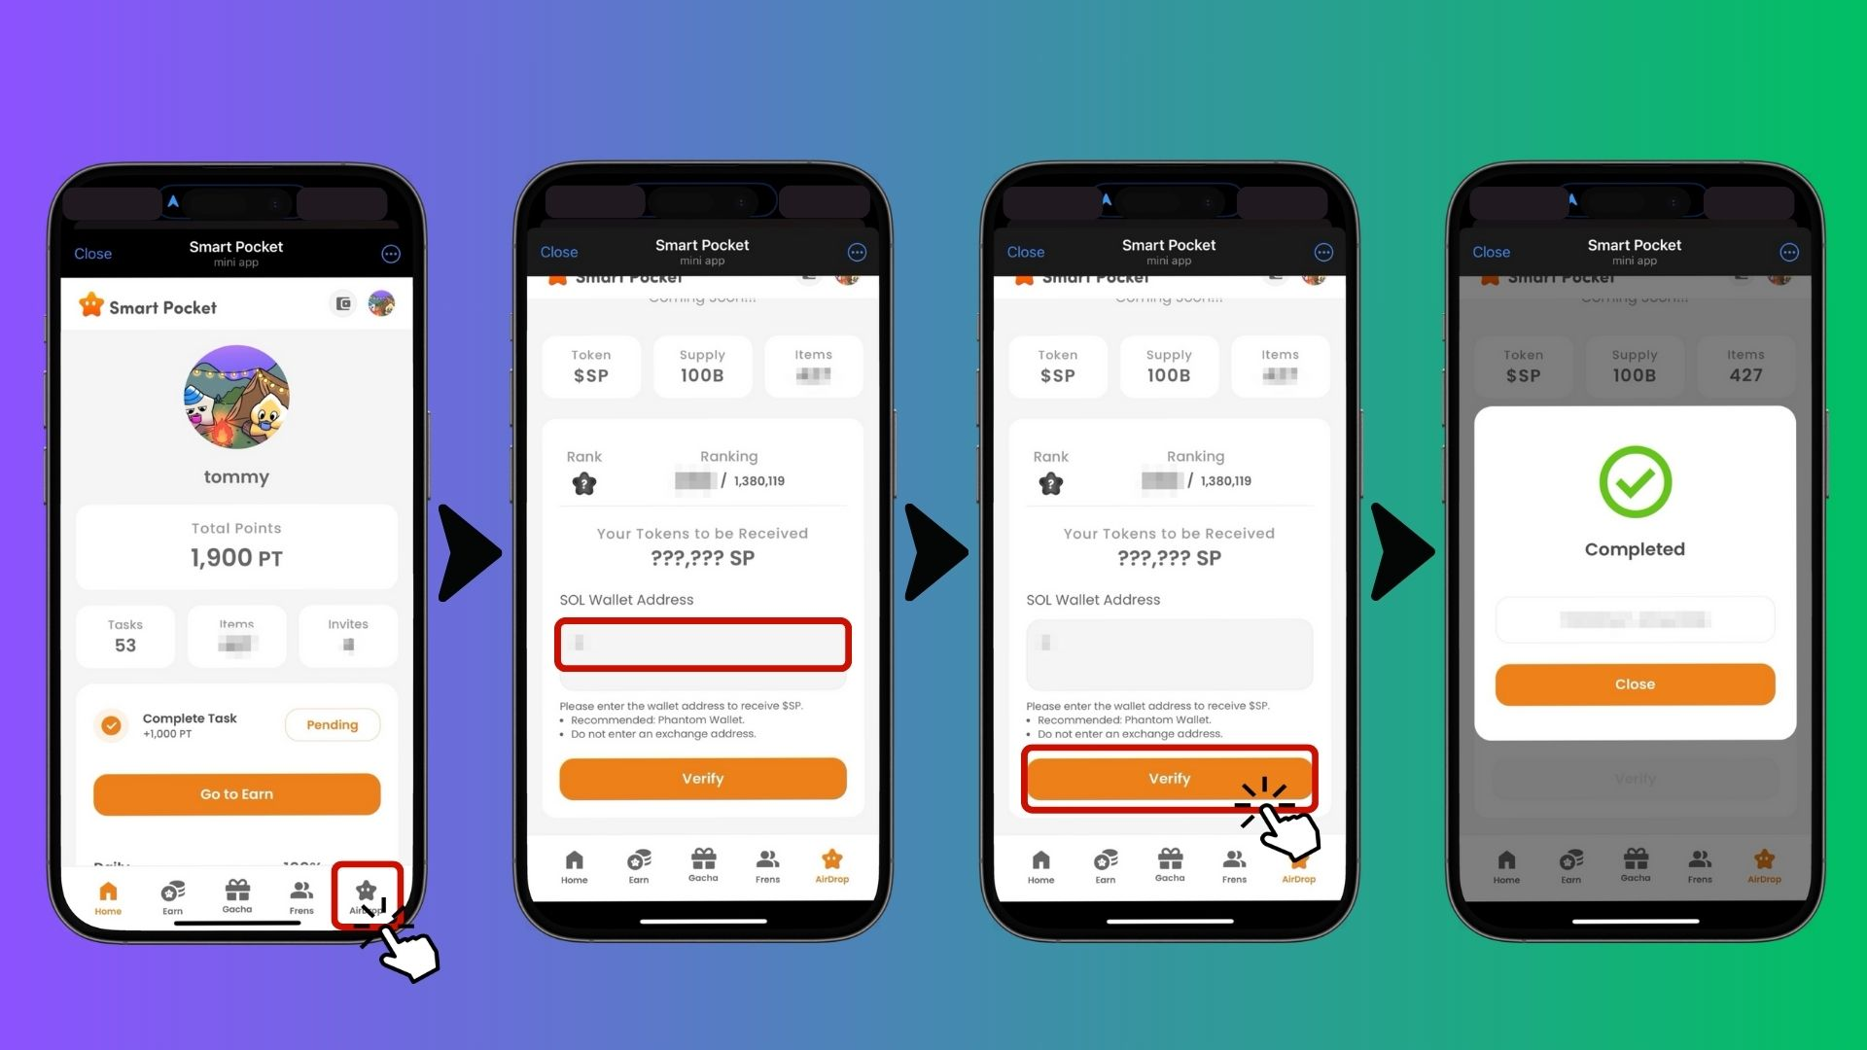  
  
Ti pari! O ti forukọsilẹ fun airdrop bayi.

# Awọn Akọsilẹ Pataki & Awọn iṣeduro

* A ko gba awọn adirẹsi apamọwọ lati awọn paṣipaarọ (fun apẹẹrẹ Binance, Coinbase).
* A nikan gba awọn apamọwọ ti ara ẹni nibiti iwọ n ṣakoso bọtini ikọkọ rẹ.
* Apamọwọ ti a ṣeduro: Phantom Wallet.
* Forukọsilẹ ni kutukutu lati jẹrisi ẹtọ rẹ si airdrop.

# Awọn Ibeere Ti A Maa N Beere

## Ibeere: Nigbawo ni airdrop yoo waye?

Idahun: Ọjọ gangan ko tii kede, ṣugbọn nipa ipari iforukọsilẹ adirẹsi SOL, iwọ yoo gba awọn token laifọwọyi ni kete ti airdrop ba bẹrẹ.

## Ibeere: Bawo ni MO ṣe le lo awọn token $SP?

Idahun: Awọn token $SP yoo fun ọ ni iraye si ọpọlọpọ awọn iṣẹ ati awọn anfani ninu ilolupo Smart Pocket. Ni ọjọ iwaju, wọn yoo tun le ṣowo lori DEX.

## Ibeere: Ṣe Mo le lo adirẹsi SOL kanna fun ọpọlọpọ awọn iroyin?

Idahun: Bẹẹni! Ti o ba nlo MetaMask ati Telegram pẹlu Smart Pocket, o le forukọsilẹ adirẹsi SOL kanna fun gbogbo awọn iroyin rẹ.

# Ipari

Iforukọsilẹ adirẹsi SOL rẹ ninu ohun elo Smart Pocket jẹ igbesẹ pataki lati gba airdrop token $SP. Nitori $SP token jẹ ọkan ninu awọn ipilẹ ilolupo Smart Pocket, maṣe padanu anfaani yii—forukọsilẹ adirẹsi SOL rẹ ni bayi!

# Jeki Imudojuiwọn!

* Smart Pocket Official X: https://x.com/smapocke
* Oju opo wẹẹbu osise Smart Pocket: https://smapocke.com/
* Smart Pocket Official Discord: https://discord.com/invite/smartpocket