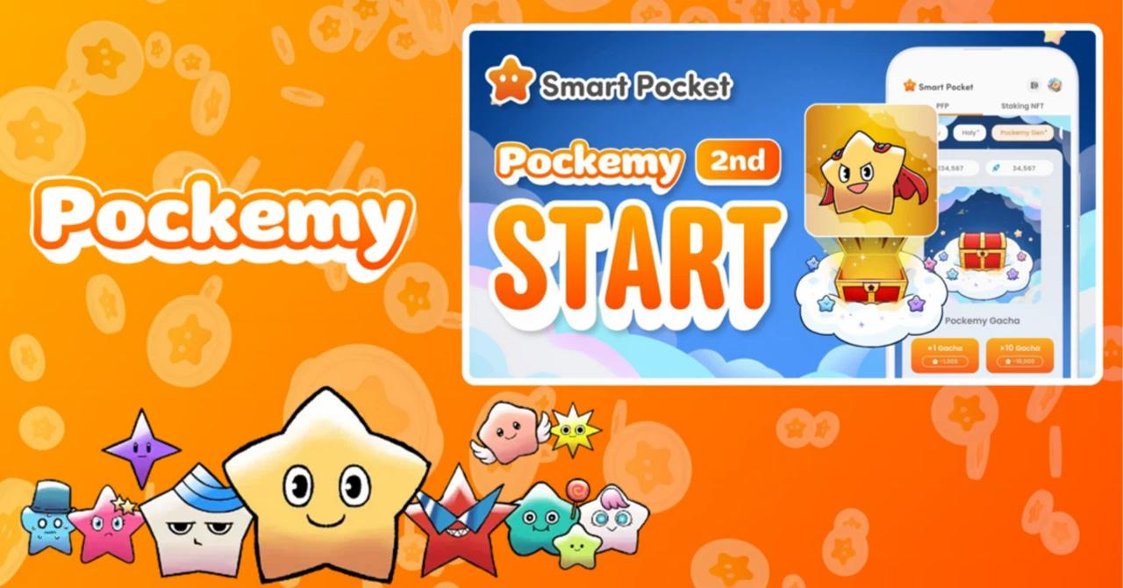

**Pockemy 2nd Gacha Ti A Ti Nduro Fun Ti De! ✨**

# Kini Pockemy?

Pockemy ni awọn ohun kikọ alailẹgbẹ 11, pẹlu ami ami rẹ "Pockemy" ati awọn ohun kikọ miiran bii "Yami," "Fushigi," "Muteki," "Kuishinbo," "Aniki," "Chibikko," "Bibiri," "Tsuntsun," "Futekusare," ati "Shinratsu." Awọn ohun kikọ wọnyi jẹ olokiki fun awọn imudara ojulowo wọn ati apẹrẹ awada, ti o jẹ ki wọn jẹ ifamọra ati olokiki.

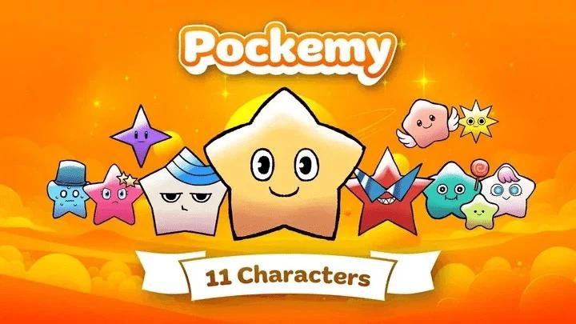

# Nipa Pockemy Generative Gacha

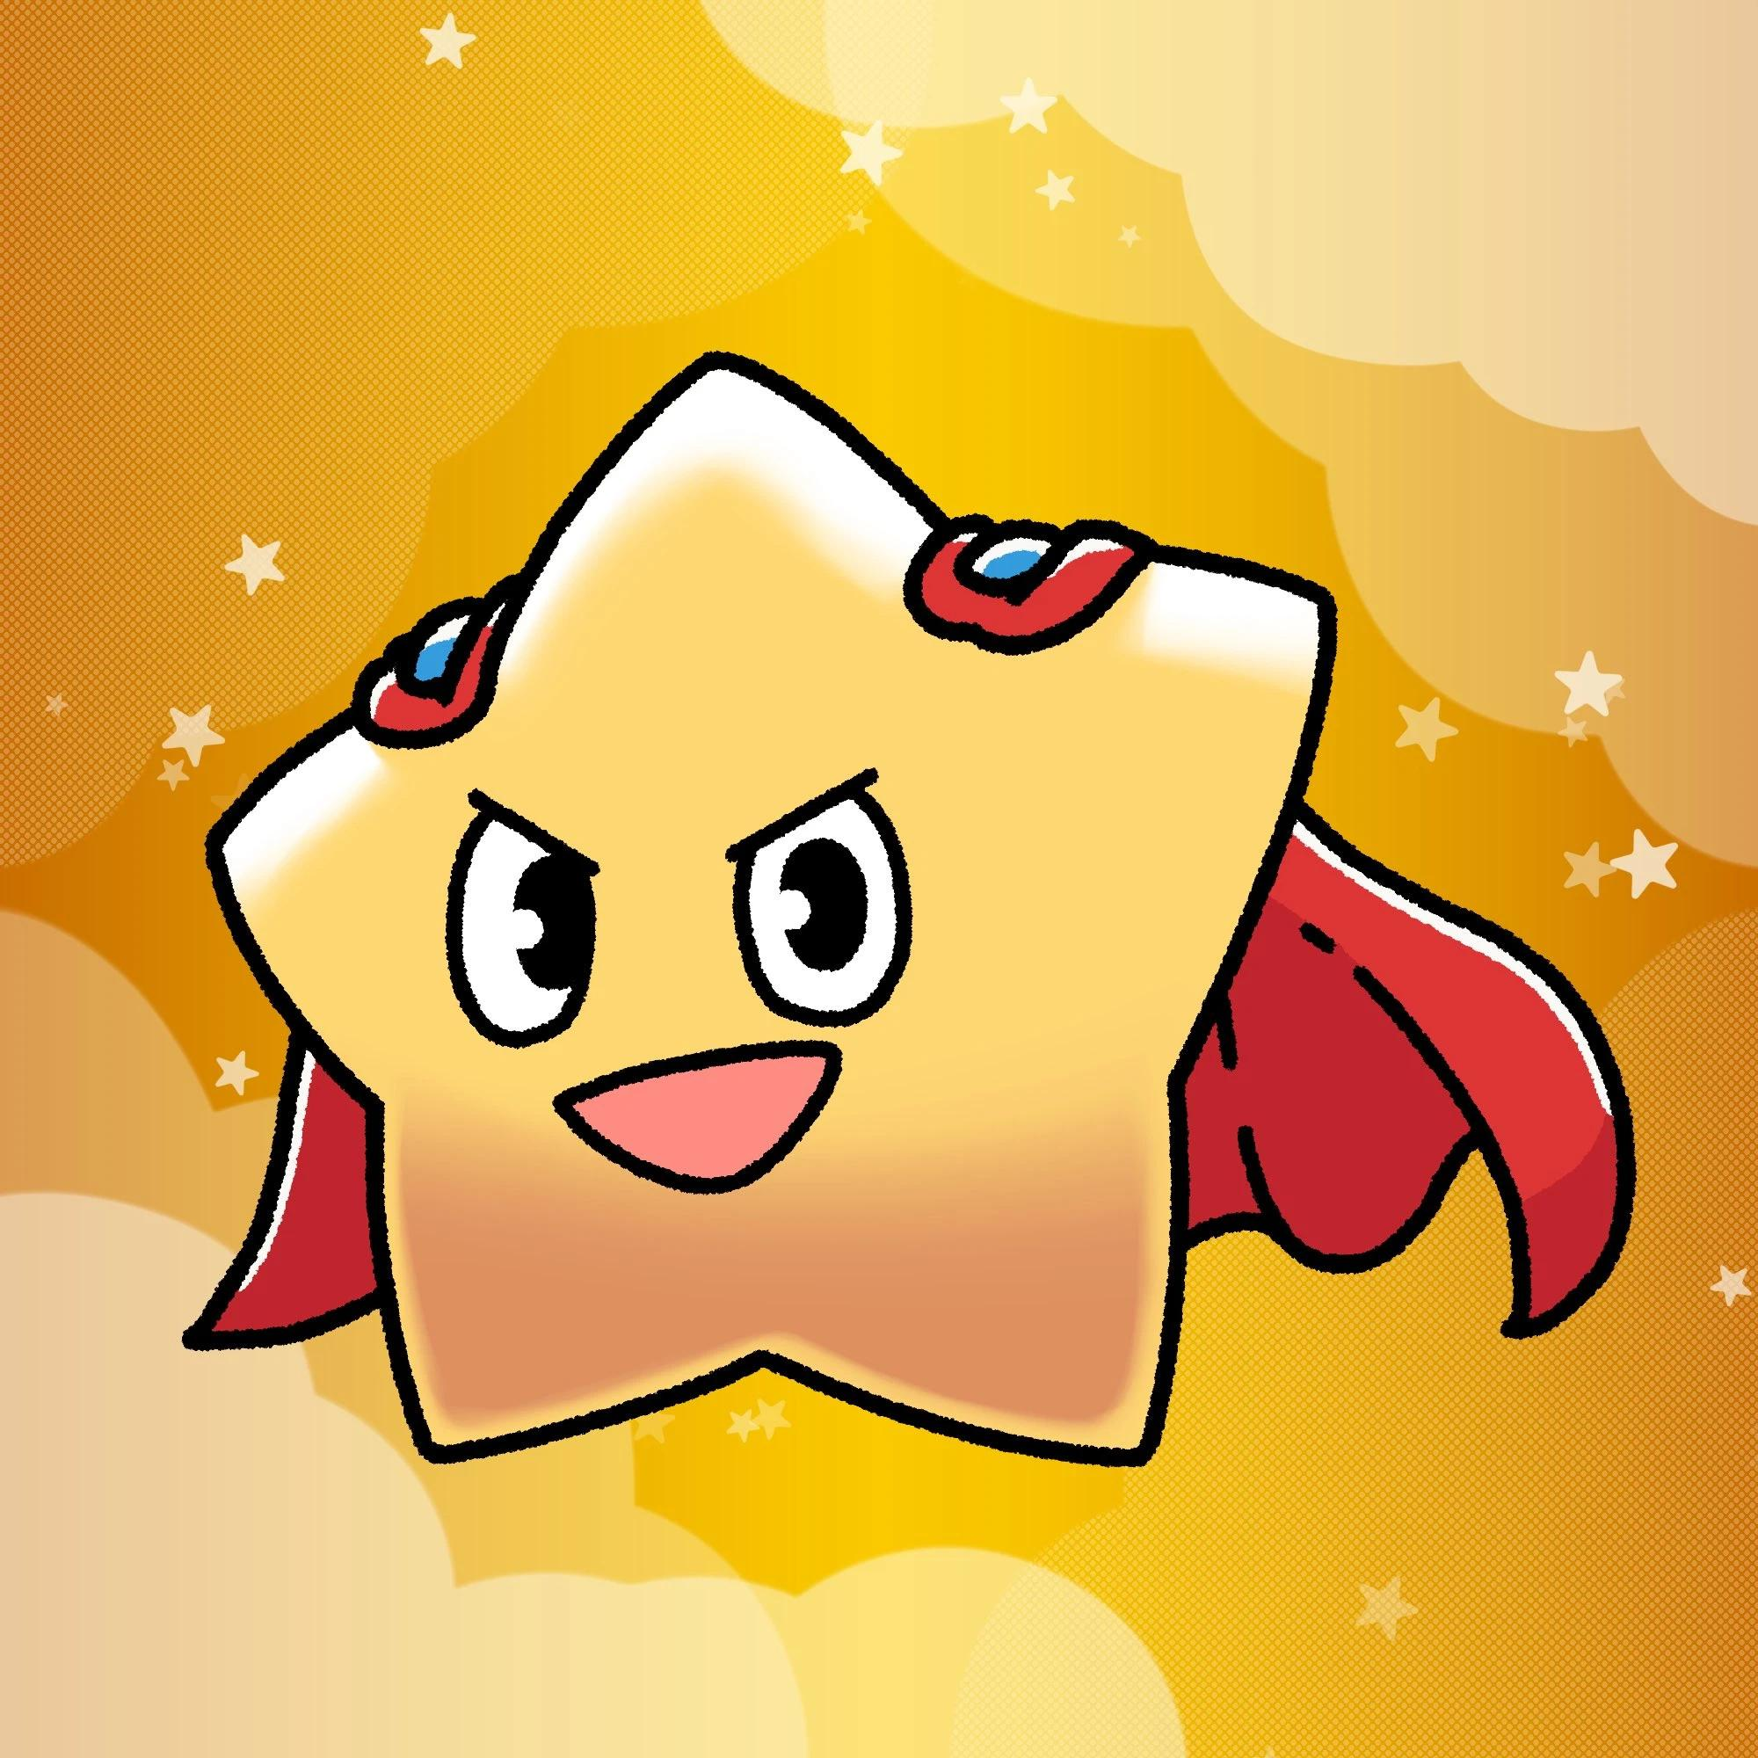

- Ọjọ Itusilẹ: Kínní 27, 2025  
- Opin Awọn ẹyà fun olumulo: 10,000  
- Awọn aaye ti o nilo fun Gacha kan: 1,000 aaye  
- Apapọ Awọn ohun kikọ: 11  
- Awọn ipele alailẹgbẹ: Super Rare (SR), Rare (R), ati Normal (N)  
- Pinpin: SR - 200, R - 2,600, N - 7,200

# Igbesi aye titun fun ipo

Pẹlu ifihan ti awọn ipele alailẹgbẹ, ipo yoo di oniruuru siwaju sii. Titi di isisiyi, ipo naa ti duro duro, ṣugbọn bayi, orire ni gbigba awọn ohun kikọ alailẹgbẹ le ni ipa nla lori ipo.

Kopa ninu awọn iṣẹ "Earn" inu ohun elo tabi awọn iṣẹlẹ lori Discord lati gba awọn aaye ki o pọ si awọn aye rẹ lati gba awọn ohun alailẹgbẹ!

# Lati ikojọpọ aaye si airdrop

- Pinpin $SP airdrop: 30% ti ipese lapapọ 100 bilionu, iyẹn ni 30 bilionu $SP.  
- Awọn olupin ipo giga yoo gba iye $SP diẹ sii.  
- Awọn ami-ẹri ti a pin yoo ṣe ifilọlẹ lori pẹpẹ Solana (SOL).

# Bawo ni a ṣe le lo Gacha

# Bawo ni lati ṣe Gacha

1. Ṣii ohun elo Smart Pocket.  
2. Yan taabu "Gacha".  
3. Yan taabu "Pockemy 2nd".  
4. Yan x1 Gacha (1,000 aaye) tabi x10 Gacha (10,000 aaye).  
5. Gba Pockemy 2nd PFP laileto!

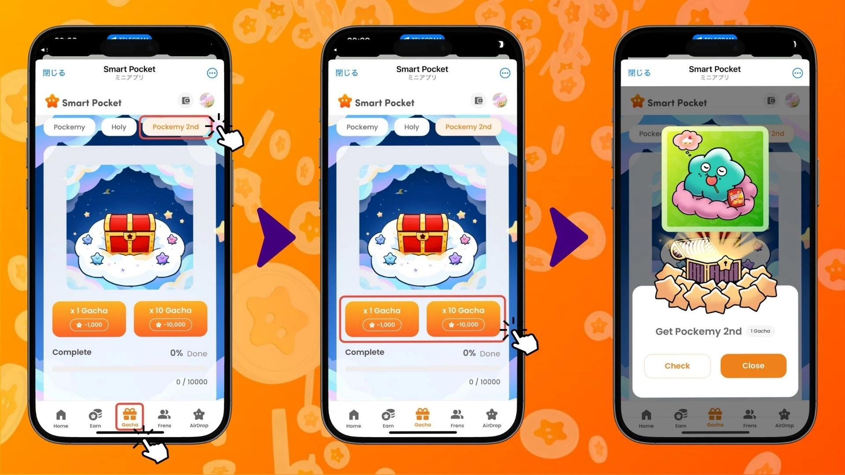

# Bawo ni lati ṣayẹwo abajade Gacha

1. Yan taabu "Earn".  
2. Tẹ "Wallet".  
3. Yan "Item".  
4. Yan "Pockemy 2nd".  
5. Awọn Pockemy 2nd PFP rẹ yoo han gẹgẹ bi ipele alailẹgbẹ wọn.

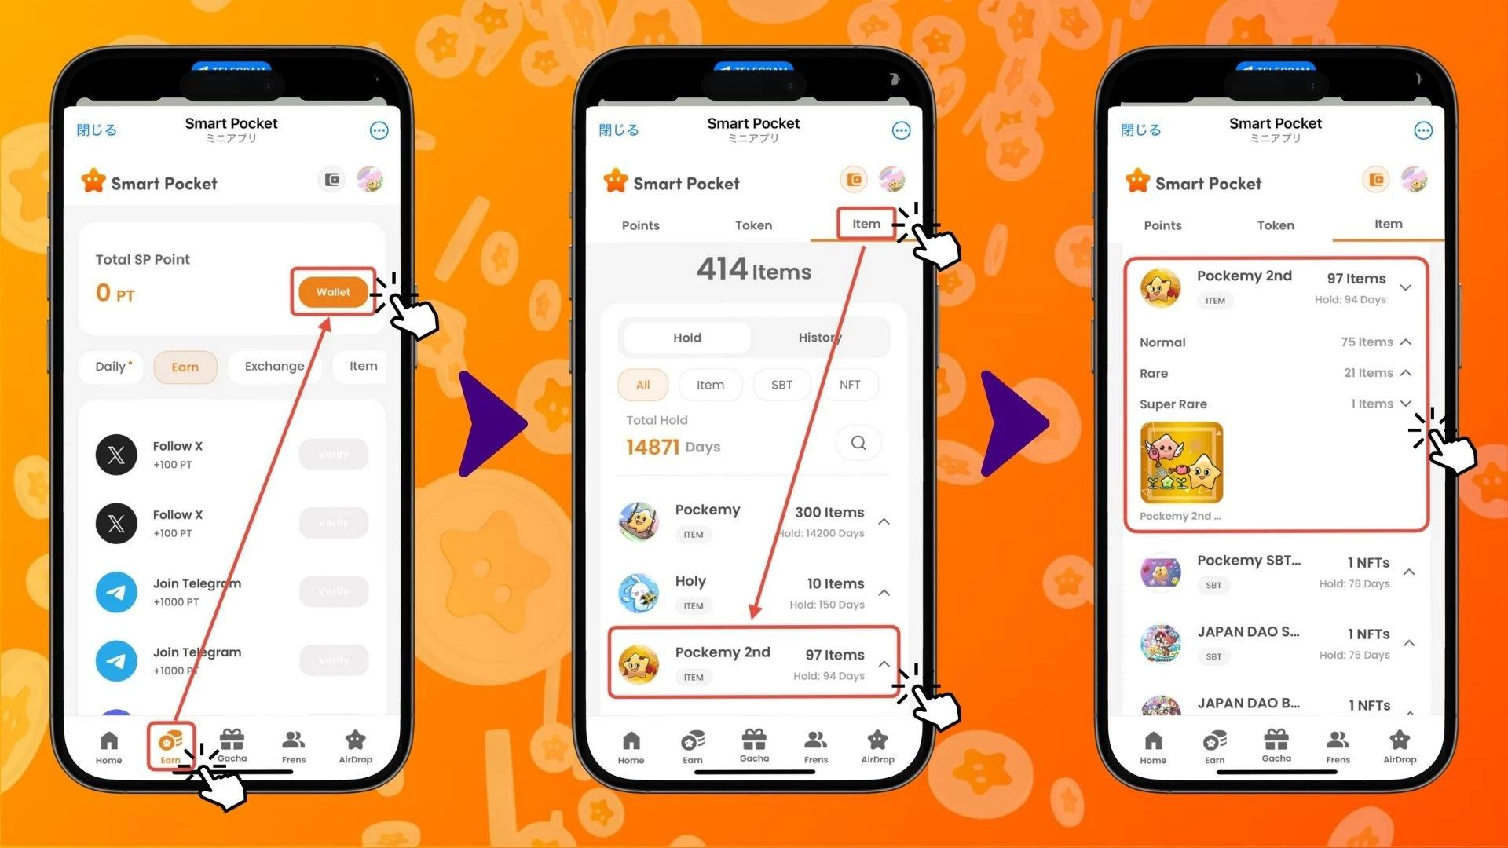

# Pataki ti ipari Gacha Pockemy ati Holy

Pockemy 2nd Gacha jẹ itusilẹ kẹta, lẹhin Pockemy PFP Gacha (300 awọn ohun) ati Holy Gacha (10 awọn ohun). Ipè ipari ti awọn Gacha wọnyi le ni ipa nla lori ipo rẹ.

# Awọn iṣẹ pataki fun igbega ipo

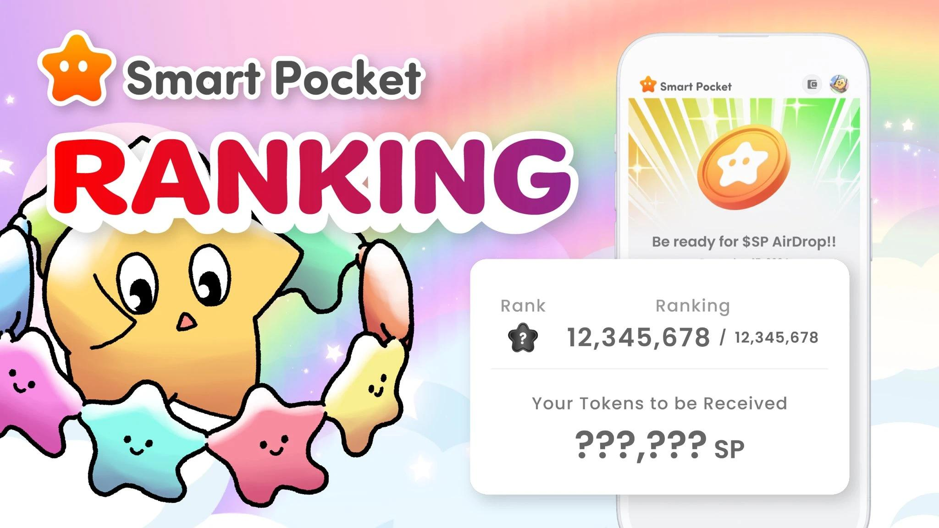

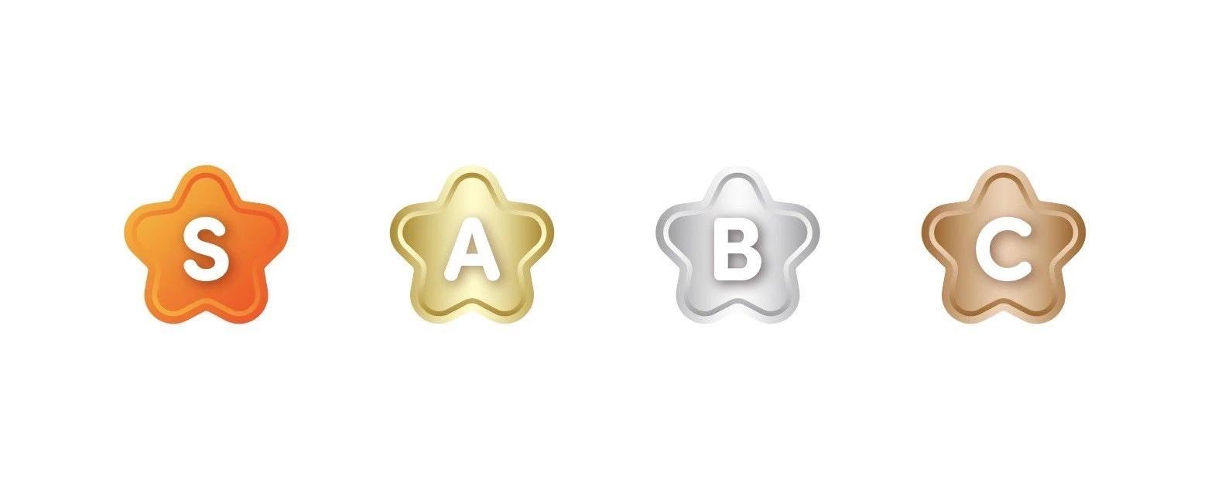

- Pee awọn ọrẹ lati gba awọn aaye.  
- Kopa ninu awọn ijiroro ati awọn iṣẹlẹ lori Discord.  
- Ṣe Gacha nigbagbogbo lati dide ninu ipo.

Awọn iṣẹ lori Discord yoo fun awọn ere nla, nitorinaa a ṣeduro gíga pe ki o kopa ni pipe! Pin abajade Gacha rẹ pẹlu agbegbe lati mu iriri rẹ dun sii!

# Ipari

Pockemy 2nd Gacha ni awọn ohun 10,000 ti o le gba, ọkọọkan n ṣe afihan ifaya alailẹgbẹ ti awọn ohun kikọ. Pẹlu awọn ipele alailẹgbẹ ti a ṣafikun, ipo yoo di ifigagbaga diẹ sii, ti o yorisi idije nla fun awọn airdrop $SP.

Ni apa keji, diẹ ninu awọn le fẹ lati gba awọn ohun kikọ ayanfẹ wọn ni iyara tirẹ.

A nireti pe iwọ yoo tẹsiwaju lati gbadun ohun elo Smart Pocket bi apakan ti iṣe ojoojumọ rẹ!

# Tẹsiwaju lati gba awọn imudojuiwọn!

Fun alaye tuntun, ṣabẹwo si awọn ọna asopọ osise:  
- Oju opo wẹẹbu osise Smart Pocket: https://smapocke.com/  
- Discord osise Smart Pocket: https://discord.com/invite/smartpocket  
- Akọọlẹ X osise Smart Pocket: https://x.com/smapocke  
- Akọọlẹ X osise Pockemy: https://x.com/pockemys  
- Akọọlẹ X osise Holy: https://x.com/holysinfo