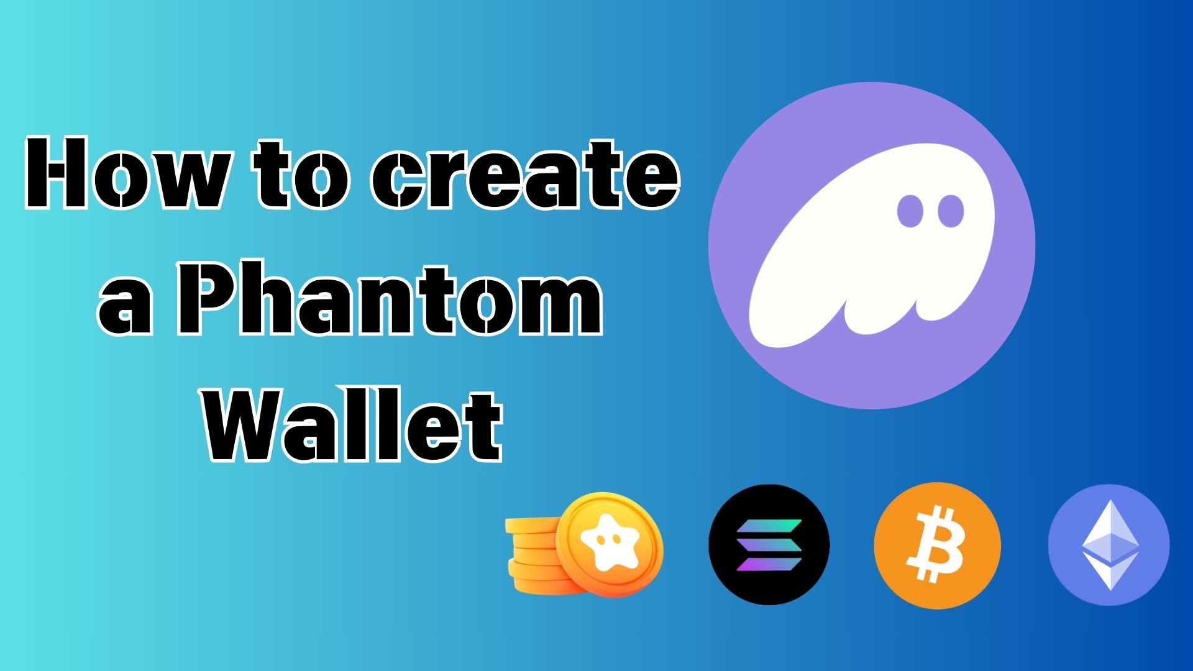

**Bawo ni a ṣe le Ṣẹda Phantom Wallet: Itọsọna pipe fun awọn alakobere**

**Ẹ káàbọ!**

**Ninu itọsọna yii, a yoo ṣalaye kini "Phantom Wallet" jẹ – apamọwọ oni-nọmba ti o gbajumo ni agbaye ti cryptocurrency ati NFT – ni ọna ti o rọrun fun awọn alakobere!**

**Ti o ba n beere, "Kini apamọwọ?" tabi "Ṣe o nira lati ṣẹda?"—maṣe yọ ara rẹ lẹnu! Nigbati o ba tẹle itọsọna yii, o le ṣẹda Phantom Wallet tirẹ ni irọrun.**

# Kini Phantom Wallet?

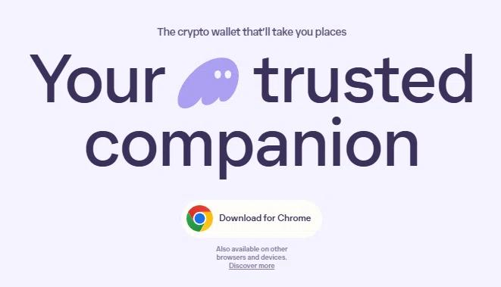  
  
Orisun: Oju opo wẹẹbu osise ti Phantom Wallet

Phantom Wallet jẹ "apamọwọ oni-nọmba" ti o ṣiṣẹ bi akọọlẹ ile-ifowopamọ tabi apamọwọ ti ara, ti o fun ọ laaye lati fipamọ ati ṣakoso awọn owo cryptocurrency ati awọn NFT.

O ti di olokiki pupọ nitori atilẹyin rẹ fun Solana blockchain, eyiti o jẹ iyara pupọ ati pẹlu awọn idiyele iṣowo kekere. Ni bayi, o tun ṣe atilẹyin Ethereum, Bitcoin, ati awọn blockchain miiran!

Oju opo wẹẹbu osise ti Phantom Wallet:  
https://phantom.com/

# Awọn ẹya akọkọ ti Phantom Wallet

Ọpọlọpọ awọn olumulo yan Phantom Wallet nitori awọn ẹya wọnyi:

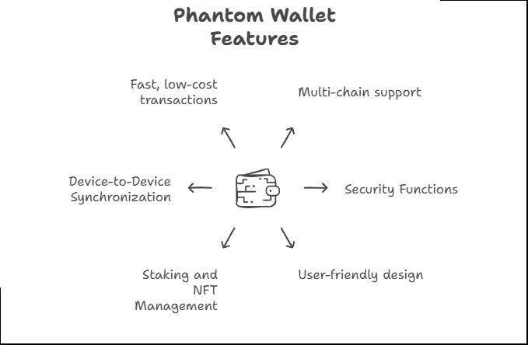

## Awọn ẹya ipilẹ

* Atilẹyin ọpọlọpọ blockchain: Solana, Ethereum, Bitcoin, Polygon, ati diẹ sii
* Iṣakoso ohun-ini tirẹ: O ko nilo lati fi awọn owo rẹ si ile-iṣẹ paṣipaarọ
* Ibamu ti o rọrun: Rọrun lati lo, paapaa fun awọn alakobere

## Aabo

* Ko si ewu ijakadi ile-iṣẹ paṣipaarọ: Awọn ohun-ini rẹ wa ni aabo paapaa ti paṣipaarọ ba jẹ hakii
* Ko si ewu idaduro ile-iṣẹ paṣipaarọ: Ti paṣipaarọ ba pari, awọn owo rẹ ko ni ipa
* Idanimọ biometric: Ifọwọsi oju tabi ika ọwọ fun aabo to pọ si

## Awọn iṣẹ ṣiṣe

* Rọrun lati fi ranṣẹ ati gba awọn owo crypto
* Paarọ awọn ami taara ninu ohun elo naa
* Staking: Gba ere lati awọn ohun-ini crypto rẹ
* Isakoso NFT: Wo ati ṣeto awọn NFT rẹ ni rọọrun

## Ibamu

* Wa fun foonuiyara ati PC: Ohun elo fun iOS/Android ati afikun ẹrọ aṣawakiri
* Iṣọkan laarin awọn ẹrọ: Lo apamọwọ kanna lori awọn ẹrọ pupọ

## Awọn anfani iṣowo

* Idunadura iyara: Paapa lori nẹtiwọọki Solana
* Awọn idiyele idunadura kekere

# Bawo ni a ṣe le ṣẹda Phantom Wallet

Awọn ọna meji wa lati ṣẹda Phantom Wallet. Yan eyi ti o baamu fun ọ!

## Ọna 1: Ṣẹda apamọwọ pẹlu adirẹsi imeeli

Ti a ṣe iṣeduro fun awọn alakobere nitori pe o rọrun julọ.

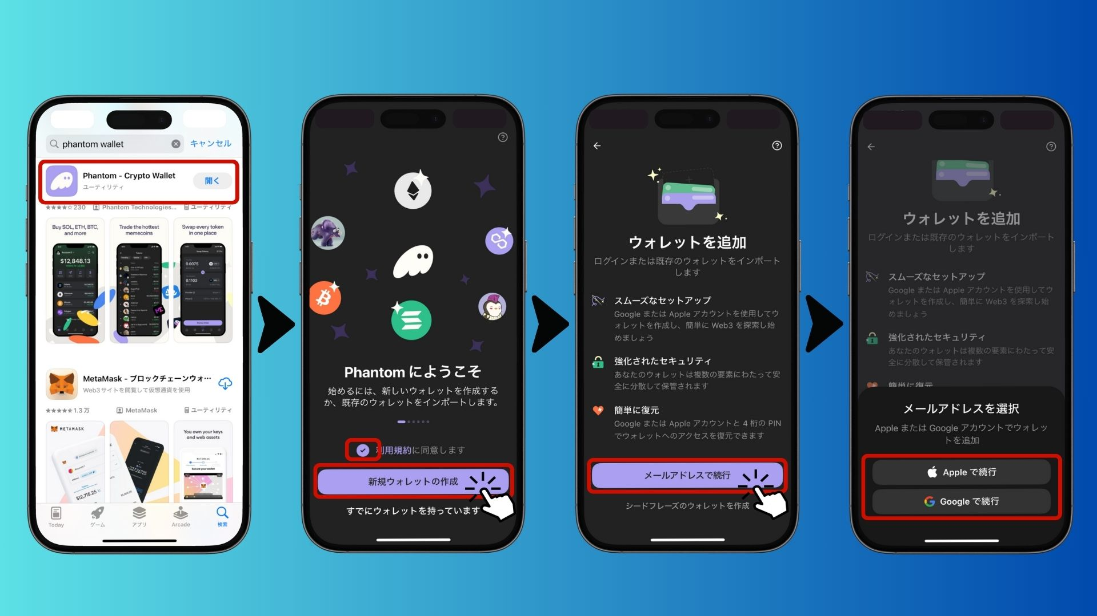  
  
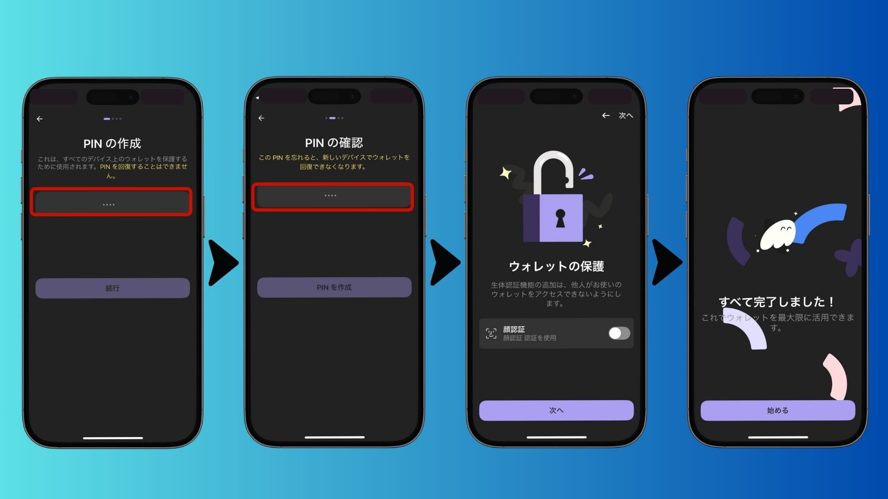

* Gbaa ohun elo Phantom lati App Store tabi Google Play
* iOS: https://apps.apple.com/jp/app/phantom-crypto-wallet/id1598432977
* Android: https://play.google.com/store/apps/details?id=app.phantom&pcampaignid=web_share
* Ṣii ohun elo naa, gba awọn ofin wọle ki o yan "Ṣẹda apamọwọ tuntun"
* Yan "Tẹsiwaju pẹlu Imeeli" (tabi wọle pẹlu akọọlẹ Apple/Google)
* Ṣeto koodu PIN mẹrin (maṣe gbagbe!)
* Mu idanimọ biometric ṣiṣẹ fun aabo to pọ si
* Apamọwọ rẹ ti ṣetan!

## Ọna 2: Ṣẹda apamọwọ pẹlu Seed Phrase

Eyi dara fun awọn ti o fẹ aabo to pọ si ati ibaramu pẹlu awọn apamọwọ miiran.

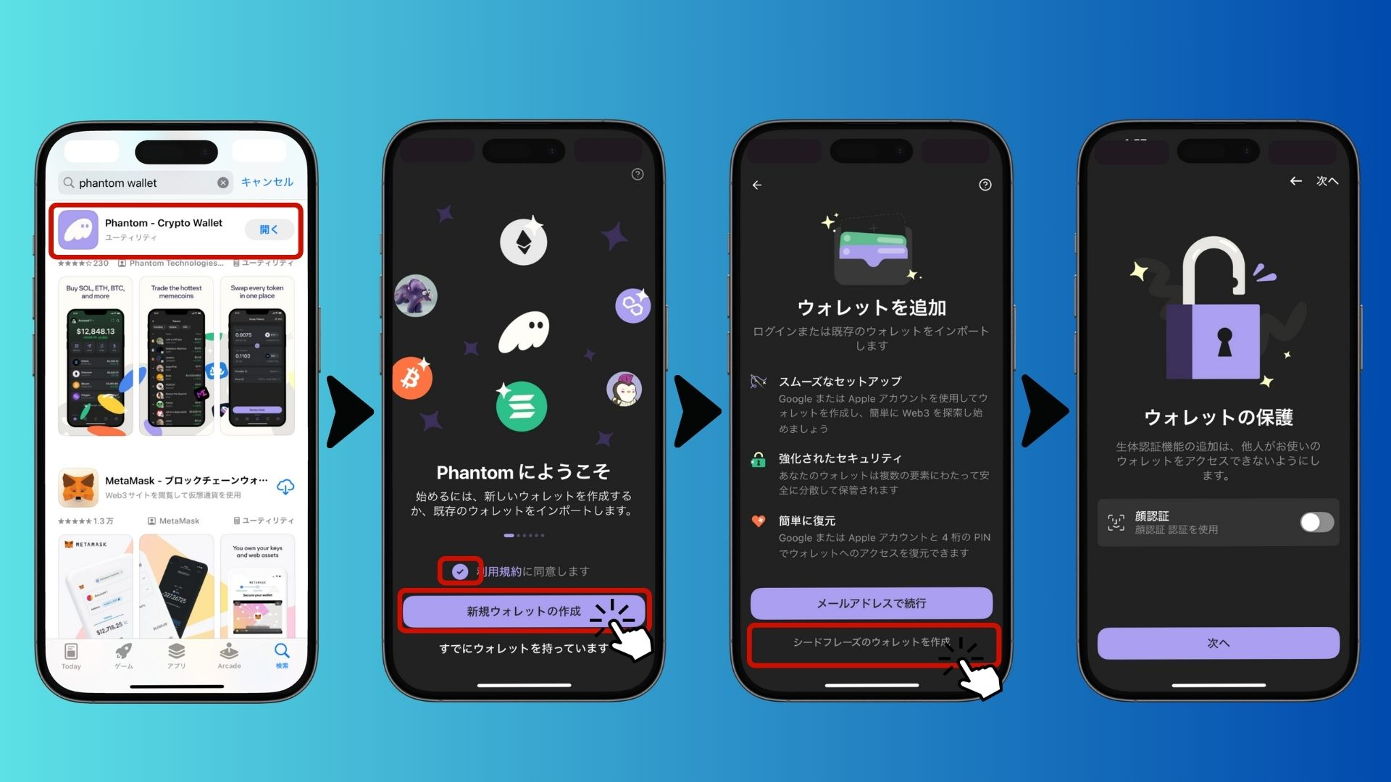  
  
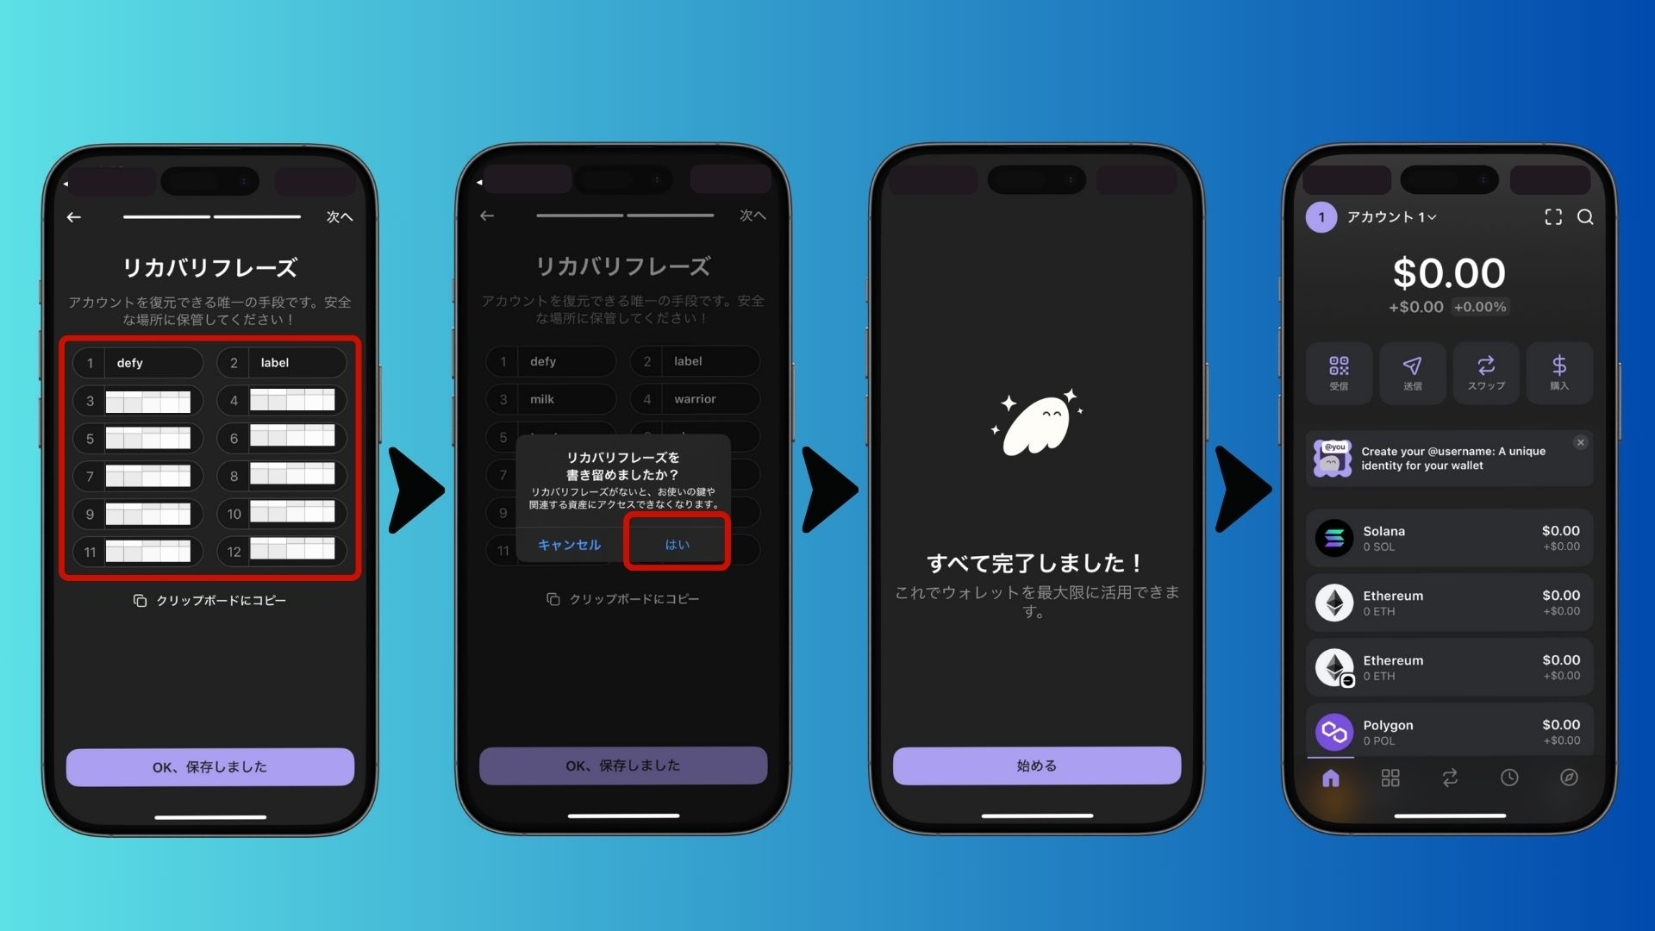

* Gbaa ohun elo Phantom lati App Store tabi Google Play
* Ṣii ohun elo naa, gba awọn ofin wọle ki o yan "Ṣẹda apamọwọ tuntun"
* Yan "Ṣẹda apamọwọ pẹlu Seed Phrase"
* Mu idanimọ biometric ṣiṣẹ fun aabo to pọ si
* Kọ si isalẹ awọn ọrọ Seed Phrase 12 (apẹẹrẹ: apple banana cat...) ki o tọju wọn ni ibi ailewu
* Ṣe ijẹrisi Seed Phrase ki o pari fifi sori ẹrọ

⚠️ Maṣe pin Seed Phrase rẹ pẹlu ẹnikẹni ki o má ṣe fipamọ rẹ ni ọna oni-nọmba!

# Awọn ewu & Awọn akiyesi

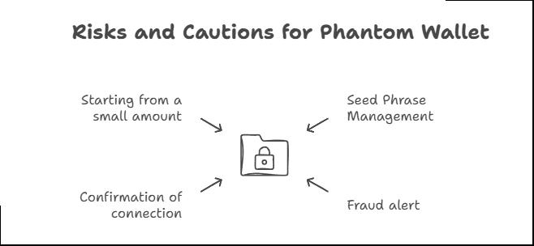

* Ṣe itọju to dara fun Seed Phrase rẹ: Ti o ba sọnu, iwọ ko le gba apamọwọ pada
* Ṣọra fun awọn itanjẹ: Yago fun awọn oju opo wẹẹbu iro ki o máṣe pin Seed Phrase rẹ
* Ṣayẹwo awọn asopọ apamọwọ: Maṣe sopọ mọ awọn oju opo wẹẹbu tabi awọn ohun elo ti o ko mọ
* Bẹrẹ pẹlu iye kekere: Ṣe adaṣe ṣaaju ṣiṣe awọn iṣowo nla

# Awọn ibeere ti a ma n beere

## Q1: Njẹ Phantom Wallet jẹ ọfẹ?

Bẹẹni, lilo apamọwọ jẹ ọfẹ. Sibẹsibẹ, diẹ ninu awọn iṣowo lori blockchain le ni awọn idiyele kekere.

## Q2: Kini yoo ṣẹlẹ ti Mo ba sọnu Seed Phrase mi?

Ti o ba sọnu Seed Phrase rẹ, iwọ ko le gba apamọwọ rẹ pada. Sibẹsibẹ, ti o ba ṣẹda rẹ pẹlu imeeli, o le gba pada pẹlu imeeli ati PIN.

## Q3: Ṣe Mo le gbe apamọwọ miiran si Phantom?

Bẹẹni, o le gbe apamọwọ miiran wọle si Phantom nipa lilo Seed Phrase rẹ.

## Q4: Njẹ Mo le lo apamọwọ kanna lori PC ati foonuiyara?

Bẹẹni, iwọ yoo nilo lati wọle pẹlu Seed Phrase kanna tabi imeeli kanna.

## Q5: Awọn owo crypto wo ni Phantom Wallet ṣe atilẹyin?

Phantom ṣe atilẹyin Solana (SOL), Ethereum (ETH), Bitcoin (BTC), Polygon (MATIC), ati diẹ sii.

# Ipari

Phantom Wallet jẹ apamọwọ ti o ni aabo ati irọrun lati lo, pipe fun awọn ti o fẹ lati ṣawari eto Solana!

Yan ọna kika ti o baamu fun ọ:

* Ọna imeeli: Rọrun ati iṣeduro fun awọn alakobere
* Ọna Seed Phrase: Aabo to gaju, dara fun awọn olumulo to ni iriri

Jọwọ ṣetọju ọrọ igbaniwọle, PIN, ati Seed Phrase rẹ ni aabo!

Bayi ti o ba ti kọ ẹkọ bi o ṣe le ṣẹda Phantom Wallet, gbiyanju rẹ ki o bẹrẹ irin-ajo rẹ ni agbaye Web3!