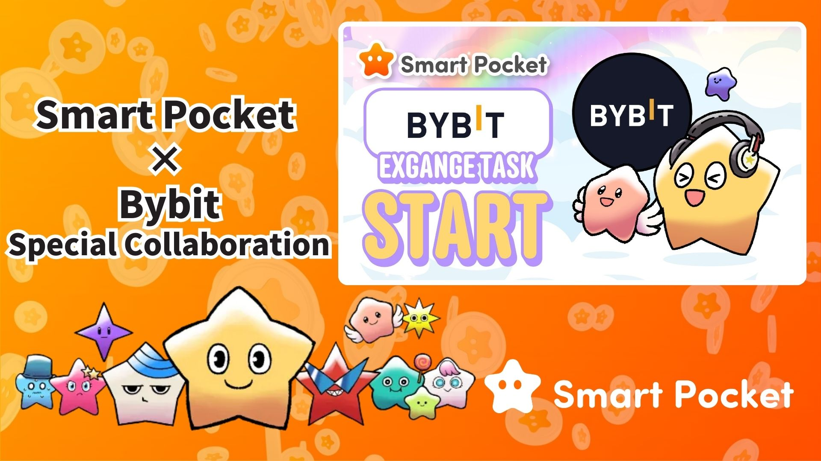

**Ibẹrẹ Ifọwọsowọpọ Smart Pocket × Bybit! Gba 11,000 Awọn Pointi Ninu Awọn Igbesẹ 2 Rọrun 🎉**

**Ẹ káàbọ!  
  
Ifọwọsowọpọ laarin Bybit, ọkan ninu awọn ọja paṣipaarọ cryptocurrency to ga julọ ni agbaye, ati Smart Pocket ti bẹrẹ ni ifowosi!  
  
Bayi, o ni aye lati gba to 11,000 SP pointi nipa ṣiṣe awọn igbesẹ ti o rọrun.**

**🔗 https://x.com/smapocke/status/1894692942251708611**

# Akosilẹ

* Kini Bybit?
* Awọn ẹya pataki ti Bybit
* Alaye nipa ifọwọsowọpọ
* Awọn igbesẹ lati pari iṣẹ-ṣiṣe
* Bawo ni a ṣe le tẹle akọọlẹ X osise ti Bybit
* Bawo ni a ṣe le fi UID Bybit rẹ sii
* Awọn akọsilẹ pataki
* Ipari
* Maṣe ṣàìgbàgbé awọn iroyin tuntun lati Smart Pocket!

# Kini Bybit?

  
  
Orisun: Bybit  
  
Bybit jẹ ọja paṣipaarọ cryptocurrency pataki kan ti a da ni ọdun 2018. O ni ori-iṣẹ rẹ ni Dubai loni, ati pe o wa fun lilo ni diẹ sii ju awọn orilẹ-ede 130 lọ kakiri agbaye.

# Awọn ẹya pataki ti Bybit

* Ọkan ninu awọn ọja paṣipaarọ cryptocurrency to ga julọ ni agbaye
* Diẹ sii ju awọn olumulo 60 milionu lọ
* Atilẹyin fun ju awọn owo-iworo 300 lọ

# Alaye nipa ifọwọsowọpọ

Ninu ifọwọsowọpọ yii, o le gba awọn pointi SP nipa ipari awọn iṣẹ-ṣiṣe meji ti o rọrun:  
  
- Tẹle akọọlẹ X osise ti Bybit (@Bybit_Official) → Gba 1,000 SP pointi  
- Fi UID Bybit rẹ sii → Gba 10,000 SP pointi  
  
Lapapọ, o le gba to 11,000 SP pointi! Maṣe fi aye yii silẹ.

# Awọn igbesẹ lati pari iṣẹ-ṣiṣe

## Bawo ni a ṣe le tẹle akọọlẹ X osise ti Bybit

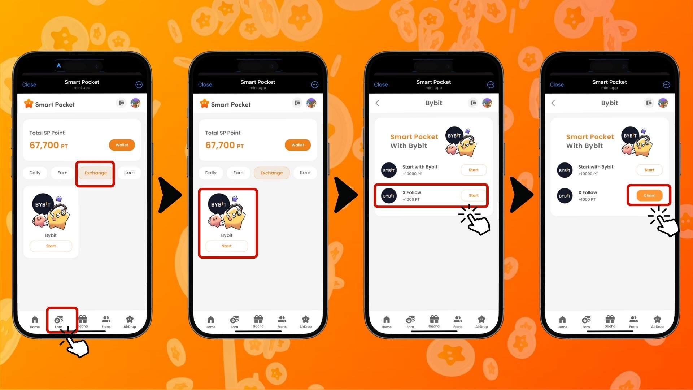  
  
1. Ṣii ohun elo Smart Pocket  
2. Lọ si taabu "Earn"  
3. Tẹ taabu "Exchange"  
4. Tẹ "Start" labẹ Bybit  
5. Tẹ "Start" lati tẹle Bybit lori X  
6. Pada si ohun elo Smart Pocket  
7. Tẹ "Claim" lati pari iṣẹ-ṣiṣe

## Bawo ni a ṣe le fi UID Bybit rẹ sii

⚠️ Akọsilẹ pataki: UID Bybit ti a lo fun iṣẹ-ṣiṣe yii le ṣee lo lẹẹkan ṣoṣo. Rii daju pe o yan akọọlẹ Smart Pocket to tọ ṣaaju ki o to tẹsiwaju.  
  
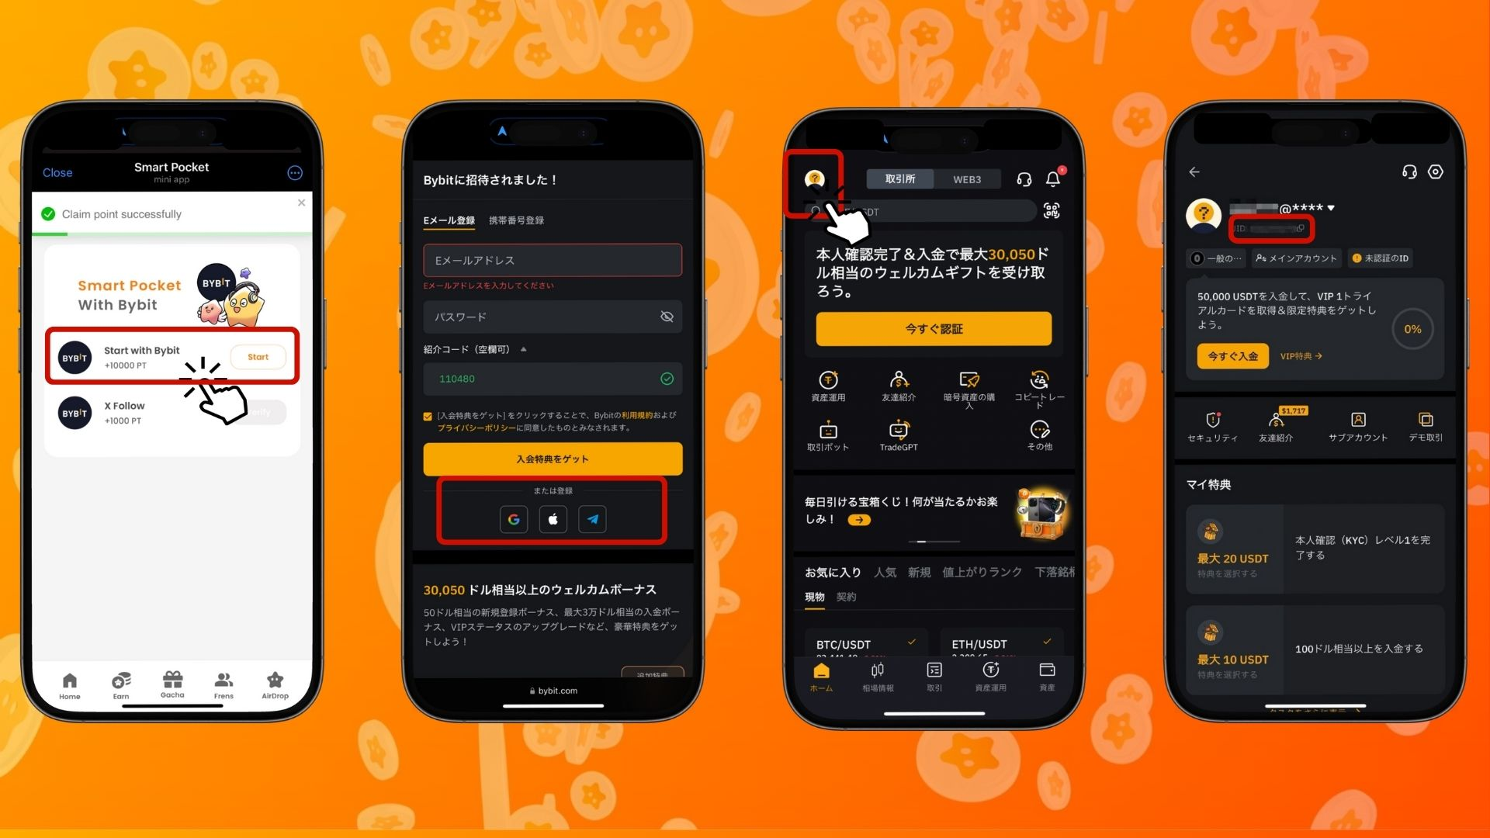  
  
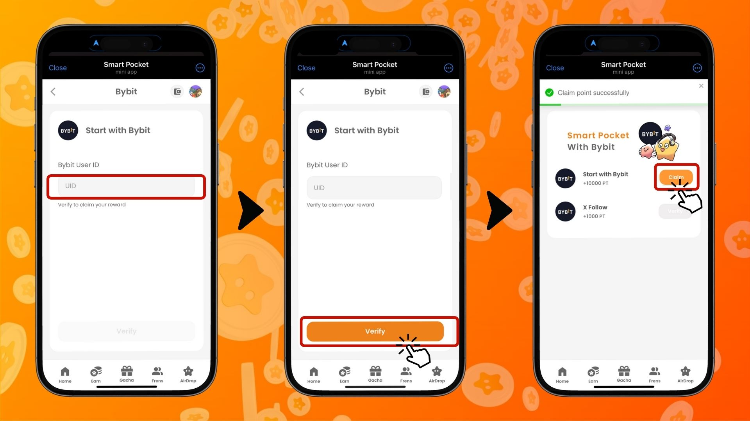  
  
1. Tẹ "Start" labẹ "Start with Bybit"  
2. Ṣẹda akọọlẹ tuntun kan  
3. Lẹhin ti o wọle si Bybit, tẹ aami ni apa osi oke ti taabu ile  
4. Daakọ UID rẹ  
5. Pada si ohun elo Smart Pocket  
6. Pàdé UID ti a daakọ sinu aaye "Bybit User ID"  
7. Tẹ "Verify"  
8. Tẹ "Claim" lati pari iṣẹ-ṣiṣe

# Awọn akọsilẹ pataki

* Idanimọ (KYC) ti Bybit gba laaye akọọlẹ kan fun ẹni kọọkan nikan.
* UID Bybit ti a lo fun iṣẹ-ṣiṣe Smart Pocket ko le ṣee lo fun akọọlẹ miiran.

# Ipari

Ifọwọsowọpọ Bybit × Smart Pocket jẹ anfani nla fun awọn olumulo Web3! Nipa ipari awọn iṣẹ-ṣiṣe meji ti o rọrun, o le gba to 11,000 SP pointi. Bybit jẹ ọkan ninu awọn ọja paṣipaarọ cryptocurrency to ga julọ ni agbaye, n pese diẹ sii ju awọn aṣayan iṣowo 300 ati iṣẹ didara to ga julọ. Maṣe padanu aye yii—Ṣẹda akọọlẹ Bybit rẹ bayi ki o bẹrẹ gbigba awọn pointi Smart Pocket!

# Maṣe ṣàìgbàgbé awọn iroyin tuntun lati Smart Pocket!

Smart Pocket maa n gbalejo awọn iṣẹ-ṣiṣe ati awọn iṣẹlẹ ti o nifẹ nigbagbogbo, pẹlu ifọwọsowọpọ yii pẹlu Bybit. Tẹle awọn ikanni osise lati duro imudojuiwọn ati lo anfani ti awọn aye tuntun!

📢 Duro imudojuiwọn:  
  
Oju opo wẹẹbu osise Smart Pocket: https://smapocke.com/  
Discord osise Smart Pocket: https://discord.com/invite/smartpocket  
Akọọlẹ X osise Smart Pocket: https://x.com/smapocke  
Telegram osise Smart Pocket: https://t.me/smartpocketjp  
  
Forukọsilẹ bayi lori Bybit ki o gbadun ifọwọsowọpọ iyalẹnu yii pẹlu Smart Pocket!