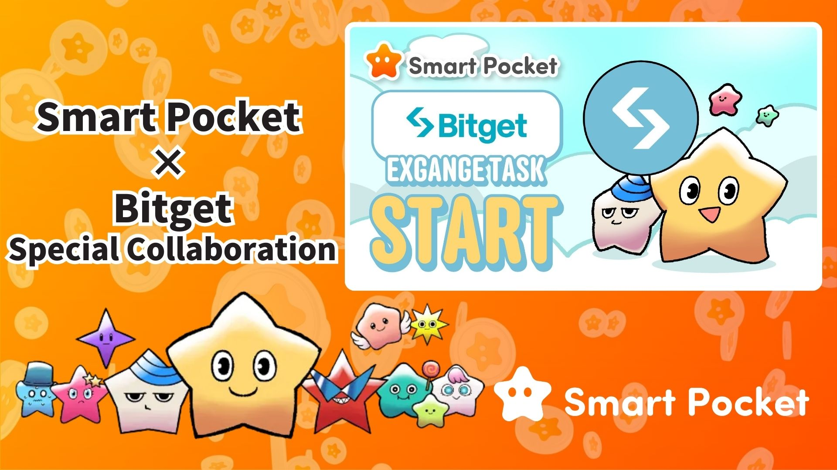

**Ibẹrẹ Ifowosowopo Smart Pocket × Bitget! Gba 11,000 Awọn Pointi ni Awọn Igbesẹ 2 Rọrun 🎉**

**Ẹ káàbọ gbogbo!**

**Pẹpẹ paṣipaarọ owó ilẹ ayé Bitget, eyiti o n dagba ni iyara, ti bẹrẹ ifowosowopo pẹlu Smart Pocket! Eyi jẹ aye rẹ lati gba to 11,000 awọn pointi SP pẹlu awọn igbesẹ rọrun.**

**Ọna asopọ: https://x.com/smapocke/status/1895405359487160635**

# Akosile

* Kí ni Bitget?
* Awọn ẹya pataki ti Bitget
* Alaye nipa Ifowosowopo
* Bawo ni a ṣe le pari awọn iṣẹ-ṣiṣe
* [Bawo ni a ṣe le tẹle iroyin X osise Bitget]
* [Bawo ni a ṣe le fi UID Bitget rẹ sii]
* Awọn ohun pataki lati mọ
* Akopọ
* Maṣe ṣàìgbàgbé awọn iroyin tuntun lati Smart Pocket!

# Kí ni Bitget?

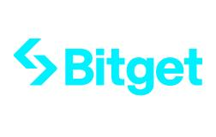  
  
Orisun: Bitget

Bitget jẹ pẹpẹ paṣipaarọ owo ilẹ-ayé pataki ti a da ni Singapore ni ọdun 2018. Lọwọlọwọ, o n ṣiṣẹ ni diẹ ẹ sii ju awọn orilẹ-ede 100 lọ ati pe o ni diẹ ẹ sii ju awọn olumulo miliọnu 40, eyiti o jẹ ki o jẹ ọkan ninu awọn paṣipaarọ owo ilẹ-ayé ti o tobi julọ ni agbaye.

# Awọn ẹya pataki ti Bitget

* Diẹ ẹ sii ju awọn orisii paṣipaarọ owo ilẹ-ayé 800 wa
* Idunadura ọjọ iwaju pẹlu leverage to 125x
* Ẹya pataki “BGB” fun awọn ẹdinwo lori awọn idiyele idunadura ati awọn anfani miiran
* Iṣẹ atilẹyin fun Web3 nipasẹ Bitget Wallet

# Alaye nipa Ifowosowopo

Pari awọn iṣẹ-ṣiṣe meji wọnyi lati gba awọn pointi SP ti o niyelori:

* Tẹle iroyin X osise Bitget (@bitgetglobal) → Gba 1,000 awọn pointi SP
* Fi UID Bitget rẹ sii → Gba 10,000 awọn pointi SP

Lapapọ, o le gba 11,000 awọn pointi SP! Maṣe padanu aye yii.

# Bawo ni a ṣe le pari awọn iṣẹ-ṣiṣe

## [Bawo ni a ṣe le tẹle iroyin X osise Bitget]

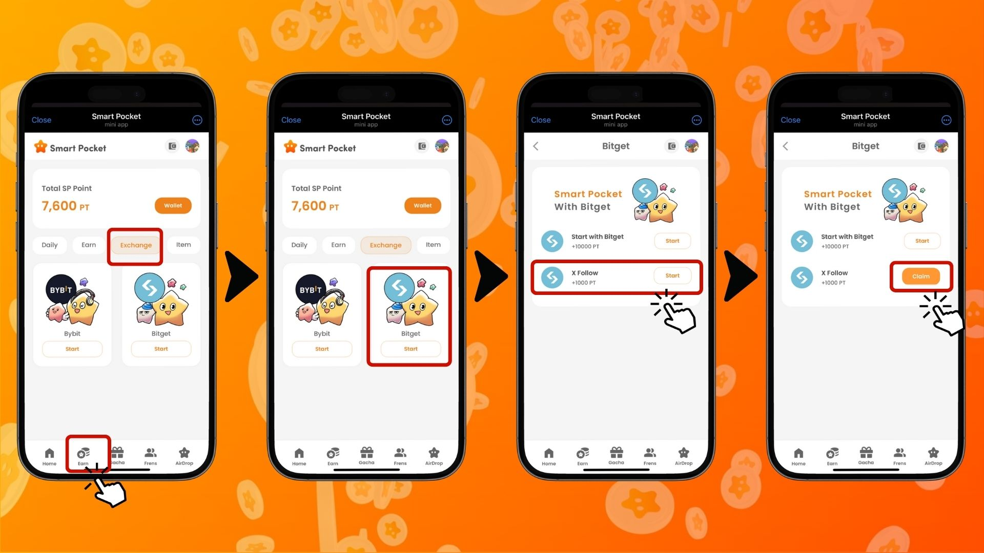  
  
1. Ṣii ohun elo Smart Pocket  
2. Lọ si taabu 'Earn'  
3. Tẹ taabu 'Exchange'  
4. Tẹ 'Start' lori Bitget  
5. Tẹ 'Start' lori 'X Follow'  
6. Tẹle iroyin X osise Bitget (@bitgetglobal)  
7. Pada si ohun elo Smart Pocket  
8. Tẹ 'Claim' lati pari

## [Bawo ni a ṣe le fi UID Bitget rẹ sii]

(Pataki) UID Bitget ti o forukọsilẹ le ṣee lo ni ẹẹkan nikan. Yan iroyin Smart Pocket ti o fẹ lo ṣaaju ki o to pari iṣẹ-ṣiṣe naa.

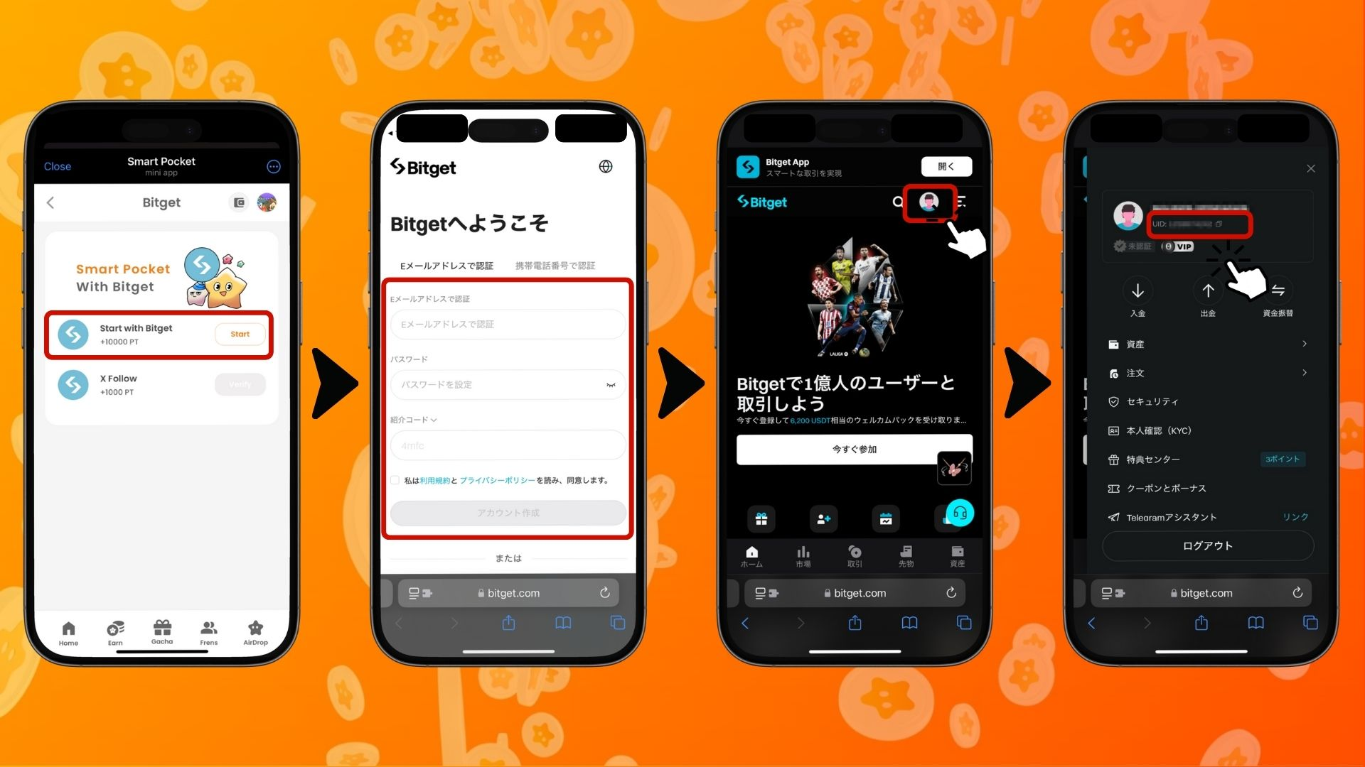

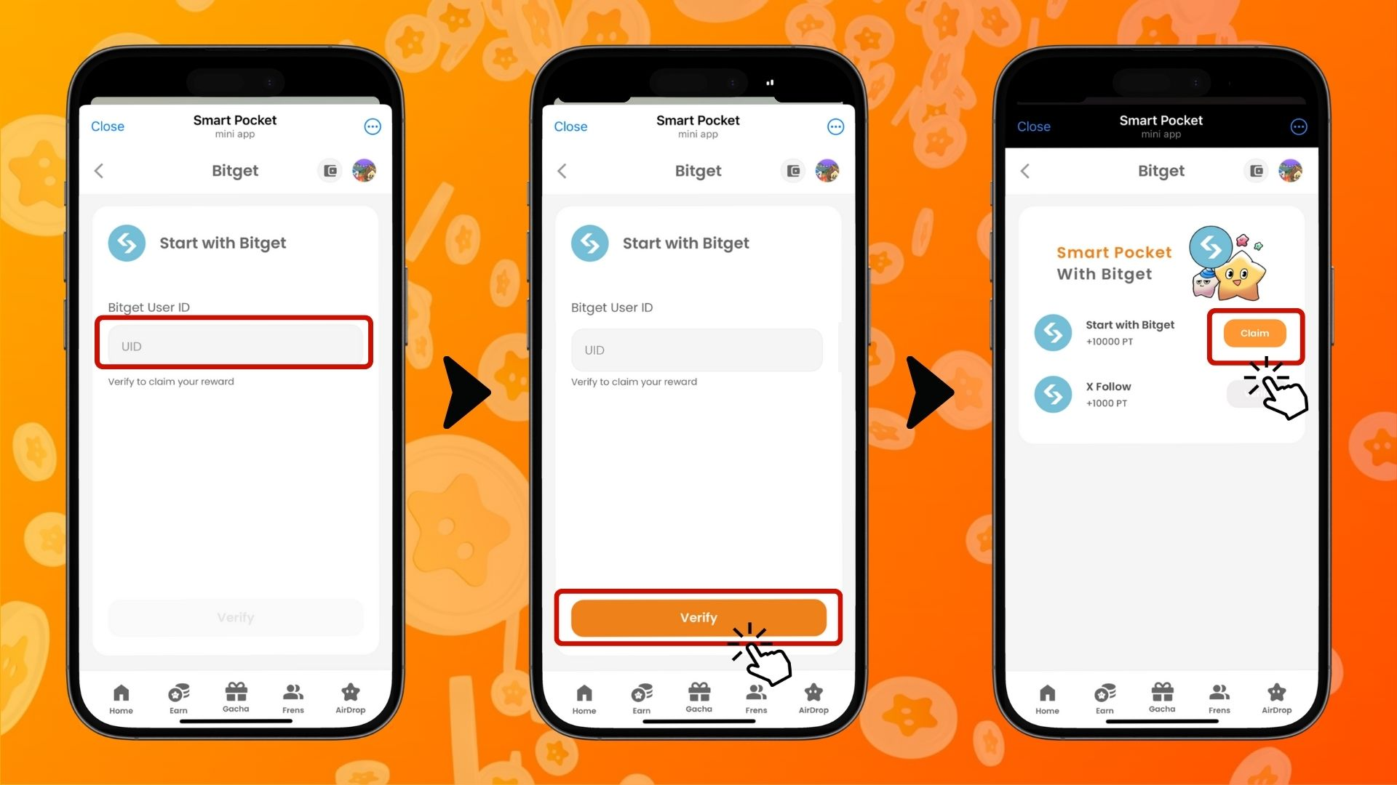  
  
1. Tẹ 'Start' lori 'Start with Bitget'  
2. Ṣẹda iroyin tuntun kan  
3. Lẹhin ti o wọle si Bitget, tẹ aami ni igun apa osi oke ti taabu ile  
4. Daakọ UID rẹ  
5. Pada si ohun elo Smart Pocket  
6. Lẹẹ UID ti o daakọ sinu aaye 'Bitget User ID'  
7. Tẹ 'Verify'  
8. Tẹ 'Claim' lati pari

# Awọn ohun pataki lati mọ

* Ijerisi ID (KYC) Bitget jẹ fun iroyin kan nikan fun eniyan kọọkan
* UID Bitget ti a lo fun Smart Pocket ko le ṣee lo pẹlu awọn iroyin miiran

# Akopọ

Ifowosowopo Bitget × Smart Pocket jẹ aye nla fun awọn olumulo Web3! Pẹlu iṣẹ-ṣiṣe meji ti o rọrun, o le gba to 11,000 awọn pointi SP. Bitget jẹ ọkan ninu awọn paṣipaarọ owo ilẹ-ayé ti o tobi julọ ni agbaye, ti o funni ni diẹ ẹ sii ju awọn orisii idunadura 840 ati ọpọlọpọ awọn iṣẹ to ti ni ilọsiwaju. Lo anfani yii lati ṣẹda iroyin Bitget ki o ṣajọ awọn pointi Smart Pocket!

# Maṣe ṣàìgbàgbé awọn iroyin tuntun lati Smart Pocket!

Yato si ifowosowopo pẹlu Bitget, Smart Pocket n ṣeto awọn iṣẹ-ṣiṣe ati awọn iṣẹlẹ igbadun nigbagbogbo. Tẹle awọn ikanni osise wọn lori media awujọ lati duro imudojuiwọn!

📢 Gba imudojuiwọn nibi:

* Oju opo wẹẹbu osise Smart Pocket: https://smapocke.com/
* Smart Pocket osise Discord: https://discord.com/invite/smartpocket
* Iroyin X osise Smart Pocket: https://x.com/smapocke
* Ẹgbẹ Telegram osise Smart Pocket: https://t.me/smartpocketjp

Ṣẹda iroyin Bitget kan loni ki o gbadun ifowosowopo pẹlu Smart Pocket!