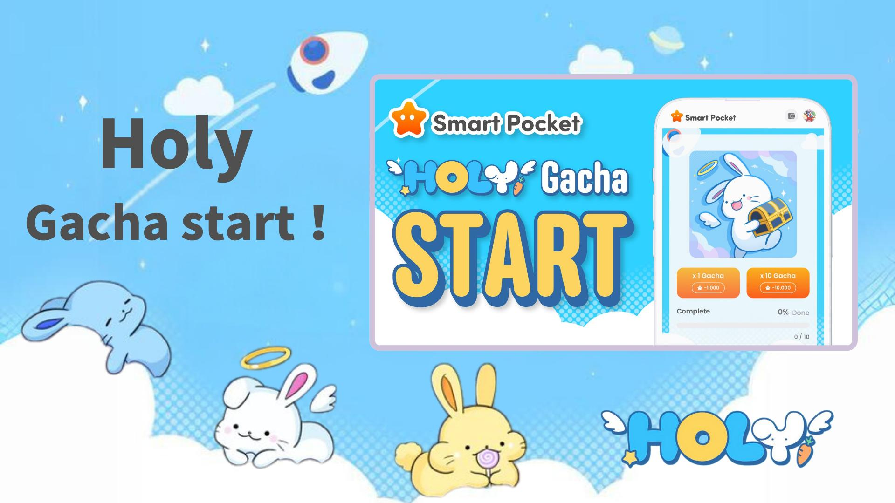

**Gba Holy nipasẹ Gacha! Idasilẹ Gacha keji ti o ti pẹ ti nduro fun lati inu ohun elo Smart Pocket ti de!**

**Ẹ káàbọ gbogbo eniyan!  
  
A ni iroyin igbadun fun yin! Gacha tuntun ti a ti n duro de, "Holy," ti de ninu ohun elo Smart Pocket. Eyi jẹ anfani pataki ti o ko gbọdọ padanu, paapaa fun $SP airdrop.  
  
https://x.com/smapocke/status/1889989719402193309  
  
Ti o ba fẹ mọ siwaju sii nipa ẹya "Gacha" ninu ohun elo Smart Pocket, ka àpilẹkọ yii:  
  
https://note.com/japan_dao/n/n521a5818be74**

# Akopọ

* Kini Holy?
* Bawo ni a ṣe le lo Gacha
* Bawo ni a ṣe le ṣayẹwo Gacha ti a gba
* Pataki ti Airdrop ati ipo ipo
* Afọwọkọ laarin Pockemy Gacha ati Holy Gacha
* Nọmba awọn ohun ti o nilo lati pari ikojọpọ
* Anfani ti ipari ikojọpọ
* Ẹbun pataki fun awọn onkawe 🎁
* Akopọ

# Kini Holy?

Holy jẹ jara pataki ti o ṣẹda nipasẹ Kin no Ono (@shoot_down_UFO). Pẹlu akori "irin-didùn ati iwosan," ikojọpọ yii darapọ awọn ohun kikọ àgùntàn pẹlu awọn eroja angẹli, fifun wọn ni aworan mimọ ati aabo.



## Awọn ẹya ara Holy

* Awọn ẹrẹkẹ ti o yi ati ẹlẹwa
* Awọn ipo ti o wuyi ti o mu awọn oluwo rẹ rin
* Agbaye alailẹgbẹ ti o kun fun idakẹjẹ

Ipolowo Holy  
https://x.com/holysinfo/status/1836336356878143848

# Bawo ni a ṣe le lo Gacha

* Ṣii ohun elo Smart Pocket
* Yan taabu Gacha
* Yan ×1 Gacha (1,000 awọn aaye nilo) tabi ×10 Gacha (10,000 awọn aaye nilo)
* Gba Holy laileto!

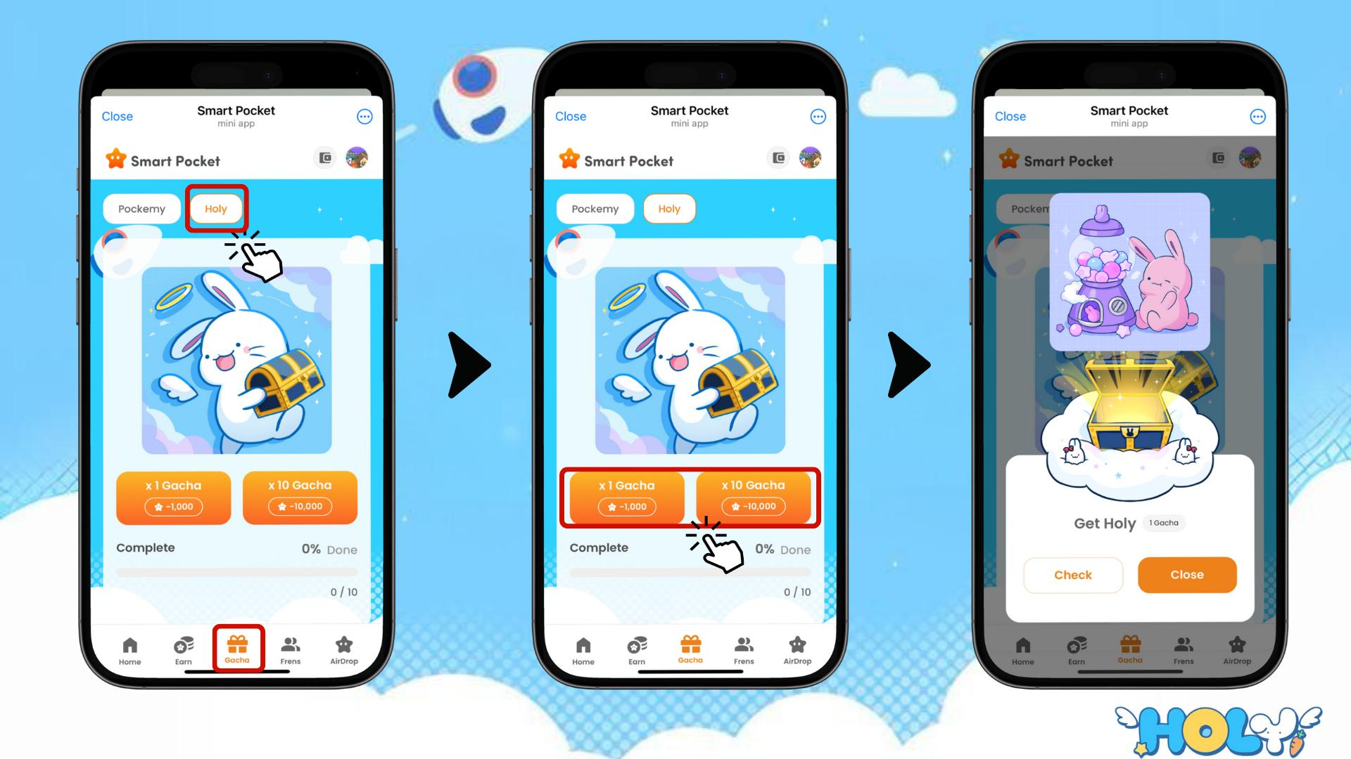

# Bawo ni a ṣe le ṣayẹwo Gacha ti a gba

* Yan taabu Earn
* Tẹ Wallet
* Yan Item
* Yan Holy
* Awọn Holy ti a gba yoo han

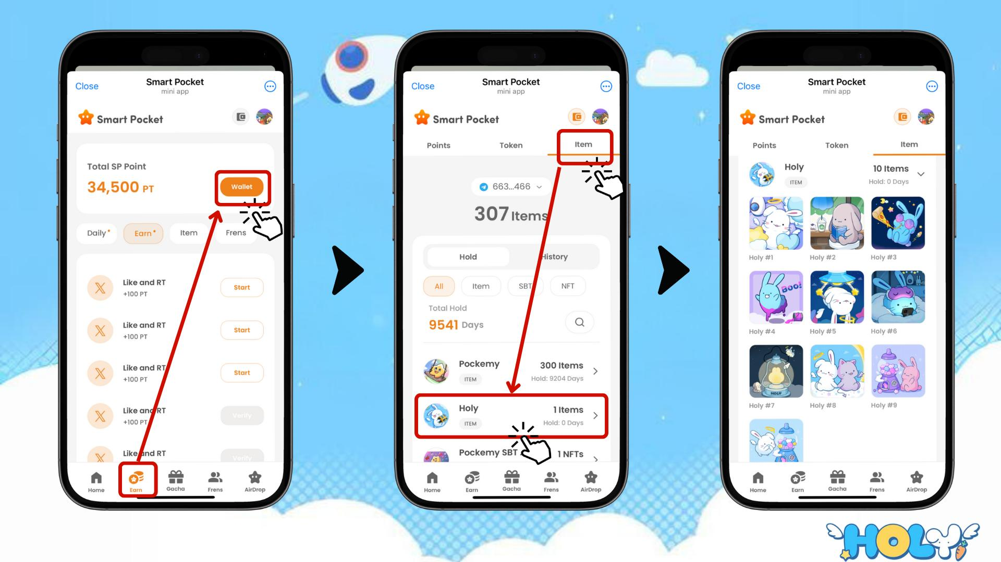

# Pataki ti Airdrop ati ipo ipo

Awọn ifosiwewe pataki fun $SP token airdrop ni "Items (nọmba awọn ohun)" ati "Ranking (ipo ipo)." Fifọwọsi awọn ipo wọnyi jẹ bọtini lati gba airdrop.

Fun alaye diẹ sii nipa awọn airdrop ati ipo ipo, ṣàbẹwò:  
https://note.com/japan_dao/n/n193cf90d526a

# Afọwọkọ laarin Pockemy Gacha ati Holy Gacha

# Nọmba awọn ohun ti o nilo lati pari ikojọpọ

Pockemy Gacha: 300 awọn ohun  
  
Holy Gacha: 10 awọn ohun

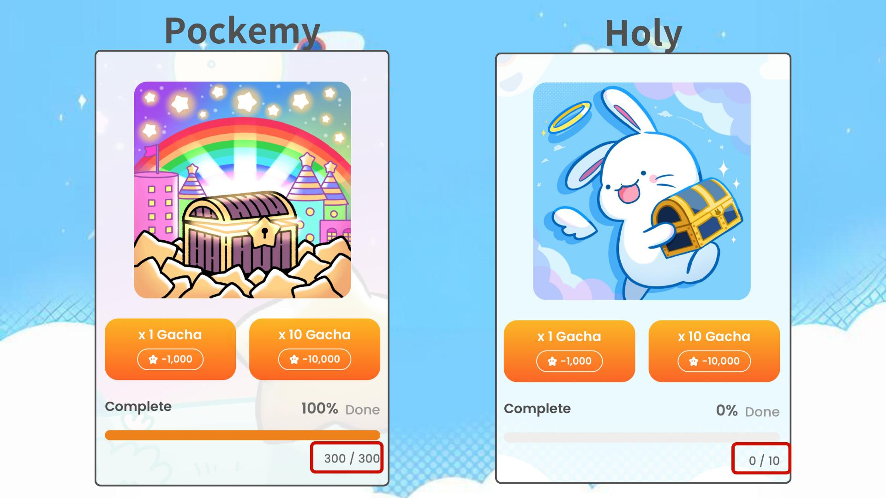  
  
Mejeeji Gacha ni ipa lori ipo ipo, nitorinaa wọn ṣe pataki. Gbadun ikojọpọ ni iyara tirẹ!

# Anfani ti ipari ikojọpọ

* Ìmúdàgba seese lati gba airdrop
* Aaye lati de ipo giga
* Seese lati gba awọn ẹbun pataki fun ipari ikojọpọ

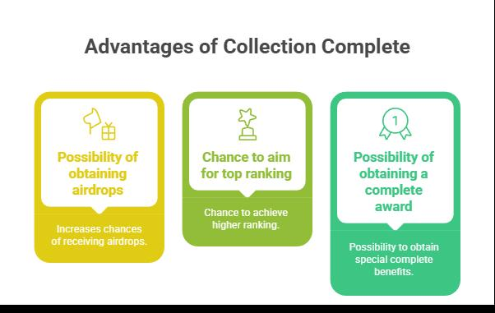

# Ẹbun pataki fun awọn onkawe 🎁

A n fi gbogbo awọn iṣẹ ọna Holy Gacha han pataki fun awọn onkawe wa!

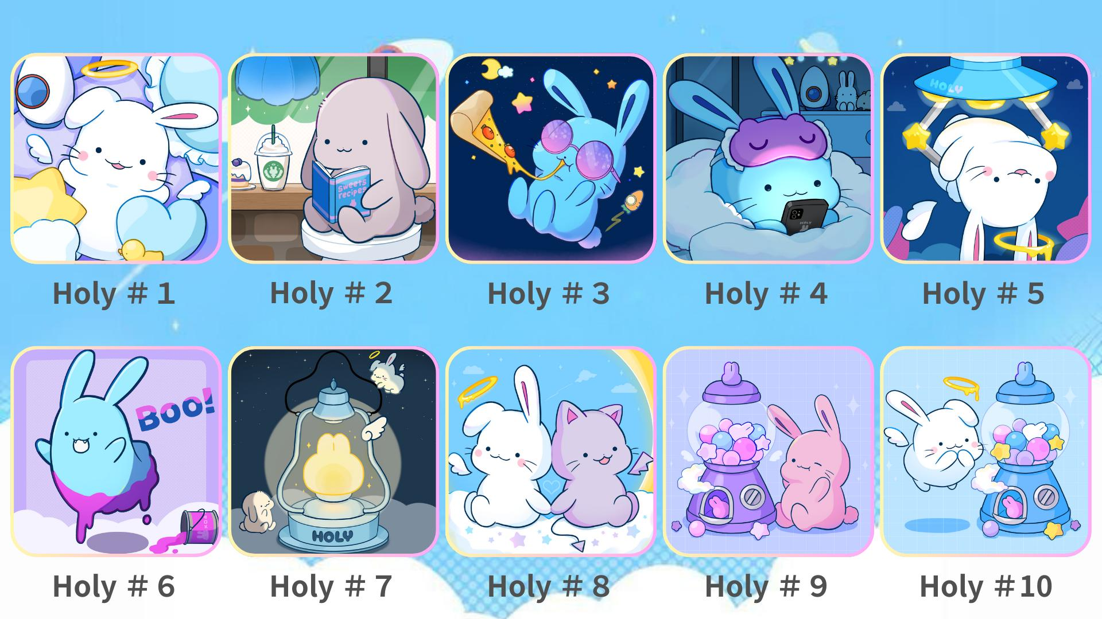  
  
Yi Gacha ki o pari ikojọpọ Holy rẹ lati goke ipo ipo!

# Akopọ

Holy Gacha jẹ ikojọpọ igbadun ati anfani pataki fun $SP airdrop. Pẹlu awọn ohun 10 nikan ti o nilo lati pari, eyi jẹ ibi-afẹde ti gbogbo eniyan le ṣaṣeyọri. Maṣe padanu anfani yii!

📢 Fun awọn imudojuiwọn tuntun 📢  
  
Oju opo wẹẹbu osise Smart Pocket: https://smapocke.com/  
  
Discord osise Smart Pocket: https://discord.com/invite/smartpocket  
  
Akọọlẹ X osise Smart Pocket: https://x.com/smapocke  
  
Akọọlẹ X osise Pockemy: https://x.com/pockemys  
  
Akọọlẹ X osise Holy: https://x.com/holysinfo