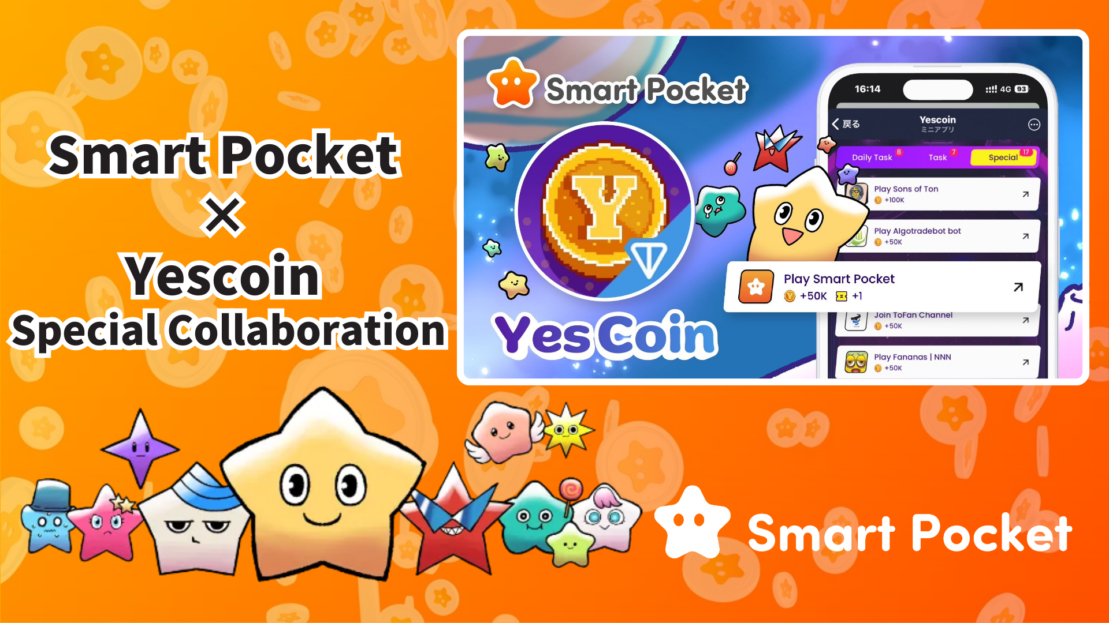

**Ifọwọsowọpọ Pataki Smart Pocket × Yescoin!**

# Gba Yescoin 50,000 Funfẹfẹ!

Ẹ kaabo gbogbo eniyan!

A ni iroyin nla fun yin! Smart Pocket ati Yescoin ti dapọ fun ifọwọsowọpọ pataki kan, ti yoo fun yin ni anfaani lati gba Yescoin 50,000 ni ọfẹ!

# Kini Yescoin?

Yescoin jẹ pẹpẹ ere tuntun ti o lo blockchain TON. Lati igba ifilọlẹ rẹ ni May ọdun 2024, o ti gba awọn olumulo to ju miliọnu 50 lọ laarin awọn oṣu diẹ, ti o jẹ ọkan ninu awọn iṣẹ akanṣe Web3 ti o tayọ julọ!

## Awọn Ẹya Pataki

* Awọn ere ti o rọrun lati ṣere ati pe gbogbo eniyan le wọle si
* Eto idije ipele marun lati Bronze si Diamond
* Gbigba owo adaṣe pẹlu awọn roboti YesPac

Wo bawo ni ere naa ṣe n ṣiṣẹ nibi:  
https://drive.google.com/file/d/1HL481hGSiIoZ4E1pal201soD2PZFDyXf/view

# Anfani Ifọwọsowọpọ

Nipa kopa ninu app Smart Pocket, o le gba Yescoin 50,000. Eyi jẹ aye nla fun awọn olumulo tuntun lati bẹrẹ!

# Bii o ṣe le Gba Yescoin (Igbesẹ-nipasẹ-Igbesẹ)

1. Ṣii Yescoin  
   https://t.me/theYescoin_bot
2. Tẹ lori taabu 'Earn'
3. Tẹ lori 'Special'
4. Tẹ lori 'Play Smart Pocket'
5. Tẹ lori 'Check'
6. Tẹ lori 'Claim'

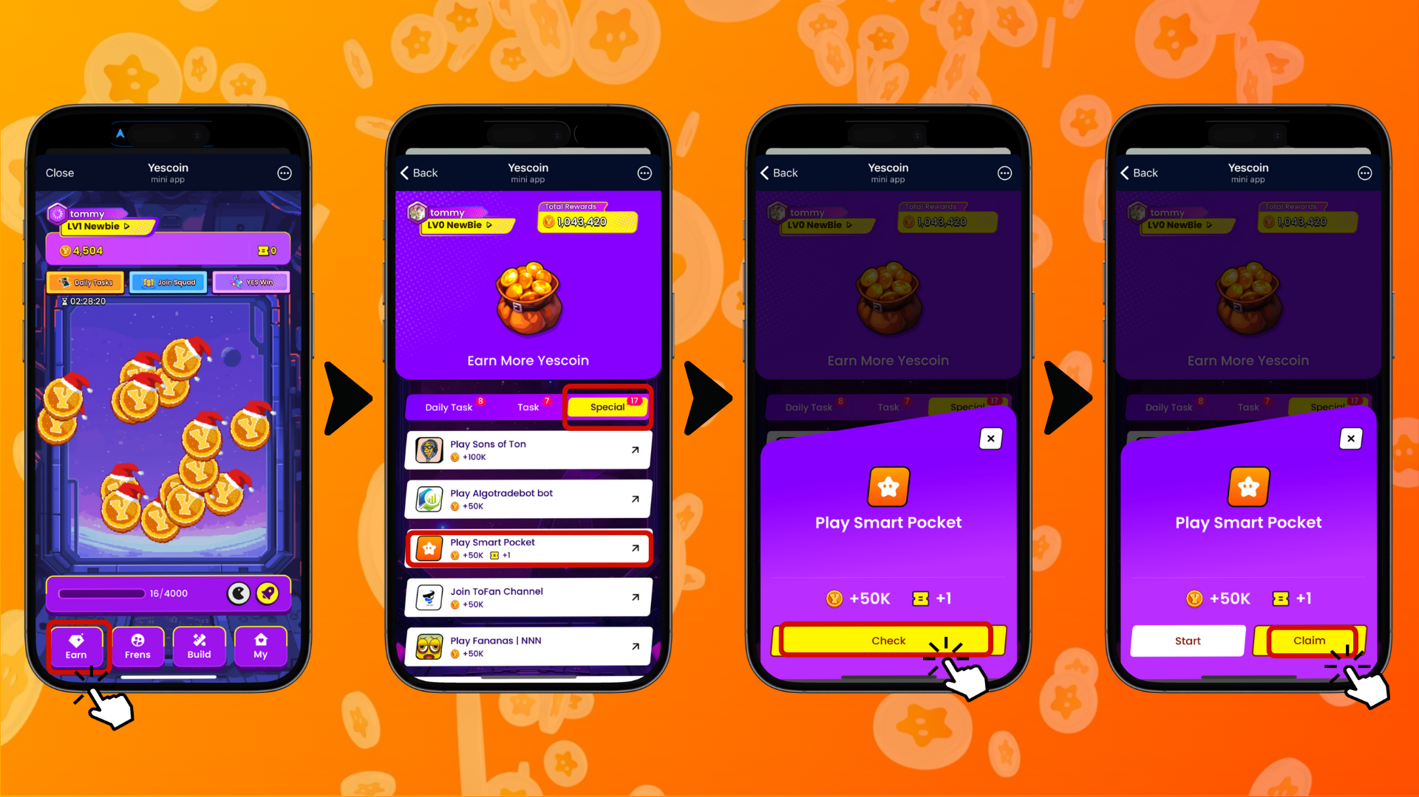

# Awọn Ifarahan Pataki

* Ti akọọlẹ rẹ ko ba ṣiṣẹ fun ọjọ marun, Yescoin yoo sun 5% ti owo rẹ.
* Awọn irinṣẹ tita-aṣiṣe ati ilokulo awọn iṣẹ-ṣiṣe ti wa ni idinamọ.
* Eto ayewo itanjẹ ti o da lori AI wa ni iṣẹ.
* Awọn akọọlẹ ti o rii lati ṣe itanjẹ le wa ni idaduro lailai.

# Akopọ

Ifọwọsowọpọ laarin Smart Pocket ati Yescoin jẹ aye nla lati jẹ ki Web3 wa ni irọrun sii. Maṣe padanu anfaani lati gba Yescoin 50,000 funfẹfẹ!

## Idi Ti O Fi yẹ ki O Kopa

* Ẹda pataki ti o rọrun lati kopa ninu
* Èbùn ifamọra ti Yescoin 50,000 funfẹfẹ
* Ilana ti o yara ati rọrun lati gba awọn ẹbun

Ti o ba jẹ tuntun si Web3, eyi ni akoko pipe lati bẹrẹ!

📢 Fun awọn iroyin tuntun julọ, ṣàbẹwò àwọn ìjápọ̀ ìjọba wọnyi:  
Oju opo wẹẹbu osise Smart Pocket: https://smapocke.com/  
Discord osise Smart Pocket: https://discord.com/invite/smartpocket  
Iroyin X osise Smart Pocket: https://x.com/smapocke  
Iroyin X osise Yescoin: https://x.com/Yescoin_Fam