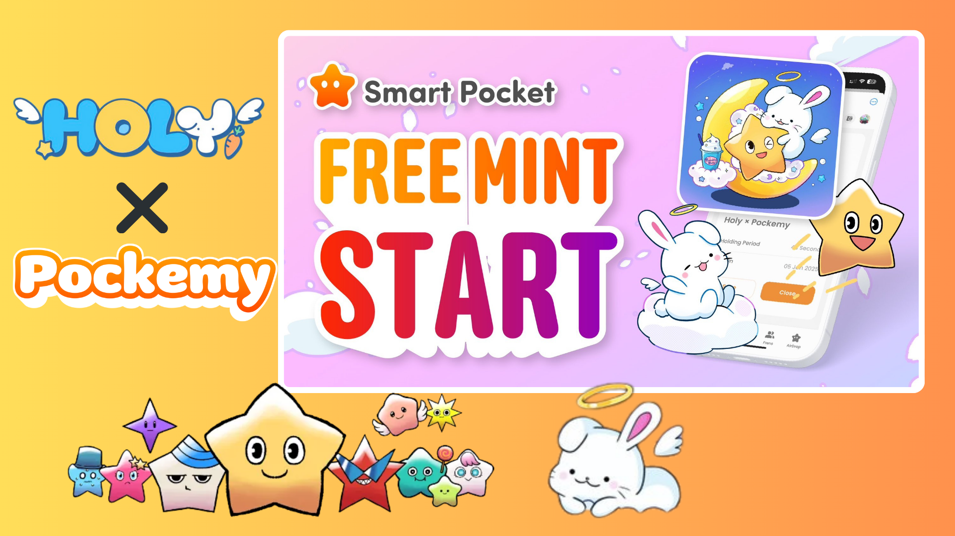

**Iṣẹlẹ Mint Ọfẹ Pataki ti Bẹrẹ lori App Smart Pocket! Gba SBT Alailẹgbẹ Holy × Pockemy!**

**Ẹ kaabo gbogbo eniyan!  
  
Ninu àpilẹkọ yii, a yoo ṣàlàyé ní kíkún nípa iṣẹlẹ tuntun ti mint ọfẹ “SBT Alailẹgbẹ Holy × Pockemy” ti o wa lori app Smart Pocket.**

# Akopọ

* Kí ni SBT Alailẹgbẹ Holy × Pockemy?
* Fun awọn olumulo tuntun ti app Smart Pocket
* Nipa Holy
* Bawo ni lati gba SBT
* Igbese 1: Wọlé si app
* Igbese 2: Bẹrẹ mint
* Igbese 3: Ṣayẹwo idaduro
* Awọn ifitonileti pataki
* Akopọ ipari

# Kí ni SBT Alailẹgbẹ Holy × Pockemy?

SBT Alailẹgbẹ Holy × Pockemy jẹ SBT pataki kan (Soulbound Token) ti o wa ni iyasọtọ lori app Smart Pocket.  
  
Awọn ẹya pataki rẹ ni:  
  
- Mint ọfẹ patapata (ko si owo ti o nilo, pẹlu owo gas)  
  
- Apẹrẹ ifowosowopo alailẹgbẹ lati ọdọ Holy ati Pockemy  
  
- Token pataki ti ko le ṣe gbigbe si ẹlomiiran  
  
- N ṣiṣẹ bi ẹri ti ipa ninu agbegbe  
  


# Fun awọn olumulo tuntun ti app Smart Pocket

Ti o ba jẹ pe o jẹ igba akọkọ ti o nlo app Smart Pocket, ma ṣe ṣàníyàn! Fifi sori rẹ rọrun pupọ ati pe o gba iṣẹju diẹ nikan.  
  
Fun itọsọna alaye, wo “Itọsọna Pipe lati Bẹrẹ pẹlu App Smart Pocket”!

# Nipa Holy

Holy jẹ lẹsẹsẹ ohun kikọ pataki kan ti a ṣẹda nipasẹ Kin no Ono (@shoot_down_UFO).  
  
- Akori: “aláwòkọ ati onírẹlẹ”  
  
- Apapọ eroja ehoro pẹlu awọn ẹya angẹli  
  
- Ti ṣe apẹrẹ lati pese imọlara mimo ati aabo  
  
  
  
Orisun: Iroyin X osise ti Holy

# Bawo ni lati gba SBT

O le gba SBT ni rọọrun pẹlu awọn igbesẹ mẹta ti o rọrun!

## Igbese 1: Wọlé si app

- Ṣii app Smart Pocket  
- Ṣii taabu Earn

## Igbese 2: Bẹrẹ mint

- Yan apakan Item  
- Wa “Holy × Pockemy”  
- Tẹ “Start”  
- Fi ayanfẹ si ati tun pin ifiweranṣẹ osise lori X  
- Tẹ “GET” lati pari ilana mint  
  
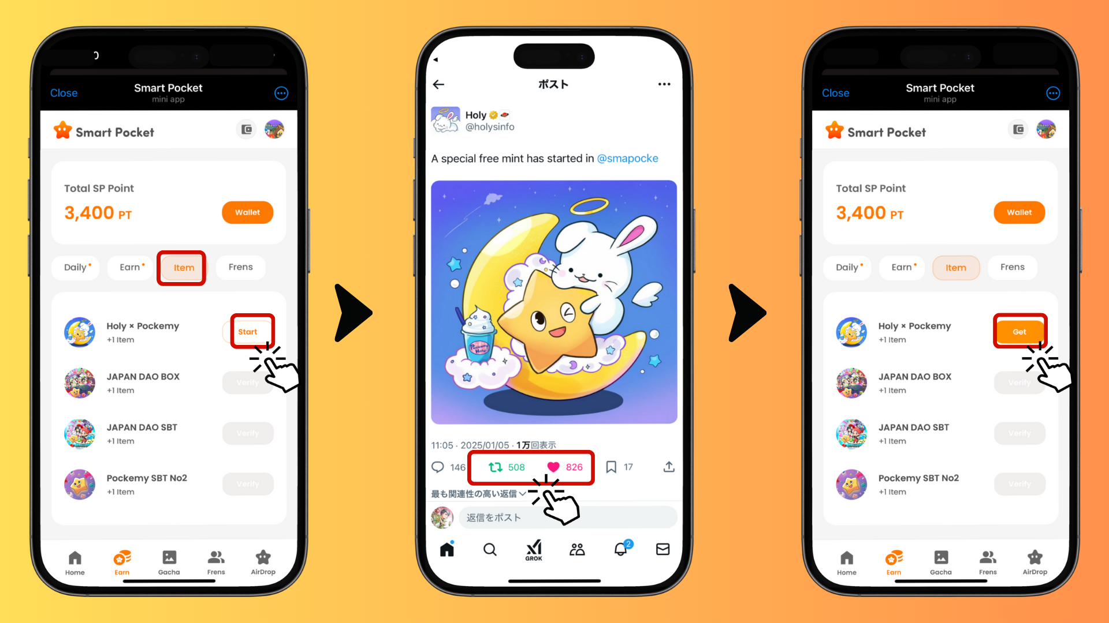

## Igbese 3: Ṣayẹwo idaduro

- Tẹ “Wallet”  
- Yan apakan Item  
- Ṣayẹwo SBT rẹ nibẹ  
  
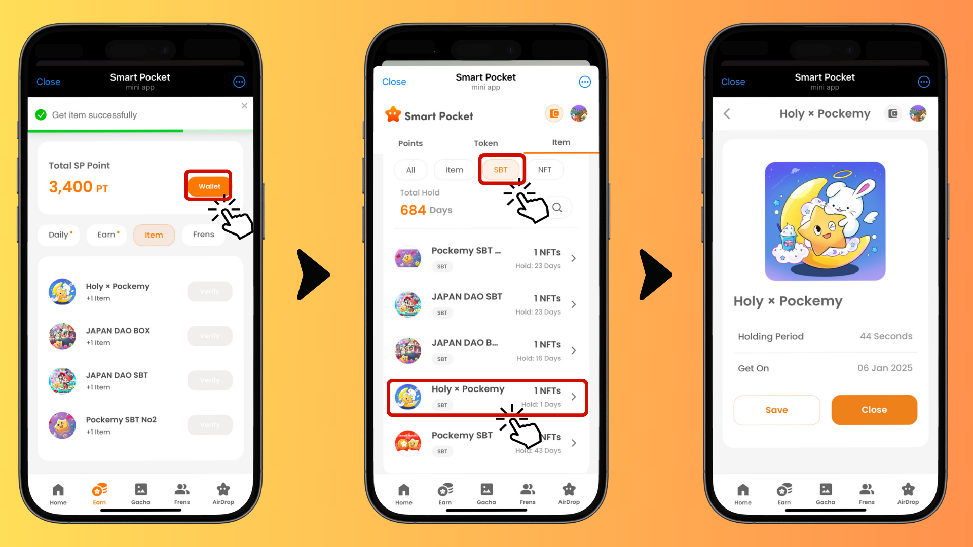

# Awọn ifitonileti pataki

- Akoko mint lopin, nitorinaa yara ṣe  
- Akọọlẹ kọọkan le gba SBT kan ṣoṣo  
- SBT jẹ token pataki ti ko le ṣe gbigbe si ẹlomiiran

# Akopọ ipari

SBT Alailẹgbẹ Holy × Pockemy jẹ ikojọpọ ifowosowopo alailẹgbẹ kan ti o wa nikan lori app Smart Pocket. O jẹ ọfẹ patapata ati pe ilana mint rọrun pupọ, ma ṣe padanu aye yii, gbiyanju bayi!  
  
📢 Fun awọn imudojuiwọn tuntun, ṣàbẹwò 📢  
  
- Oju opo wẹẹbu osise Smart Pocket: https://smapocke.com/  
  
- Discord osise Smart Pocket: https://discord.com/invite/smartpocket  
  
- Iroyin X osise Smart Pocket: https://x.com/smapocke  
  
- Iroyin X osise Pockemy: https://x.com/pockemys  
  
- Iroyin X osise Holy: https://x.com/holysinfo