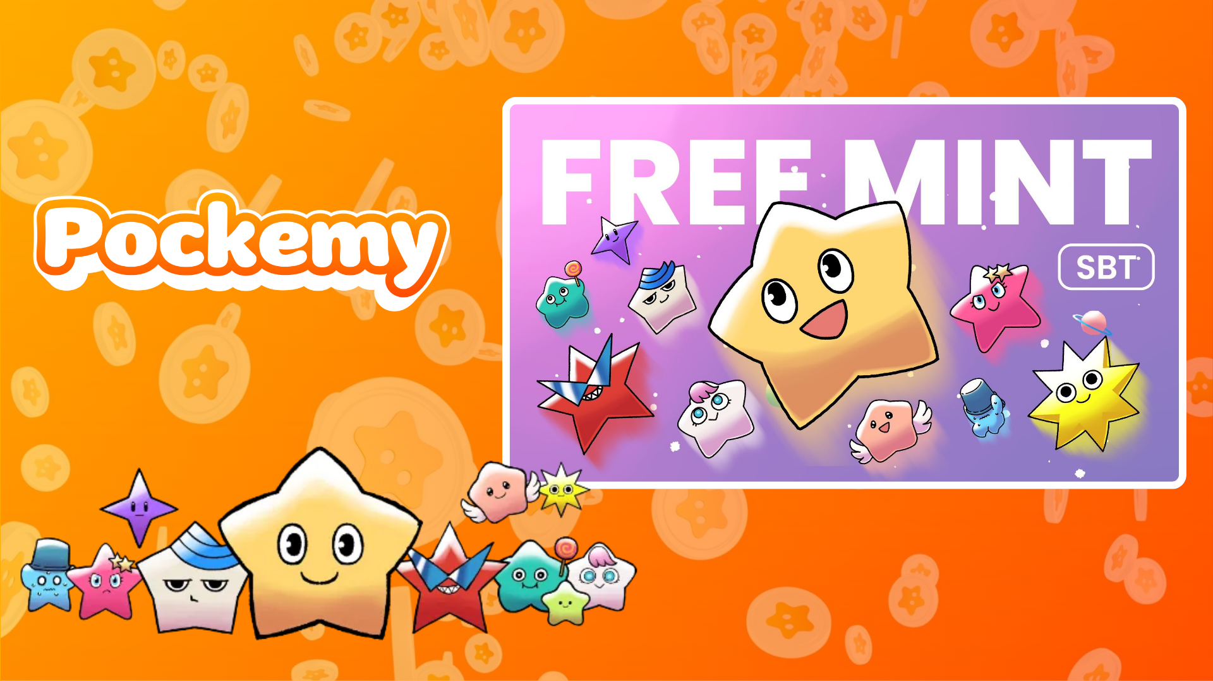

**Smart Pocket Mini: Itọsọna Pockemy SBT No.2**

# Kí ni Pockemy SBT No.2?

Pockemy SBT No.2 jẹ Soulbound Token (SBT) pataki ti o wa ni iyasoto lori app Smart Pocket Mini. Awọn ẹya-ara pataki ni:  
- Ọfẹ patapata lati mint (ko si owo gas tabi awọn idiyele miiran).  
- NFT ti ko le gbe lọ tabi ta.  
- Ohun elo alailẹgbẹ fun awọn olumulo ti app Smart Pocket Mini.

# Bawo ni lati bẹrẹ pẹlu Smart Pocket Mini

Ti o ba jẹ tuntun si app Smart Pocket Mini, o rọrun lati bẹrẹ! Wo itọsọna fifi sori ẹrọ nibi: https://note.com/japan_dao/n/n41015b5af06a

# Nipa Pockemy

Pockemy jẹ ohun kikọ ẹlẹwa ti o mu ọla wa si agbaye Smart Pocket pẹlu awọn abuda alailẹgbẹ rẹ:  
- Ẹda ti o wuyi ni apẹrẹ irawọ.  
- Alagbara, iwari, ati ti o ni ireti laibikita pe o jẹ aibikita.  
- Apakan ti itan pẹlu awọn ohun kikọ 11 miiran ti o ni iyasọtọ.

# Bawo ni lati gba SBT

Minting rọrun ni awọn igbesẹ mẹta nikan:

## Igbese 1: Wọle si app

- Ṣii app Smart Pocket Mini.  
- Lọ si taabu Earn.

## Igbese 2: Bẹrẹ Minting

- Lọ si apakan Item.  
- Wa "Pockemy SBT No.2."  
- Tẹ "Start" ati lẹhinna tẹ "Mint" lati pari ilana naa.  
  
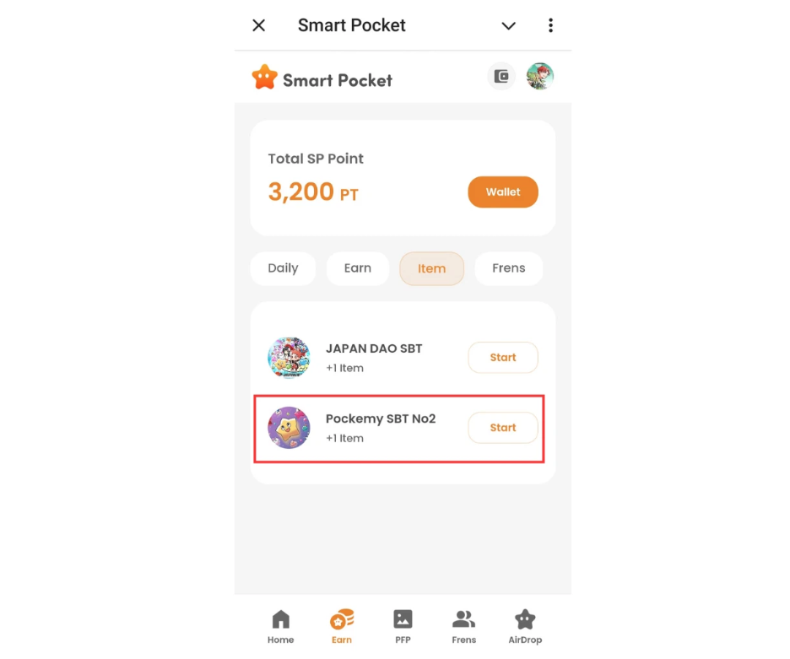

## Igbese 3: Ṣayẹwo Ohun ini

- Ṣayẹwo nọmba ohun-ini rẹ lori taabu Home.  
- Wo awọn alaye ni taabu Wallet.  
  
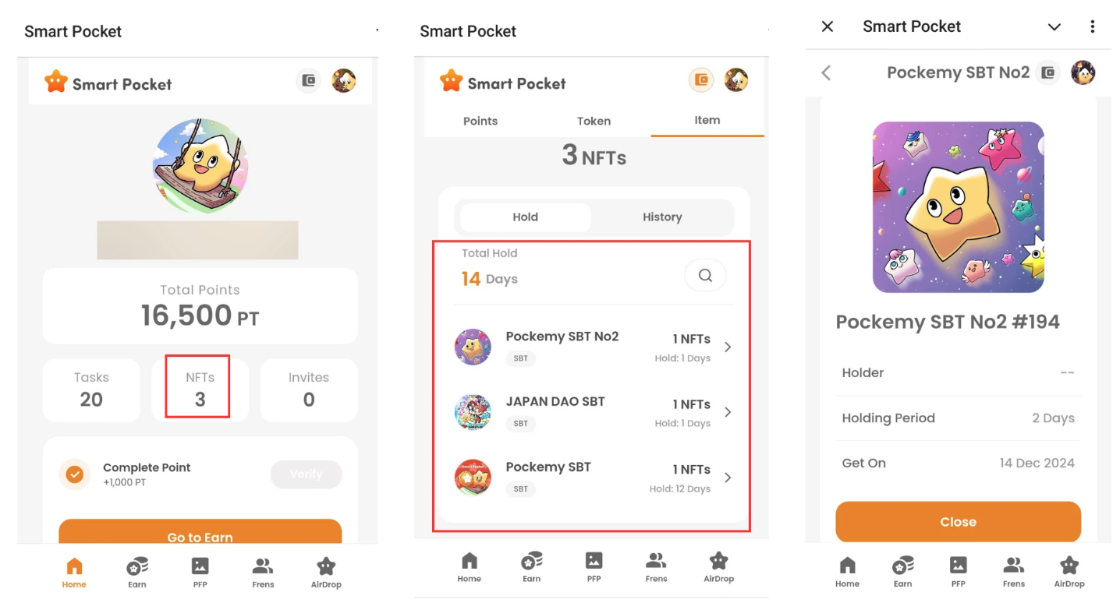

# Awọn akọsilẹ Pataki

- Minting ni opin akoko, ṣe iyara!  
- Akọọlẹ kan nikan le mint SBT kan.  
- SBT ko le gbe lọ.

# Ipinnu

Pockemy SBT No.2 jẹ NFT pataki ti o wa fun awọn olumulo ti app Smart Pocket Mini nikan. O jẹ ọfẹ ati rọrun lati mint, maṣe padanu aye yii!

# Duro ni imudojuiwọn

* Oju opo wẹẹbu osise ti Smart Pocket: https://smapocke.com/
* Discord osise ti Smart Pocket: https://discord.com/invite/smartpocket
* Smart Pocket X Account osise: https://x.com/smapocke
* Pockemy X Account osise: https://x.com/pockemys