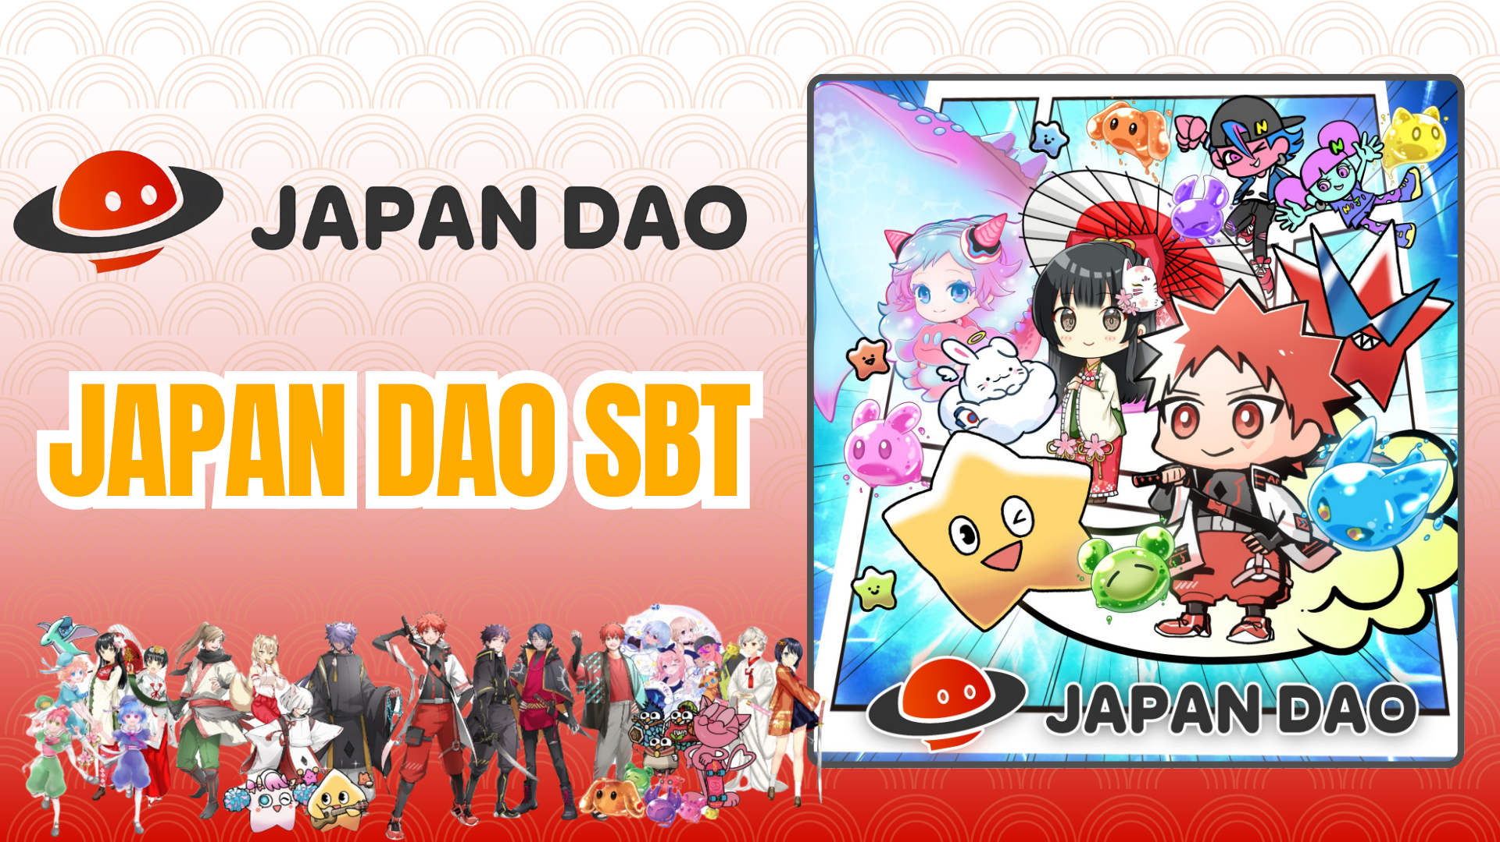

**Smart Pocket Mini App Mint Ọfẹ: Itọsọna JAPAN DAO SBT**

# Kí ni JAPAN DAO SBT?

JAPAN DAO SBT jẹ Soul-Bound Token (SBT) pataki, ti o wa ni pataki lori app Smart Pocket Mini. Awọn ẹya rẹ pẹlu:

* Mint patapata ni ọfẹ (ko si awọn owo gbigbe tabi awọn idiyele miiran)
* NFT alailẹgbẹ, ti ko le ṣe gbigbe tabi ta

# Bí o ṣe le Bẹrẹ pẹlu Smart Pocket Mini

Tuntun si Smart Pocket Mini? O rọọrun lati bẹrẹ! Ṣayẹwo itọsọna fifi sori ni isalẹ:

Ọna asopọ: https://note.com/japan_dao/n/n41015b5af06a

# Nipa JAPAN DAO

JAPAN DAO jẹ ile-iṣẹ iṣẹ-ọnà ti awọn eniyan ti o kopa lati awọn orilẹ-ede 150 ju lọ. Darapọ bayii lati kopa ninu awọn iṣẹ agbaye ti o ni idaniloju!

Ọna asopọ: https://x.com/japandaoen/status/1867790608812978336

# Nipa Ile-iṣẹ Animation

Kọ ẹkọ diẹ sii nipa ile-iṣẹ iṣẹ-ọnà ninu àpilẹkọ ni isalẹ:

Ọna asopọ: https://note.com/japan_dao/n/nf89ee51d142a

# Báwo Láti Gba SBT

## Igbesẹ 1: Ṣii App

* Ṣii app Smart Pocket Mini
* Lọ si taabu 'Earn'

## Igbesẹ 2: Bẹrẹ Mint

* Yan apakan 'Item'
* Wa 'JAPAN DAO SBT'
* Tẹ 'Start'
* Tẹ 'Mint' lati pari

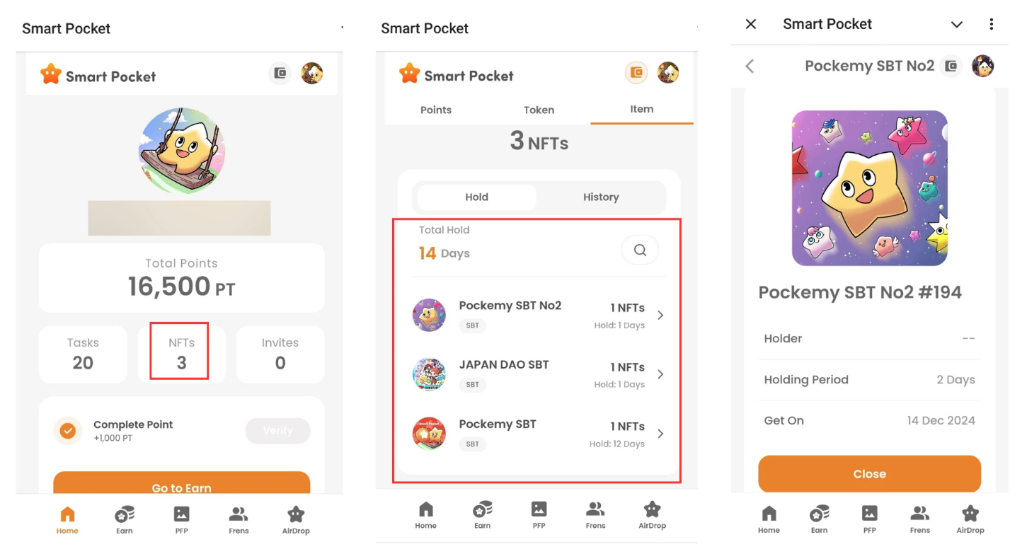

## Igbesẹ 3: Ṣayẹwo Ohun-ini

* Ṣayẹwo nọmba ni taabu 'Home'
* Wo alaye ni taabu 'Wallet'

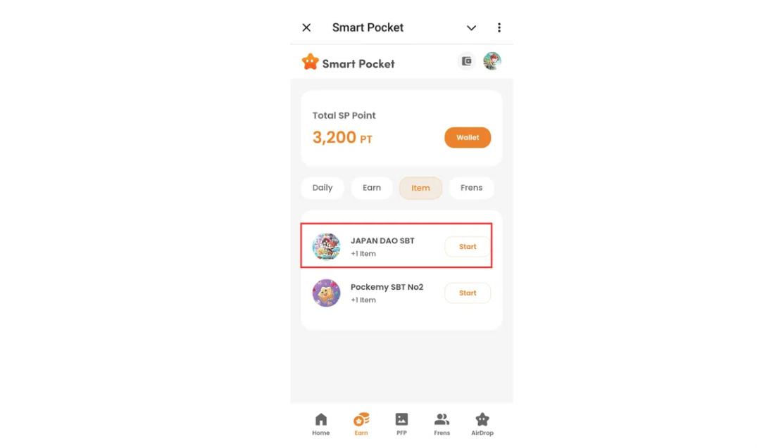

Ọna asopọ: https://note.com/japan_dao/n/nfa9879331899

# Awọn Akọsilẹ Pataki

* Mint jẹ titi akoko, yara ṣe
* SBT kan ṣoṣo ni a le mint fun akọọlẹ kọọkan
* SBT ko le ṣe gbigbe

# Ipari

JAPAN DAO SBT jẹ SBT pataki ti o wa nikan lori app Smart Pocket Mini. O jẹ ọfẹ patapata ati rọrun lati mint, nitorinaa lo anfani yii bayi!

# Awọn Ọna Asopọ Osise

* Oju-iwe ayelujara osise JAPAN DAO: https://japandao.jp/
* Discord osise JAPAN DAO: https://discord.com/invite/japandao
* Iwe iroyin X osise JAPAN DAO: https://x.com/japandaojp
* Iwe iroyin X agbaye osise JAPAN DAO: https://x.com/japandaoen