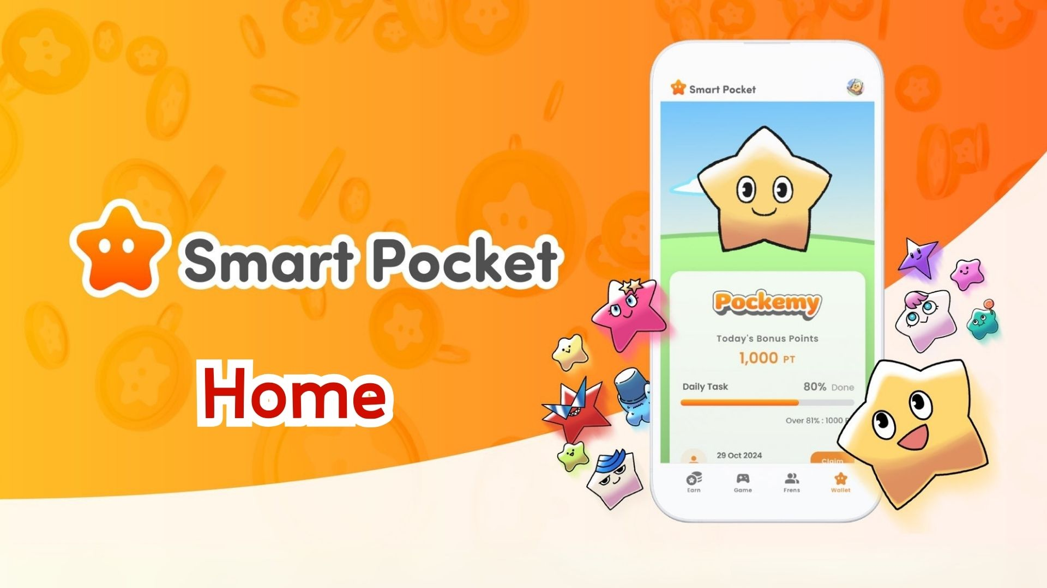

**Itọsọna Pipe lori Ẹya Home ti App Smart Pocket! Bawo ni Lati Ṣakoso Awọn Dọla Rẹ Ni Pipe**

**Ẹ ku ọjọ!  
  
Ninu itọsọna yii, a yoo ṣalaye ni kikun nipa iṣẹ "Home" – ọkan ninu awọn ẹya pataki julọ ninu ohun elo Smart Pocket!  
  
Akọkọ iboju Home ni a kun fun ọpọlọpọ awọn ẹya to wulo ti o fun laaye lati wo gbogbo awọn iṣẹ rẹ ni kedere. Lẹhin kika itọsọna yii, iwọ yoo ni anfani lati lo app naa ni ọna to munadoko julọ!**

# Atokọ akoonu

* Kini o le ṣe lori iboju Home  
  Alaye Olumulo  
  Bii a ṣe le ṣayẹwo akoonu Wallet  
  Your AirDrop (Alaye nipa Airdrop)  
  Bii o ṣe le tọpinpin ilọsiwaju awọn iṣẹ  
  Bawo ni a ṣe n gba Awọn Dọla Pipe  
  Nipa Ẹya Gacha  
  Akopọ

# Kini o le ṣe lori iboju Home

Iboju Home jẹ ile-iṣẹ iṣakoso fun gbogbo awọn iṣẹ rẹ ninu app Smart Pocket. O le wo awọn alaye wọnyi ni kia kia:  
  
- Orukọ olumulo, aami, ati ipo  
- Ipo Wallet  
- Your AirDrop  
- Awọn iṣẹ ati iṣẹlẹ  
- Gacha

# Alaye Olumulo

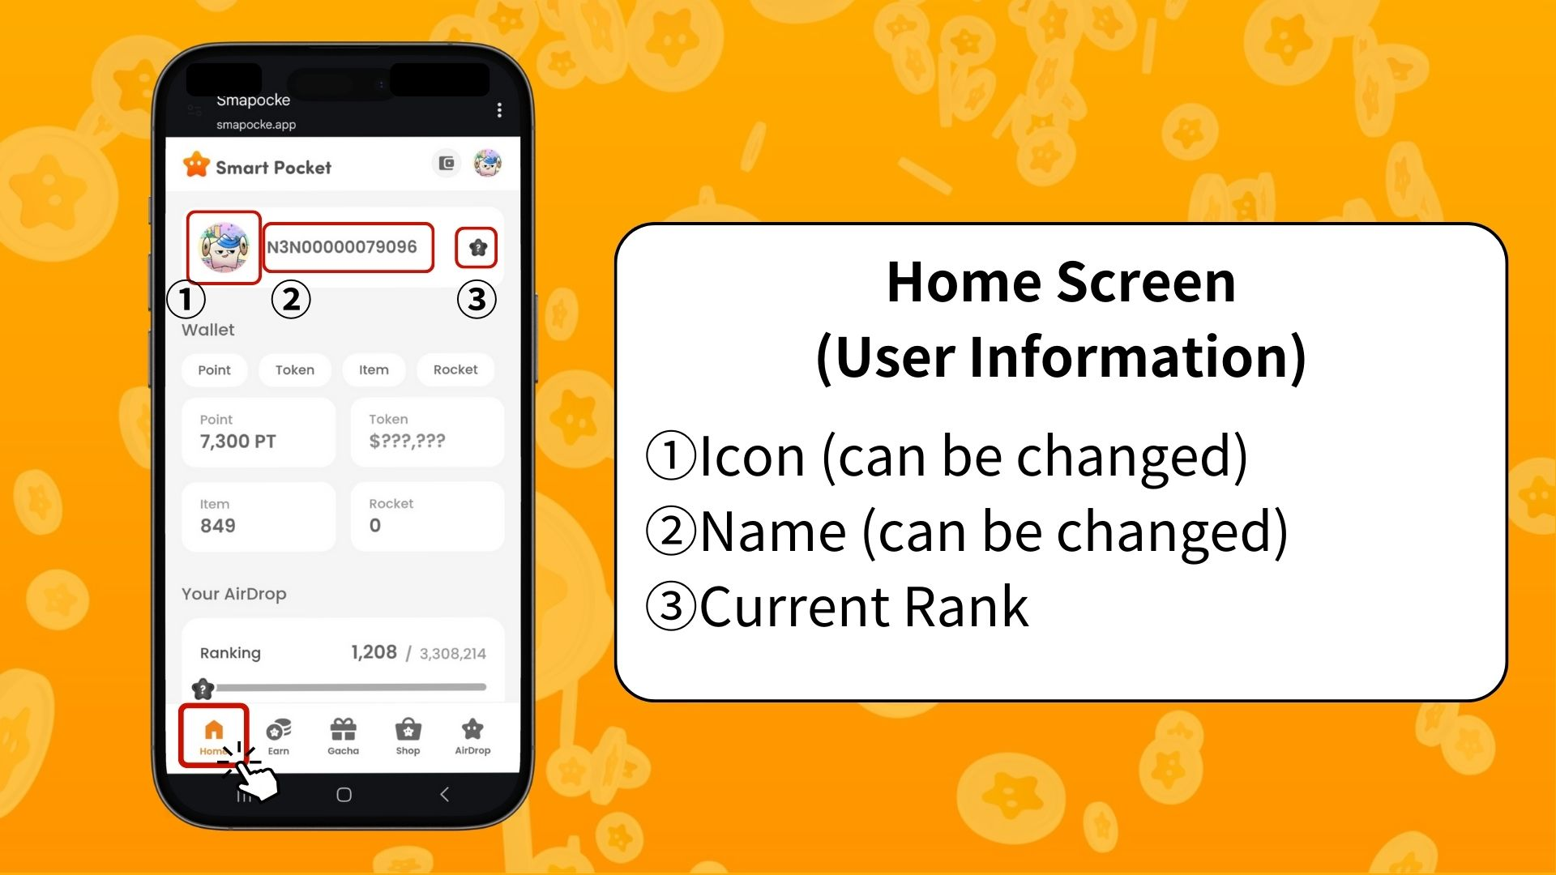  
  
Aami (le yipada)  
Eyi ni aworan profaili rẹ. O le yipada si PFP ti o gba lati Gacha.  
  
Orukọ (le yipada)  
Orukọ iroyin tabi orukọ apeso, o le yipada ni ominira.  
  
Ipo lọwọlọwọ  
Ipo olumulo yoo jẹ ọkan ninu S / A / B / C da lori ipo rẹ (lẹhin snapshot).

# Bii a ṣe le ṣayẹwo akoonu Wallet

Ninu iboju Wallet, o le ni rọọrun ṣayẹwo ipo ti awọn nkan oriṣiriṣi.  
  
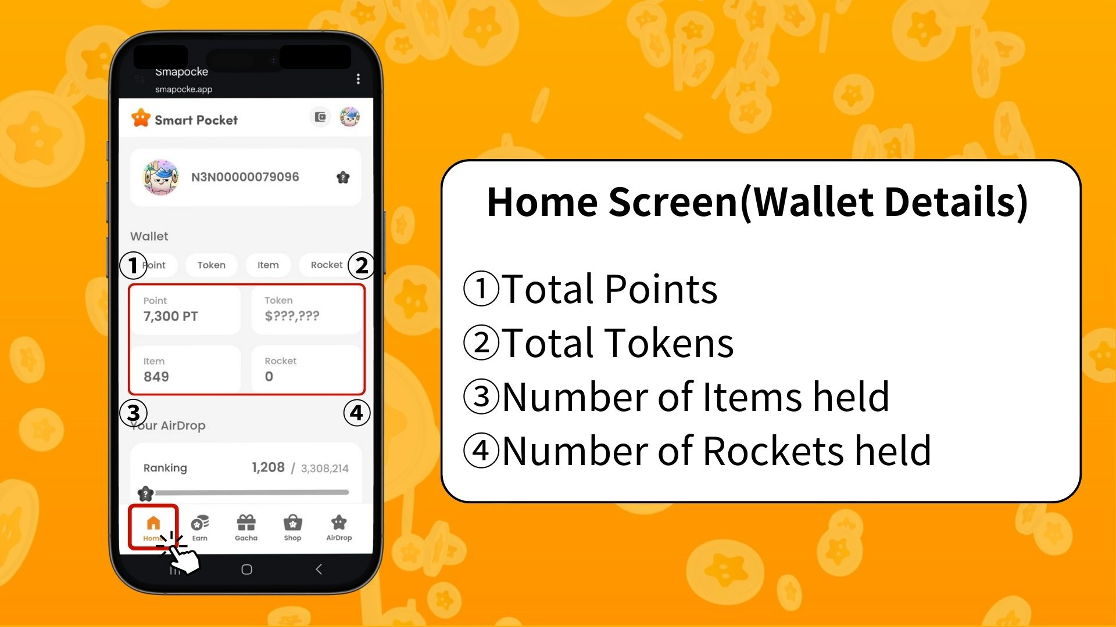  
  
Dọla (Point)  
Awọn aaye ti a gba nipasẹ ṣiṣe awọn iṣẹ ati bori ni awọn iṣẹlẹ.  
  
Token  
Iwọn awọn ohun-ini crypto ti o ni lọwọlọwọ.  
  
Itemu  
Iye awọn ohun ti o wa lọwọlọwọ.  
  
Rocket  
Iye Rocket ti o ra lati ile itaja.  
  
✅ Fun alaye diẹ sii lori Wallet, ka:  
https://note.com/japan_dao/n/ndce1c1b252cc

# Your AirDrop (Alaye nipa Airdrop)

Nibi ni o ti le ri alaye nipa pinpin awọn token (airdrop) ni ọjọ iwaju. Da lori iṣẹ rẹ ni inu app, iwọ yoo gba ẹbun ti o ba pade awọn ipo.  
  
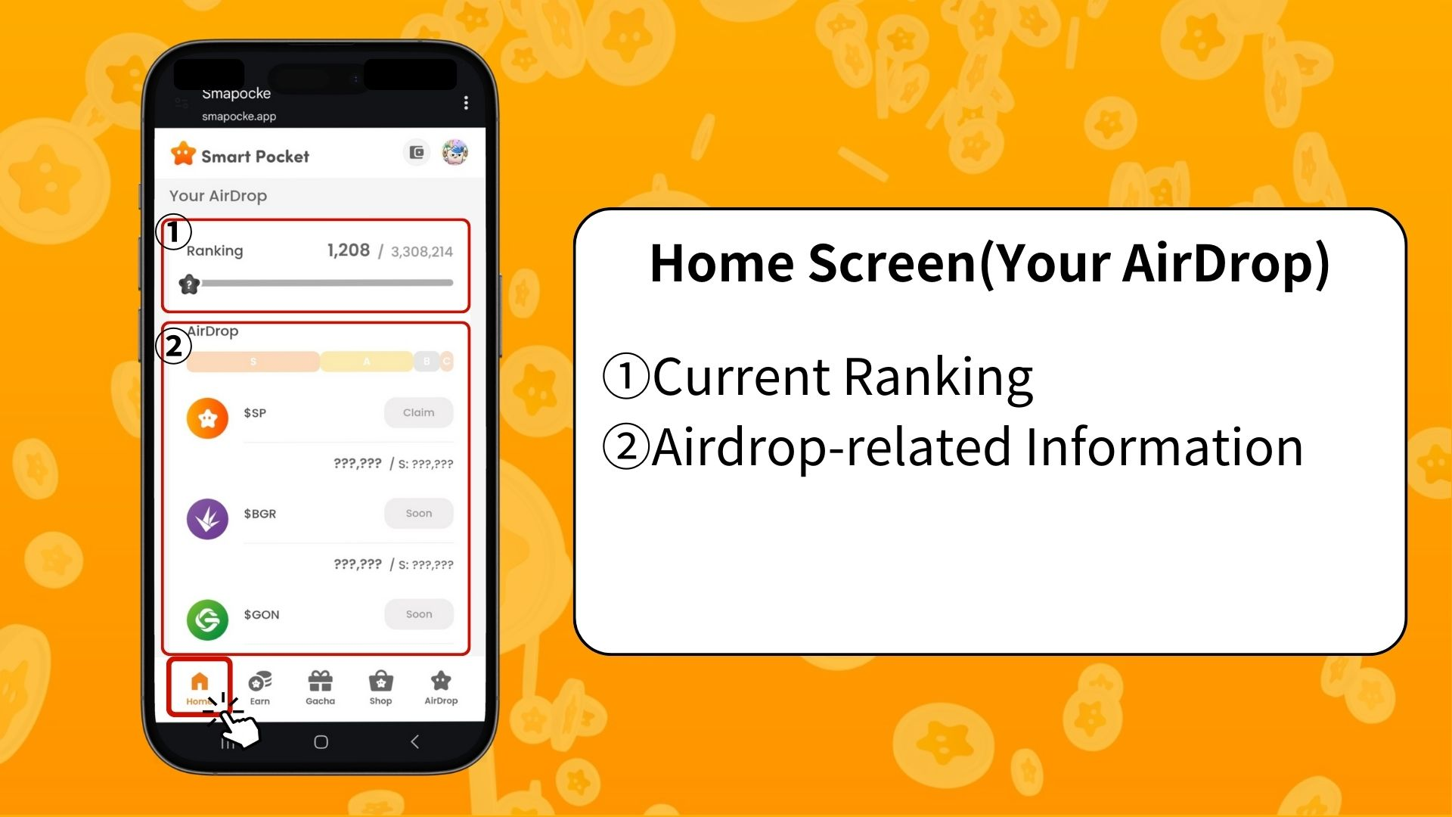  
  
Ipo lọwọlọwọ  
Wo ipo rẹ lọwọlọwọ ati ipo lẹhin snapshot (S / A / B / C).  
  
Alaye Airdrop  
Awọn alaye nipa awọn airdrop to n bọ yoo han. Ti o ba pade awọn ibeere, iwọ yoo ni ẹtọ lati gba.

# Bii o ṣe le tọpinpin ilọsiwaju awọn iṣẹ

Ilọsiwaju kọọkan yoo han pẹlu igi ilọsiwaju lati 0% si 100%.  
  
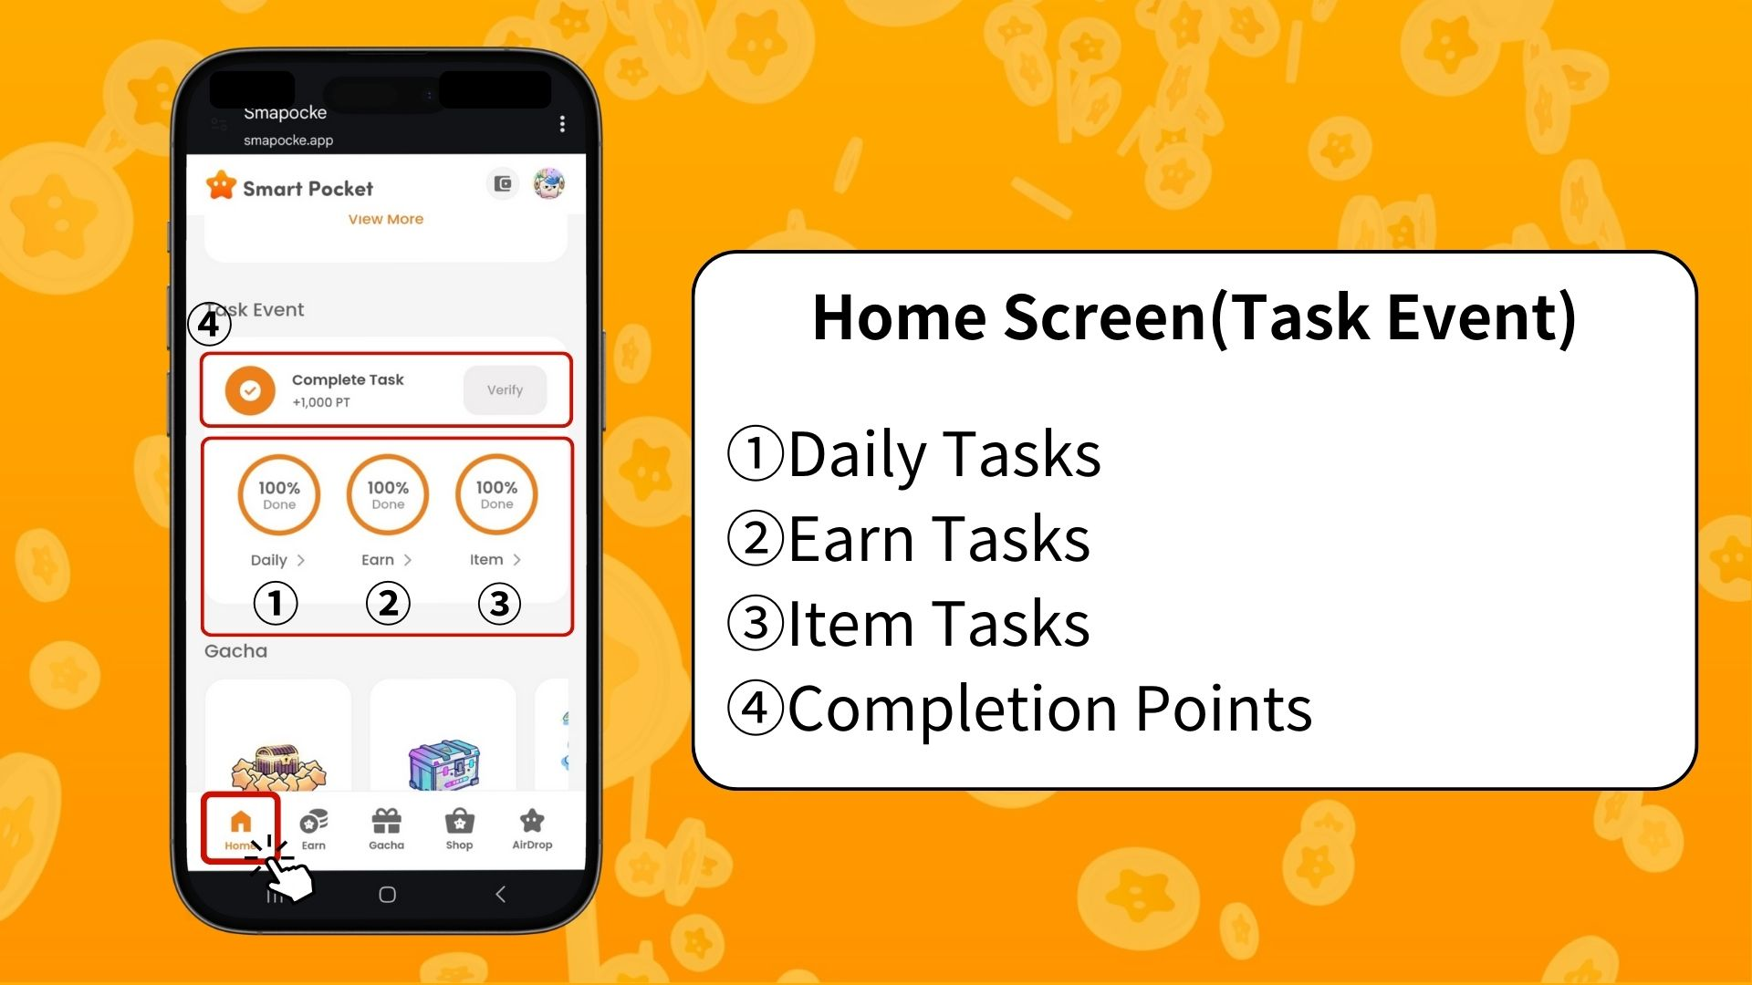  
  
Iṣẹ ojoojumọ (Daily Task)  
Awọn iṣẹ ipilẹ ti o ṣe imudojuiwọn lojoojumọ (wọlé, fẹran ati retweet lori X).  
  
Iṣẹ Earn  
Awọn iṣẹ ti o ni ibatan si media awujọ gẹgẹbi X, Instagram, YouTube.  
  
Iṣẹ Item  
Awọn iṣẹ ti o ni ibatan si gbigba NFT ati SBT.

## Bawo ni a ṣe n gba Awọn Dọla Pipe

Eyi jẹ aye pataki pupọ ti a maa n foju!  
  
Pari gbogbo Daily, Earn ati Item iṣẹ  
Tẹ “Claim”  
Ti o ba di “Verify,” iwọ yoo gba 1000 PT!  
  
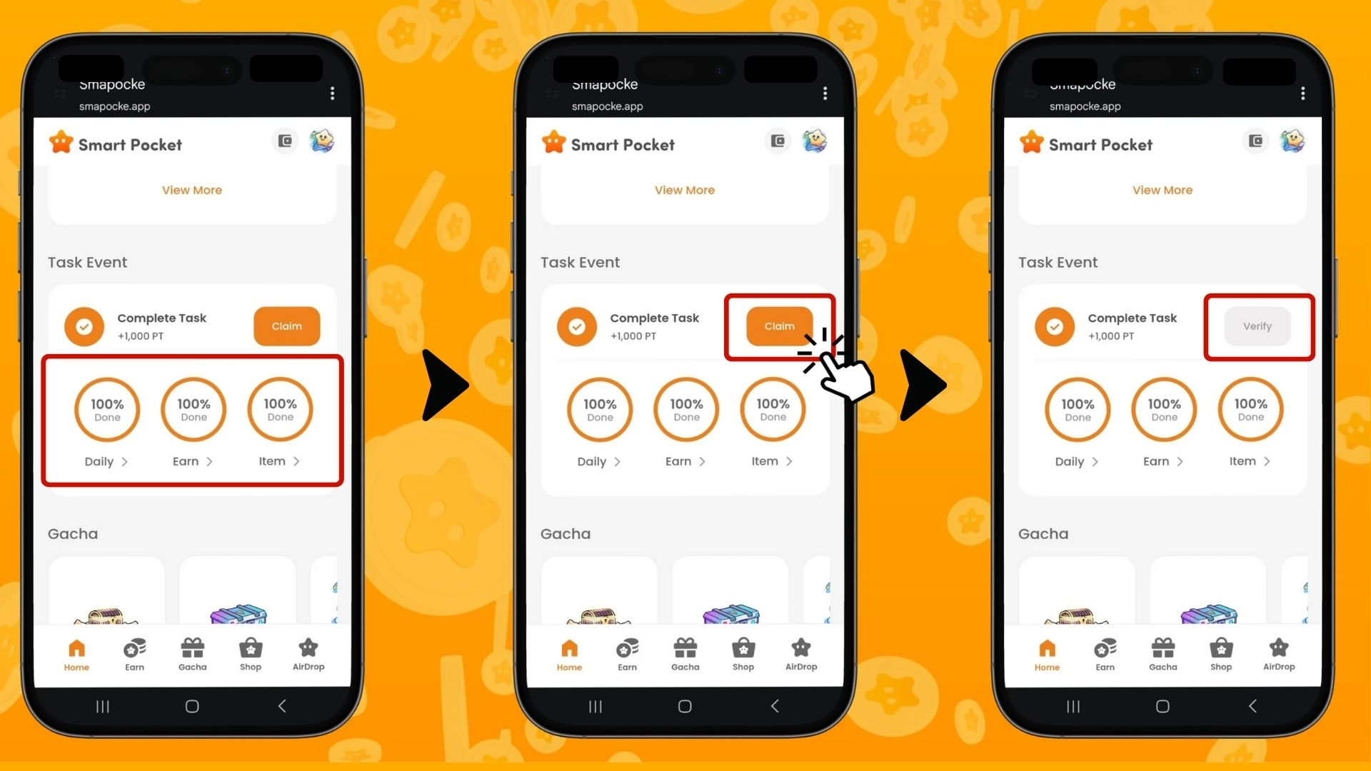  
  
※ Pataki: Lẹhin ti pari iṣẹ, rii daju pe o tẹ bọtini “Claim”. Maṣe padanu anfani 1000 PT yii!  
  
✅ Ka diẹ sii nipa gbigba awọn dọla nipasẹ awọn iṣẹ:  
https://note.com/japan_dao/n/nfa9879331899

# Nipa Ẹya Gacha

Ninu “Gacha”, o le wo awọn PFP lọwọlọwọ ti o wa ati lo awọn dọla tabi Rocket rẹ lati ṣe idasilẹ Gacha.  
  
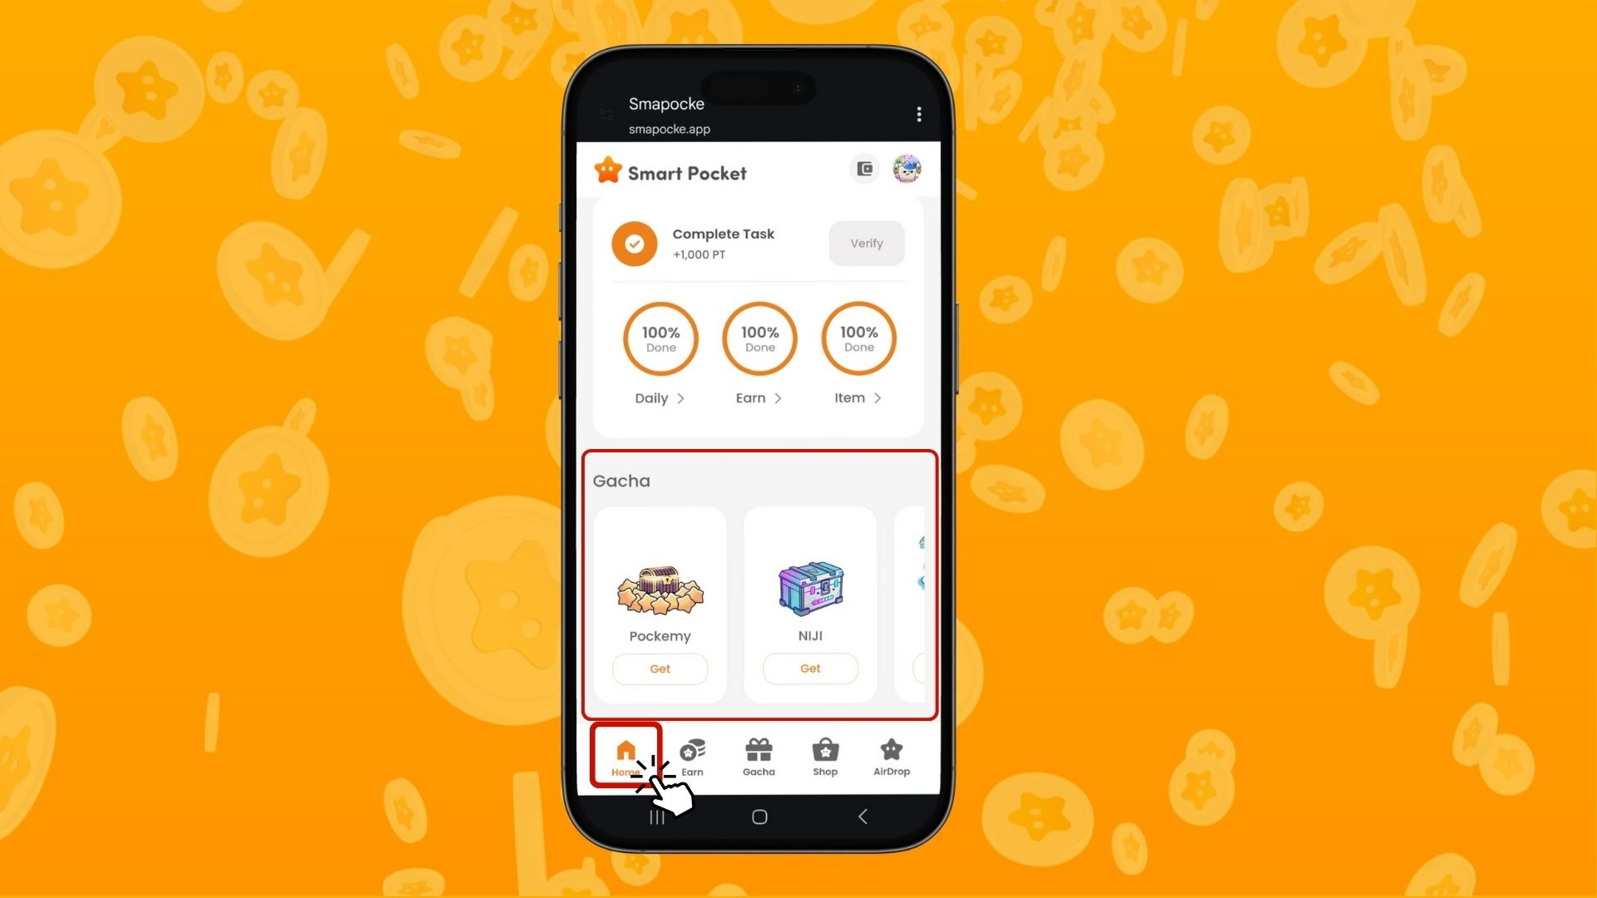

# Akopọ

Iboju Home jẹ ẹya pataki lati ṣakoso awọn iṣẹ rẹ ni Smart Pocket pẹlu irọrun. Ṣọra fun:  
  
- Ṣayẹwo dọla rẹ nigbagbogbo  
- Tọpinpin ilọsiwaju iṣẹ  
- Gba awọn dọla ipari rẹ ni idaniloju  
  
Lo awọn dọla ati Rocket rẹ lati kopa ninu Gacha ati gba ipo giga.  
  
Ra Rocket ni ibamu pẹlu ipo rẹ.  
  
📢 Fun alaye tuntun:  
  
Smart Pocket Oju opo wẹẹbu osise: https://smapocke.com/  
Smart Pocket Discord osise: https://discord.com/invite/smartpocket  
Smart Pocket iroyin X osise: https://x.com/smapocke  
Pockemy iroyin X osise: https://x.com/pockemys