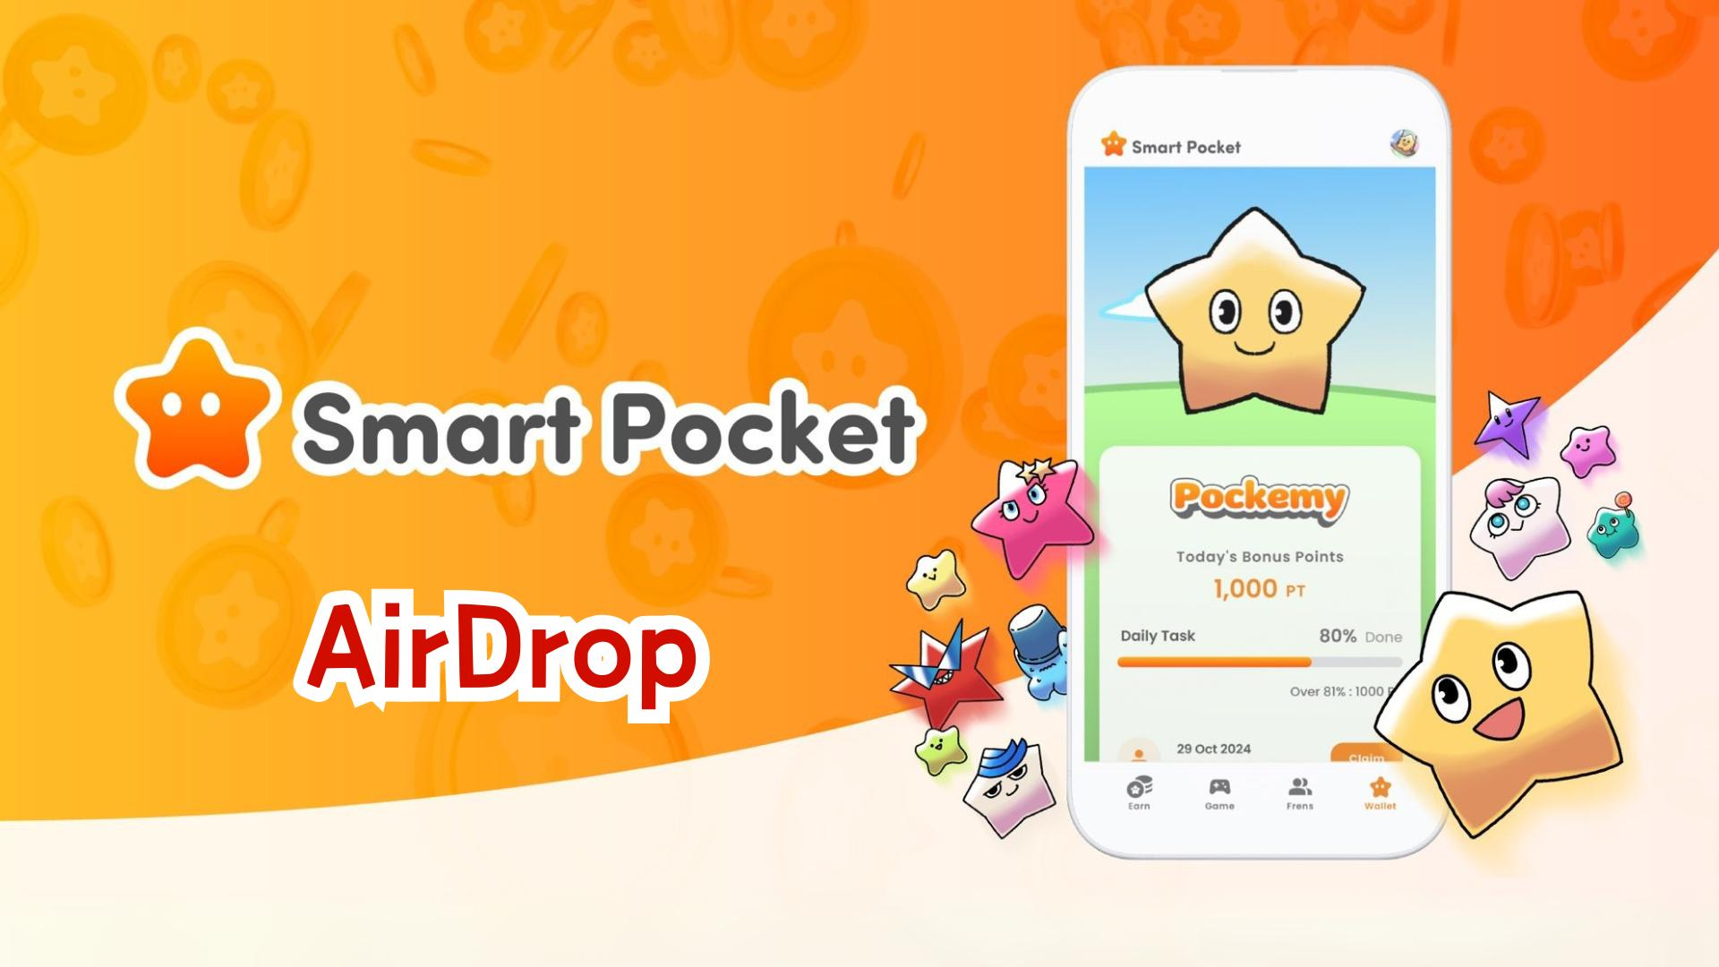

**Ìlò Smart Pocket Ṣafihan Ẹya AirDrop! Itọsọna Pipe Fun Gbigba $SP Tokens**

**Ẹ káàbọ gbogbo eniyan!  
  
Ni igba ti a ti ṣafihan ẹya Wallet, loni a ni ayọ lati ṣafihan taabu tuntun "AirDrop" ti gbogbo eniyan ti nduro de!**

**Wo ikede osise nibi: https://x.com/smapocke/status/1865293104221393092**

**Ti o ko ba ti ka itọsọna ẹya Wallet, wo nibi: https://note.com/japan_dao/n/ndce1c1b252cc**

# Àkóónú

* Ẹya tuntun ninu ìlò Smart Pocket
* Nipa $SP Tokens
* Àwọn ipò lati gba AirDrop
* Ikadii

# Ẹya tuntun ninu ìlò Smart Pocket

Ẹya AirDrop jẹ afikun tuntun ti o fanimọra si ìlò Smart Pocket, ti o wa fun awọn olumulo tuntun ati awọn ti o wa tẹlẹ!

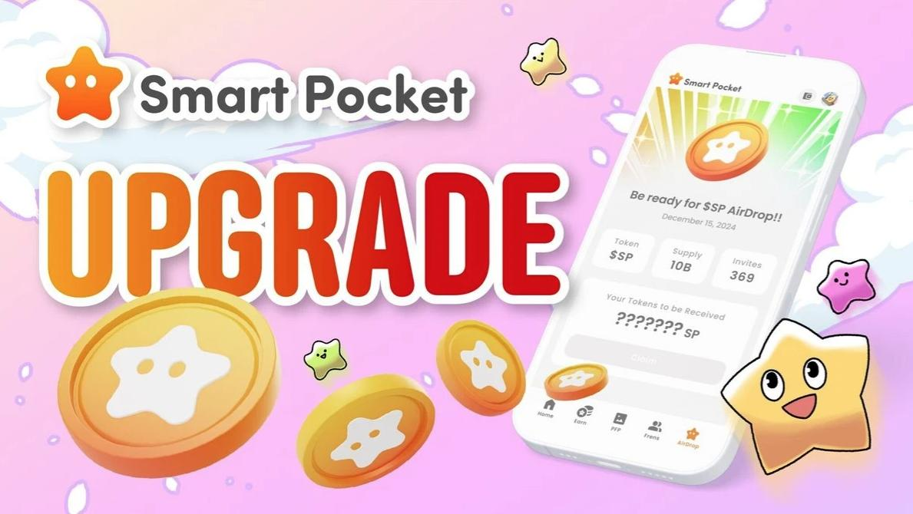

# Nipa $SP Tokens

$SP jẹ tuntun julọ ninu eto ilolupo Smart Pocket.

## Àwọn ẹya pataki

* Lapapọ Ipese: 100 bilionu tokens (100B)
* Pipin Token: Awọn alaye yoo kede nigbamii. Awọn token le pin da lori ipo, nini $SP BOX NFTs ati awọn NFTs pataki miiran.
* Àwọn Ètò Ọjọ iwaju:
* Anfani lati gba AirDrops nipasẹ SP staking fun awọn iṣẹ tuntun
* Ètò lati gba awọn token lati ọdọ awọn iṣẹ ọjọ iwaju
* Àwọn lilo lọpọlọpọ ninu ilolupo eda

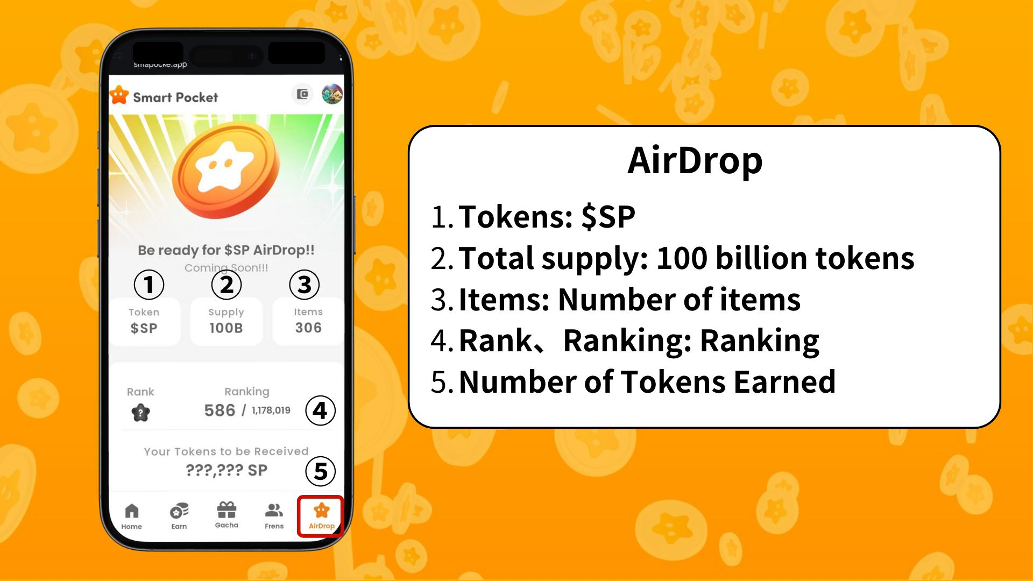

# Àwọn ipò lati gba AirDrop

Lọwọlọwọ, awọn ipo fun gbigba AirDrop da lori iye Items (nọmba ohun) ati ipo Ranking.

* Lo awọn ojuami lati paarọ fun awọn ohun Pockemy diẹ sii
* Mint awọn SBT pataki larọwọto

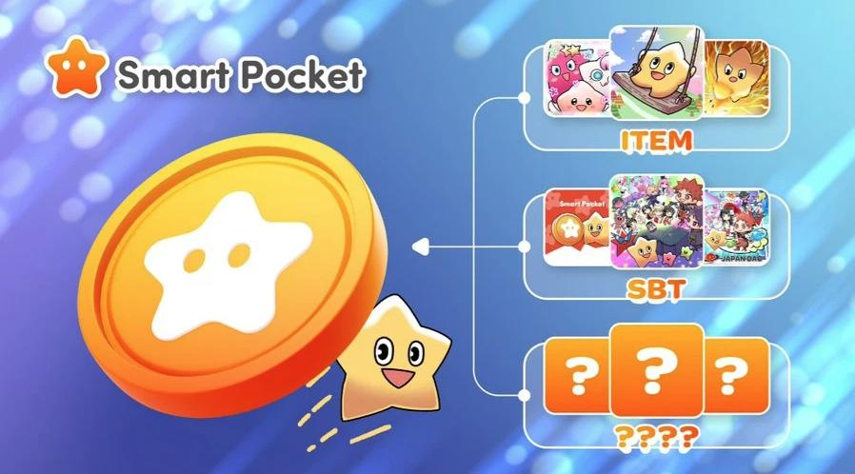

Ìpò ti pin si S, A, B, ati C, ati pe iye AirDrop yoo dale lori ipo rẹ.



Akiyesi: Bi o ti gba ọpọlọpọ awọn ohun diẹ sii, ipo rẹ yoo ga. Nitorinaa, a ṣeduro lilo awọn ojuami SP.  
  
Fun alaye siwaju sii lori bi o ṣe le gba awọn ojuami ati gba NFTs/SBT pataki, wo nibi: https://note.com/japan_dao/n/nfa9879331899

Wo itọsọna PFP Gacha nibi: https://note.com/japan_dao/n/n521a5818be74

# Ikadii

Pẹlu afikun ẹya AirDrop, ìlò Smart Pocket ti di pẹpẹ ti o wuni pupọ. Pẹlu ipari iṣẹ-ṣiṣe ojoojumọ, minting SBT ati lilo ẹya gacha, awọn olumulo ni awọn aye diẹ sii lati gba awọn $SP tokens.

Jẹ ká gbadun aye Smart Pocket ti n dagba nigbagbogbo pọ!

# 📢 Duro Imudojuiwọn 📢

* Oju opo wẹẹbu osise Smart Pocket: https://smapocke.com/
* Smart Pocket osise Discord: https://discord.com/invite/smartpocket
* Akọọlẹ X osise Smart Pocket: https://x.com/smapocke
* Akọọlẹ X osise Pockemy: https://x.com/pockemys