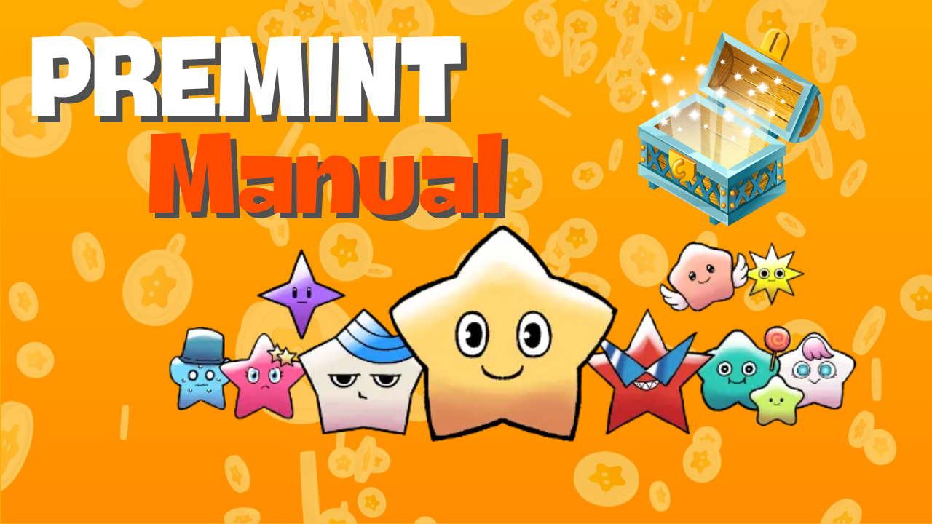

**Itọsọna PREMINT**

# Ⅰ. Kini PREMINT?

PREMINT jẹ irinṣẹ fun iṣakoso awọn eniyan ti o kopa ninu bọọlu fun awọn ẹtọ rira pataki NFT (AL: Allowlist). O ṣe iranlọwọ fun awọn alakoso iṣẹ akanṣe lati rii daju ododo ati lati ṣawari iyanjẹ. Iṣowo ni bọọlu jẹ ọfẹ ati pe o nilo awọn igbesẹ ti o rọrun lati lo fun AL.

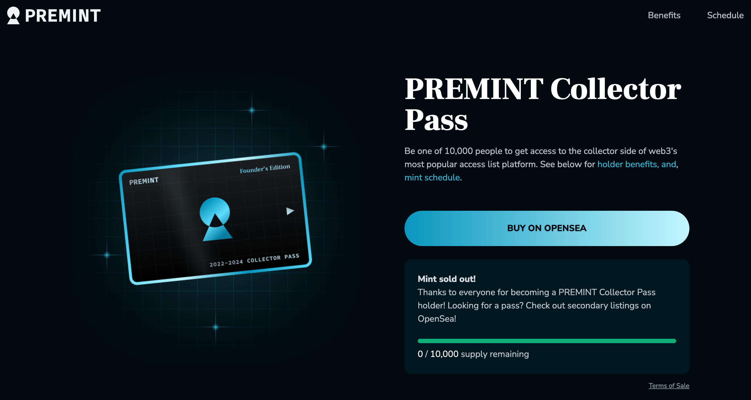

# Ⅱ. Igbaradi Ṣaaju ṣiṣe ibeere si PREMINT

Awọn nkan wọnyi ni o nilo fun lilo PREMINT:  
  
- Apamọwọ (MetaMask)  
- Akoonu Discord  
- Akoonu X (Twitter)  
  
Ti o ko ba ni MetaMask tabi akọọlẹ Discord kan, o le ṣẹda ọkan ni irọrun nipa lilo awọn ọna asopọ wọnyi:  
  
- [Bii a ṣe le ṣẹda MetaMask](https://note.com/japan_dao/n/n52a4afbd67f7)  
- [Bii a ṣe le ṣẹda akọọlẹ Discord](https://note.com/japan_dao/n/nd1693cf6b2b5)

# Ⅲ. Awọn igbesẹ lati ṣe ibeere si PREMINT

## 1. So Apamọwọ pọ

## 2. So Awujọ pọ

## 3. Ṣe ibeere si PREMINT

Tẹle awọn igbesẹ wọnyi:  
  
1. Da ọna asopọ ti o yẹ lati X (Twitter) tabi iru ẹrọ miiran silẹ ki o ṣii MetaMask.  
  
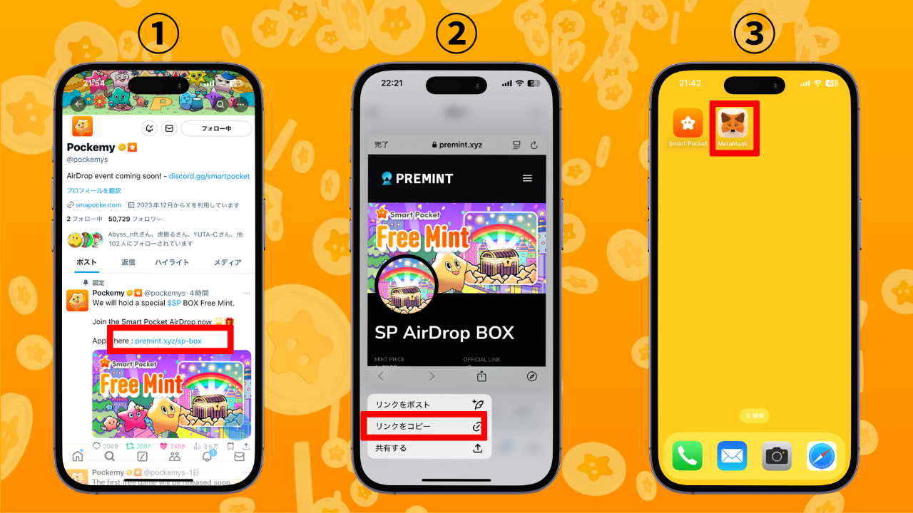  
  
2. Ṣii aṣawakiri MetaMask ki o lẹẹmọ ọna asopọ ti a da silẹ lati buwolu wọle.  
  
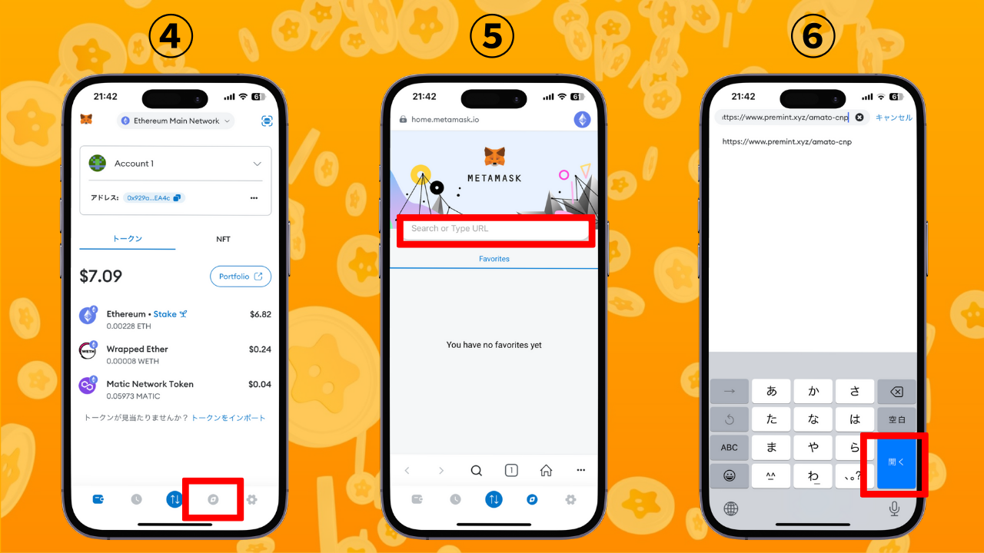  
  
3. Tẹ lori "Login To Register," yan apamọwọ rẹ, tẹ ọrọ igbaniwọle sii, fowo si, ki o so apamọwọ pọ.  
  
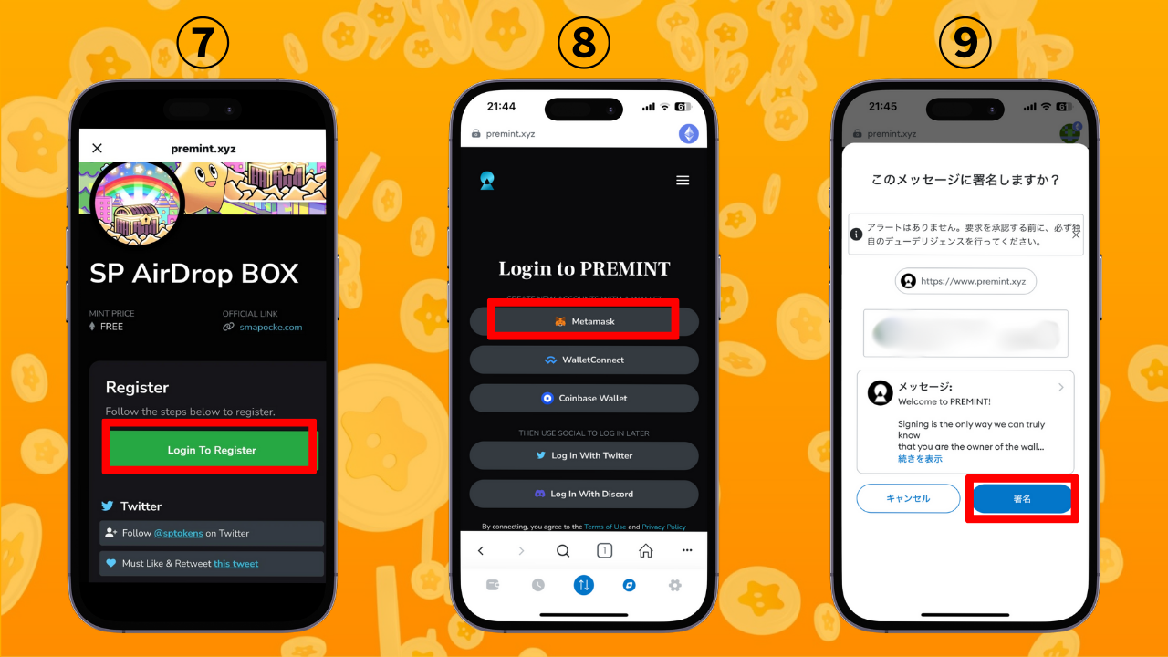  
  
4. Ṣayẹwo boya awọn ipo ikopa (ti a tọka ninu apoti pupa ni oke) ti pari. Tẹ "Click To Register." Ni kete ti eyi ba han, ibeere rẹ ti pari!

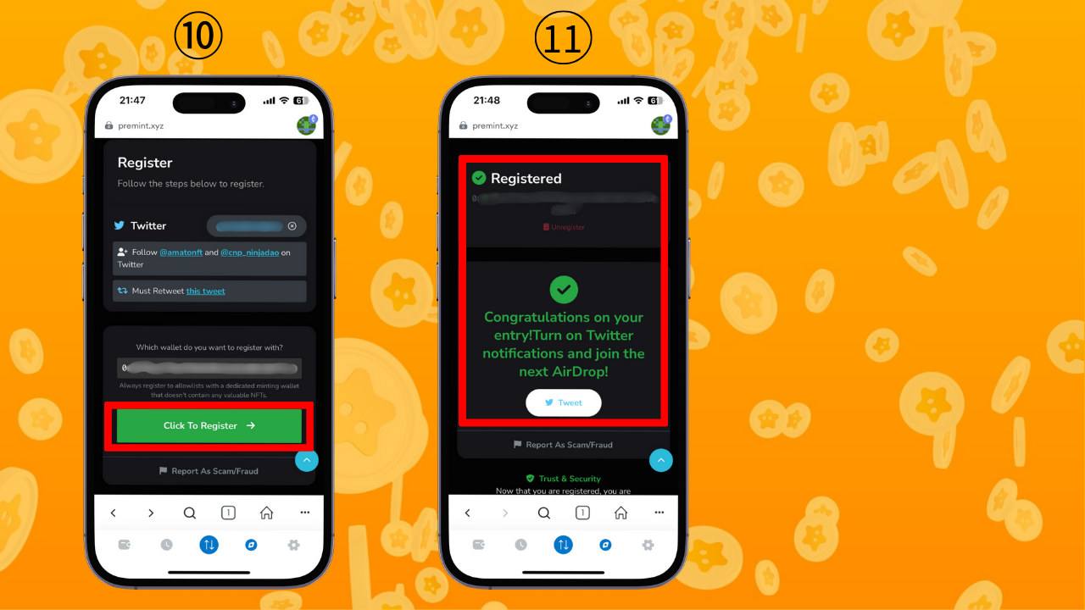

# Ⅳ. Akopọ

Itọsọna yii ṣe akopọ PREMINT. Ni kete ti o ba pari iforukọsilẹ akọkọ rẹ, awọn ibeere atẹle yoo jẹ irọrun diẹ sii. PREMINT n pese ọna pataki si awọn anfani bii AL fun awọn iṣẹ akanṣe olokiki, mint ọfẹ, ati awọn airdrops. Lo PREMINT ni ọwọ ati gba awọn anfani nla papọ! 🌟

📢 Alaye Tuntun 📢  
  
- [Oju opo wẹẹbu osise ti Smart Pocket](https://smapocke.com/)  
- [Discord osise ti Smart Pocket](https://discord.com/invite/smartpocket)  
- [Iwe akọọlẹ X osise ti Smart Pocket](https://x.com/smapocke)  
- [Iwe akọọlẹ X osise ti Pokemy](https://x.com/pockemys)