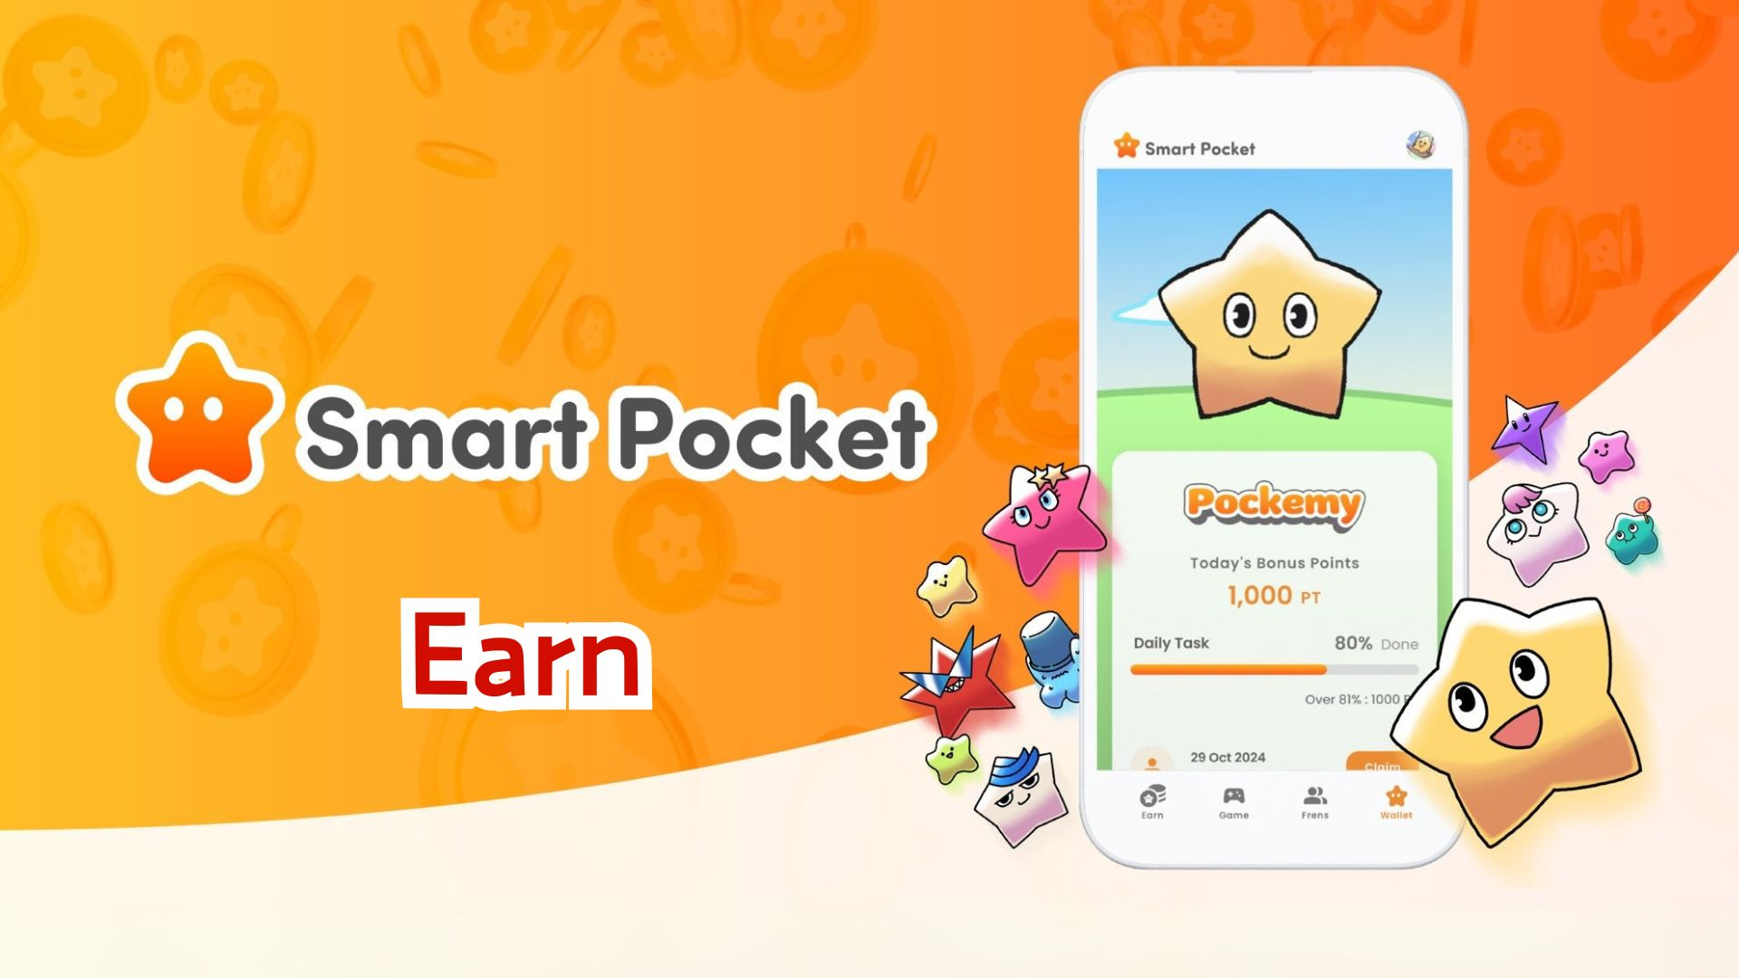

**Itọsọna Pipe Fun Gbigba Awọn Points pẹlu Ohun elo Smart Pocket!**

**Ẹ ku ọjọ!**

**Ni igba ti a ti kọkọ ṣafihan bi a ṣe le bẹrẹ pẹlu ohun elo Smart Pocket. Ni akoko yii, a yoo ṣalaye ni alaye nipa ẹya ti a ti nreti 'Earn' ati bi o ṣe le gba awọn points!**

# Àkójọ Èrò

* Kini ẹya Earn?
* Gba awọn points pẹlu awọn taabu 'Daily' ati 'Earn'
* Àwọn àpẹẹrẹ iṣẹ-ṣiṣe pataki
* Awọn igbesẹ lati gba awọn points
* Gba awọn points pẹlu taabu 'Collab'
* Awọn igbesẹ lati gba awọn points
* Àwọn ìmòran fun gbigba awọn points ni irọrun
* Gba Awọn ohun Smart Pocket ati SBT ti o ni iyasọtọ!
* Bawo ni a ṣe le gba SBT
* Awọn igbesẹ

# Kini ẹya Earn?

Ẹya Earn ngbanilaaye lati gba SP Point nipa ṣiṣe awọn iṣẹ ojoojumọ. O le ṣajọ awọn points nipasẹ awọn iṣẹ-ṣiṣe lọpọlọpọ lori media awujọ ati ilowosi ninu agbegbe!

# Gba awọn points pẹlu awọn taabu 'Daily' ati 'Earn'

Ni taabu Earn, awọn ipenija ojoojumọ wa ti o le pari ni gbogbo ọjọ.

## Àwọn àpẹẹrẹ iṣẹ-ṣiṣe pataki

* Tun gbe ifiweranṣẹ osise ranṣẹ lori X
* Tẹle akọọlẹ osise lori X
* Darapọ mọ olupin Discord Smart Pocket
* Forukọsilẹ lori ikanni YouTube Pockemy
* Tẹle Pockemy lori Instagram

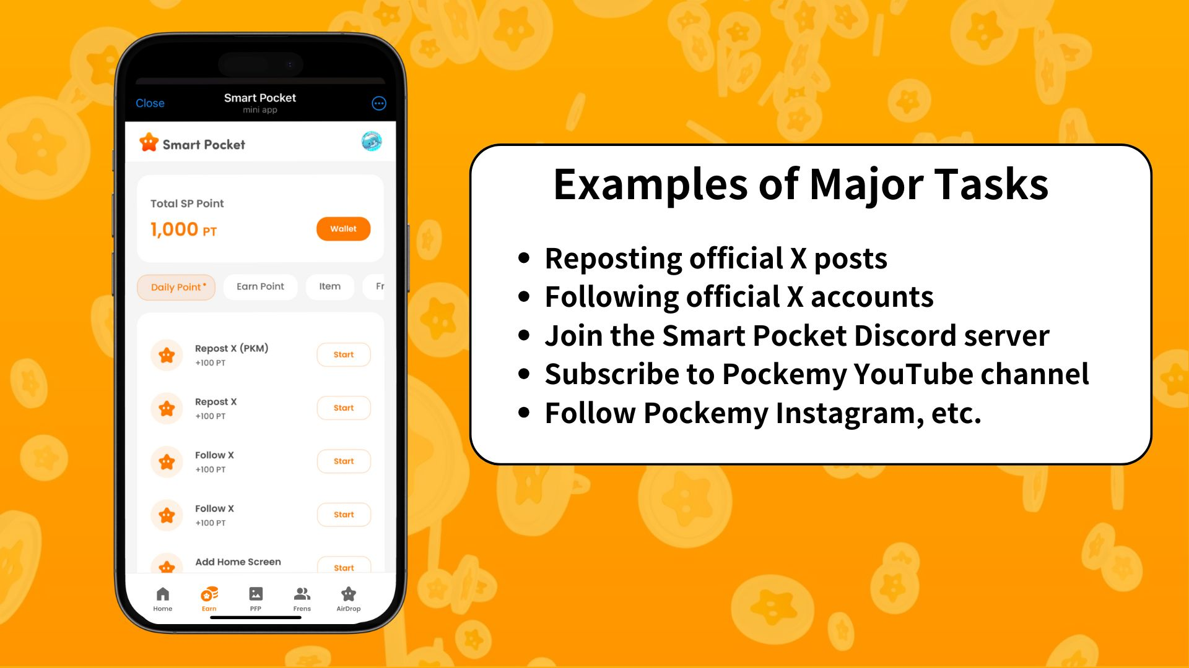

## Awọn igbesẹ lati gba awọn points

1. Ṣii taabu Earn
2. Yan iṣẹ-ṣiṣe Daily Point ti o fẹ
3. Tẹ 'Start' lati bẹrẹ iṣẹ-ṣiṣe
4. Pari iṣẹ-ṣiṣe
5. Tẹ 'Claim' lati gba awọn points rẹ

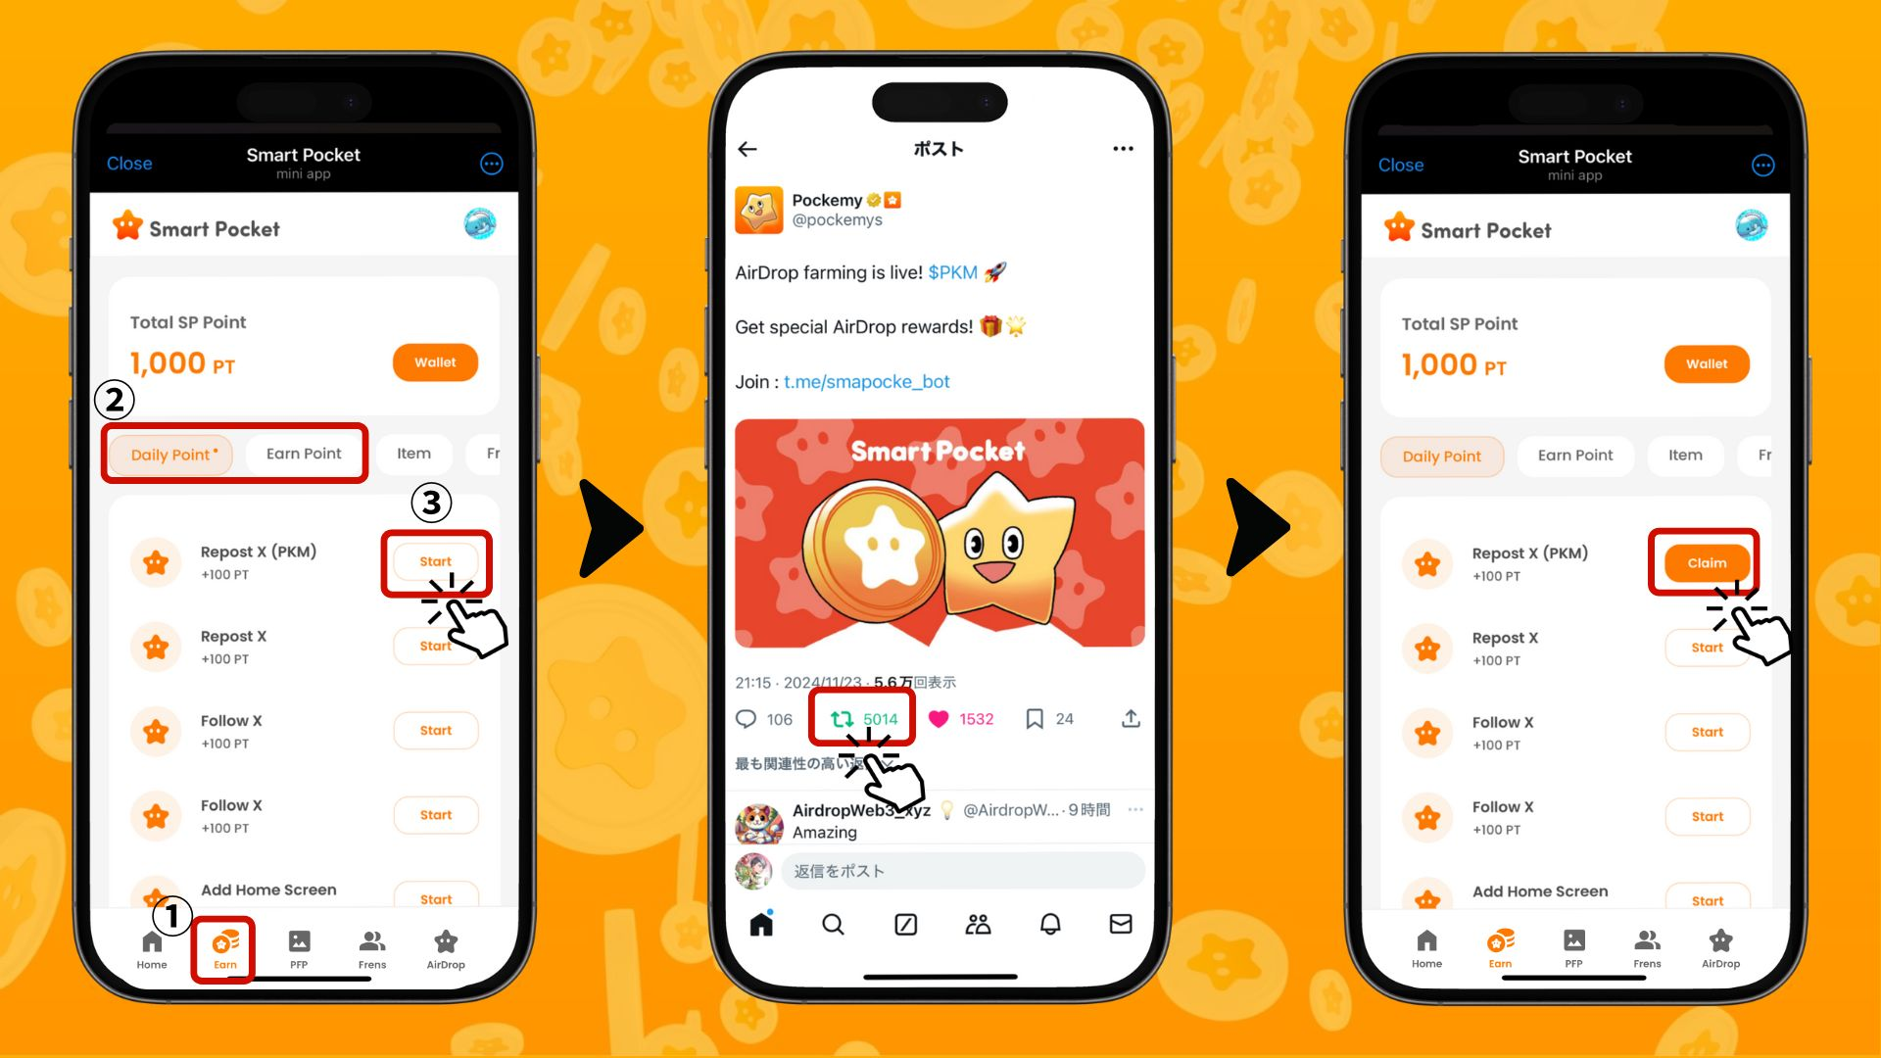

# Gba awọn points pẹlu taabu 'Collab'

Awọn iṣẹ-ṣiṣe Collab ngbanilaaye lati gbadun akoonu awọn alabaṣepọ ati ni akoko kanna gba SP Points. O le yan iru iṣẹ-ṣiṣe ti o nifẹ si ati pe ko ṣe dandan lati pari gbogbo wọn.

## Awọn igbesẹ lati gba awọn points

1. Ṣii taabu Earn
2. Yan iṣẹ-ṣiṣe Collab ti o fẹ
3. Tẹ 'Start' lati bẹrẹ iriri naa
4. Pari iriri naa
5. Tẹ 'Claim' lati gba awọn points rẹ

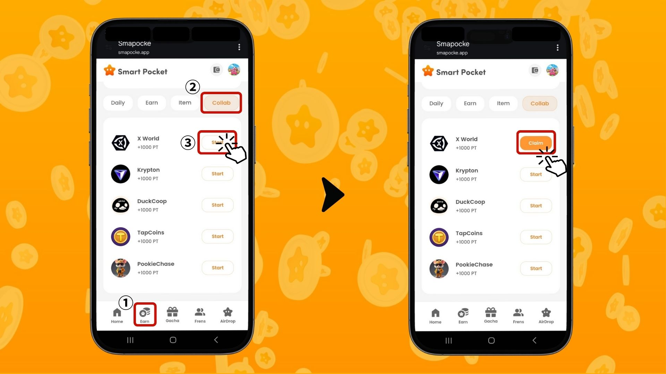

# Àwọn ìmòran fun gbigba awọn points ni irọrun

* Wọle lojoojumọ – Awọn iṣẹ-ṣiṣe ojoojumọ ni imudojuiwọn ni gbogbo ọjọ, nitorinaa o dara lati wọle nigbagbogbo!
* Gbiyanju gbogbo awọn iṣẹ-ṣiṣe – Paapaa awọn points kekere le ṣajọ ni akoko pupọ.

# Gba Awọn ohun Smart Pocket ati SBT ti o ni iyasọtọ!

O le lo SP Points rẹ lati gba awọn ohun iyasọtọ Smart Pocket. Sibẹsibẹ, minting SBT ọfẹ ko nilo SP Points.

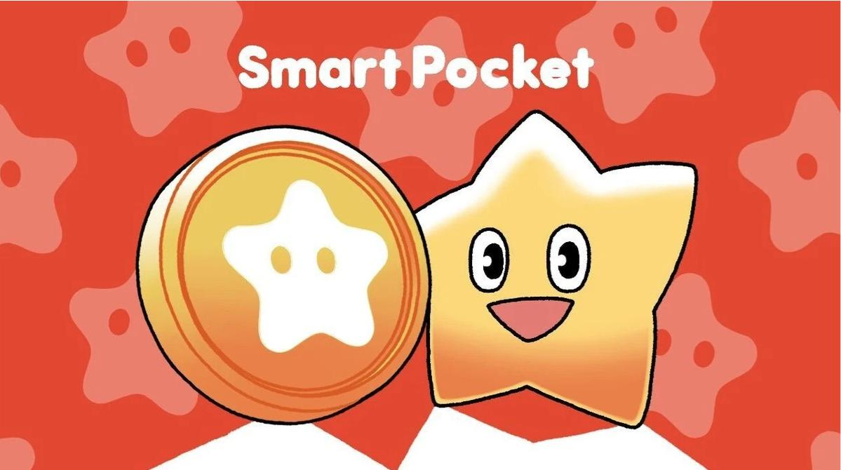

## Bawo ni a ṣe le gba SBT

Ẹnikẹni le gba SBT ni irọrun.

## Awọn igbesẹ

1. Ṣii taabu Earn
2. Tẹ 'Item'
3. Tẹ 'Start'
4. Tẹ 'Mint'

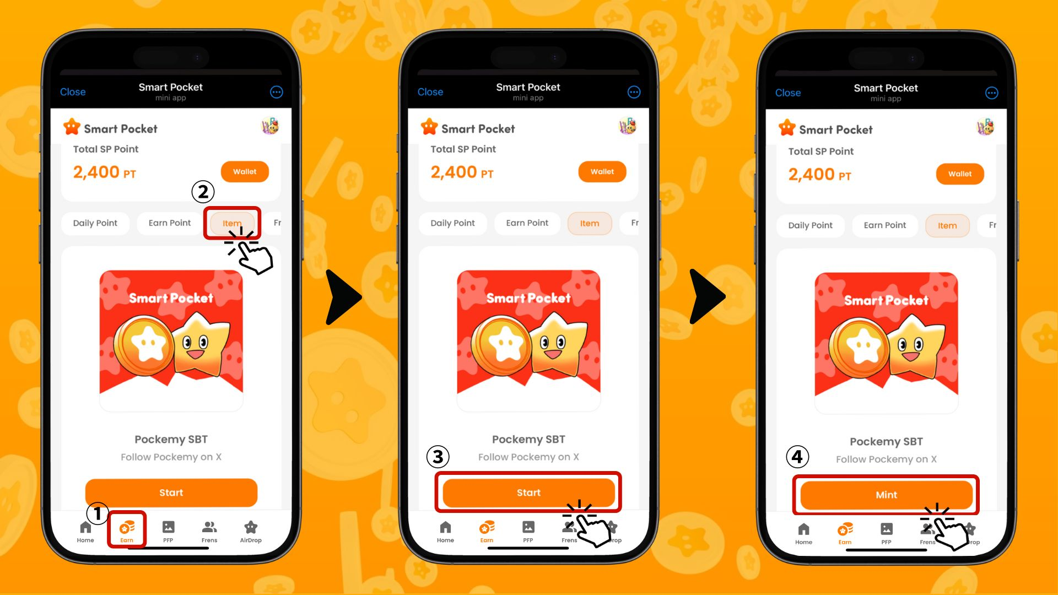

## Bawo ni a ṣe le ṣayẹwo awọn ohun (PFP) ti a gba

Pẹlu awọn points ti a kojọ, o le gba awọn ohun (PFP) ni irọrun.

## Awọn igbesẹ

1. Ṣii ohun elo Smart Pocket
2. Yan taabu Gacha
3. Yan taabu fun gacha
4. Yan '×1 Gacha' (1,000 points) tabi '×10 Gacha' (10,000 points)
5. Gba PFP laileto!

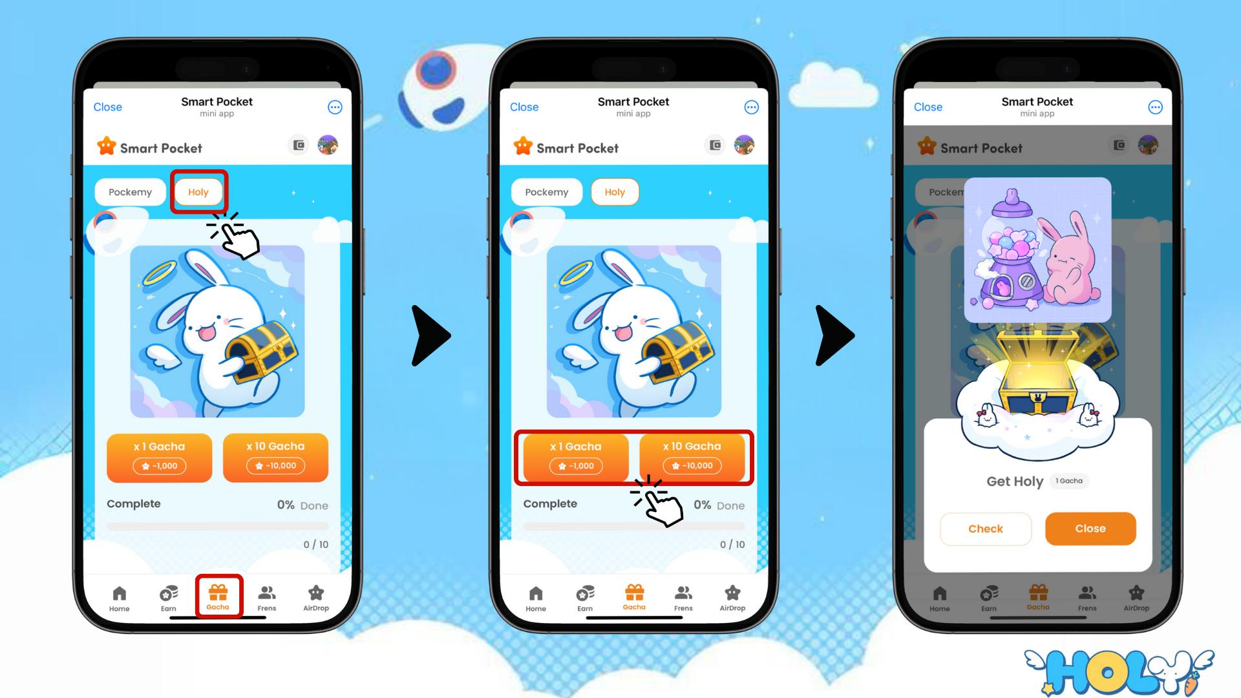

# Bawo ni a ṣe le ṣayẹwo awọn ohun, SBT ati NFT ti o wa

## Awọn igbesẹ

1. Ṣii taabu Wallet
2. Tẹ 'Item'
3. Yan 'All', 'Item', 'SBT', tabi 'NFT'
4. Tẹ lori taabu ti o fẹ lati ṣayẹwo
5. Tẹ lori ohun, SBT tabi NFT lati wo awọn alaye bi ọjọ ti o gba.

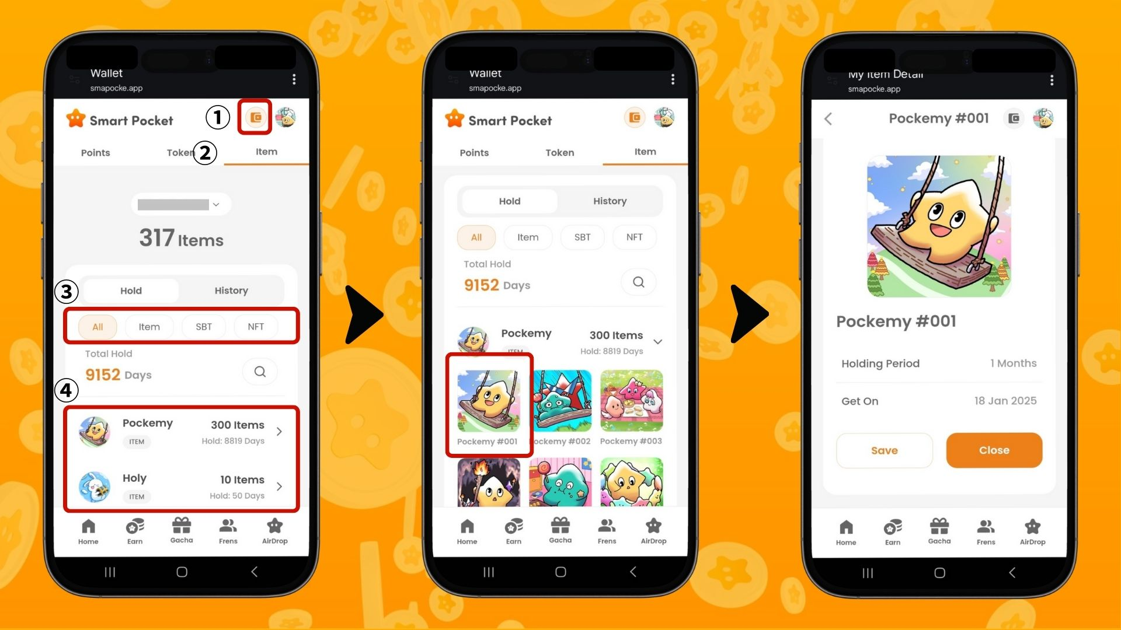

# Ipari

Ẹya Earn jẹ ọkan ninu awọn ẹya akọkọ ti ohun elo Smart Pocket. O jẹ eto imotuntun ti o yipada awọn iṣẹ ojoojumọ awujọ rẹ si awọn points.

Ninu nkan ti o tẹle, a yoo ṣafihan ẹya 'Frens' ati ṣalaye bi o ṣe le gba awọn points nipasẹ awọn ìpe! Ni akoko yii, gbiyanju ẹya Earn ki o bẹrẹ si gba awọn points!

Gbadun gbigba awọn points pẹlu ohun elo Smart Pocket!

# 📢 Awọn Imudojuiwọn Tuntun 📢

* Oju opo wẹẹbu osise Smart Pocket: https://smapocke.com/
* Smart Pocket Discord osise: https://discord.com/invite/smartpocket
* Smart Pocket X osise: https://x.com/smapocke
* Pockemy X osise: https://x.com/pockemys