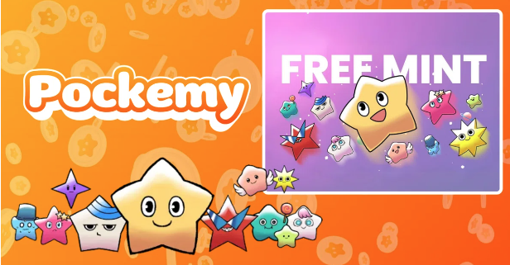

**Ẹdà NFT Pockemy Pataki (SBT) Fun Minti Ọfẹ!**

**A n gba iforukọsilẹ lọwọlọwọ lori PREMINT fun minti ọfẹ ti **NFT Pockemy Pataki**.**

**Nipasẹ ipari iforukọsilẹ rẹ lori PREMINT, iwọ yoo ni ẹtọ fun minti ọfẹ. Maṣe padanu aye yii—jọwọ rii daju pe o pari iforukọsilẹ rẹ!**

# Nipa Minti Ọfẹ Yi

Eyi jẹ **minti ọfẹ fun awọn oluyanjú atilẹyin akọkọ**, ati NFT pataki kan yoo wa ni idasilẹ.

## Awọn Ifarabalẹ Pataki

1. NFT yi jẹ **SBT (Soulbound Token)** ati pe ko le ta tabi gbe lọ.
2. **Iforukọsilẹ lori PREMINT jẹ dandan**, ati apamọwọ ti a forukọsilẹ gbọdọ jẹ kanna bi eyi ti o lo lati wọle si Smart Pocket APP.
3. NFT SBT yi yatọ si awọn NFT 300 nikan ti Smart Pocket ti pese fun ọfiisi.

# Bii o ṣe le Forukọsilẹ lori PREMINT

* Jọwọ forukọsilẹ nipa lilo ọna asopọ ni isalẹ.
* Ti o ko ba mọ bi o ṣe le forukọsilẹ, jọwọ tọka si àpilẹkọ ni isalẹ.

# Ìṣẹ̀lẹ̀ Pataki Kan Nlọ lọwọ ni Smapoke App!

Lati ṣe ayẹyẹ ifilọlẹ ti “Pockemy Premint,” iṣẹ apinfunni pataki kan nlọ lọwọ ni app Smapoke.

🔗 Ọna asopọ Iṣẹ-ṣiṣe: [https://www.smapocke.app/list/open_event](https://www.smapocke.app/list/open_event)

⏰ Akoko ipari: Ọjọ kẹta, Oṣu Kẹwa ọdun 2024

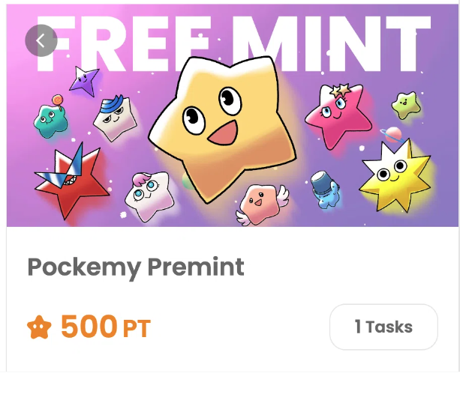

# Maṣe Gbagbe Alaye Tuntun Nipa NFT Pockemy Pataki

Jọwọ rii daju pe o pari iforukọsilẹ lori PREMINT ki o duro de minti ọfẹ ti NFT Pockemy pataki. NFT yi yoo jẹ alailẹgbẹ fun olukuluku oluwa rẹ.

📢 **Gba awọn imudojuiwọn tuntun nibi**

Àkọọlẹ PockemyX: [https://x.com/pockemys](https://x.com/pockemys)

Àyéwọlé Smart Pocket: [https://smapocke.com/](https://smapocke.com/)

Smart Pocket Discord osise: [https://discord.com/invite/smartpocket](https://discord.com/invite/smartpocket)