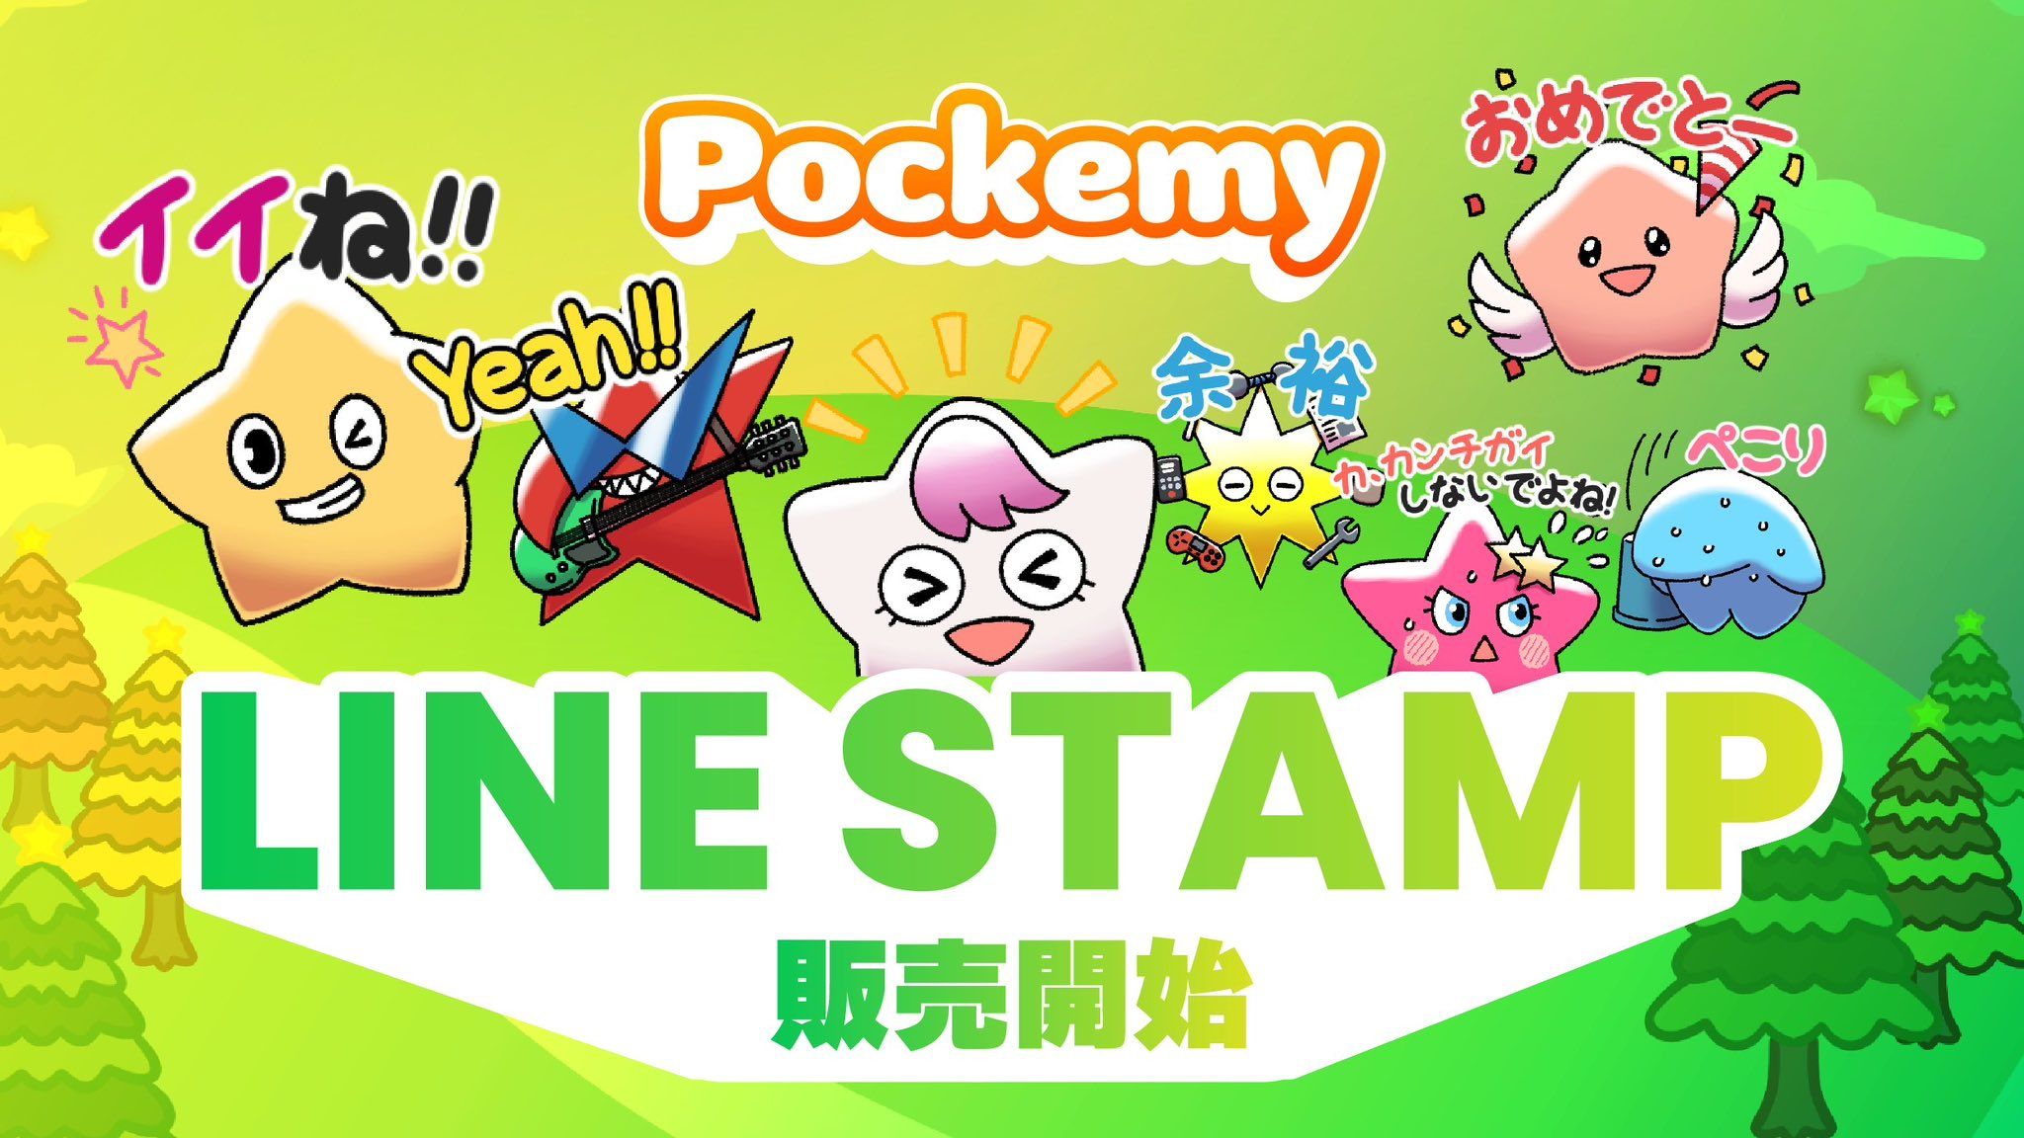

**Awọn nkan isere LINE osise ti JAPAN DAO: Itusilẹ Akọkọ!**

**Àmi ìṣòwò osise Smart Pocket, **Pokemy**, ti de nikẹhin lori awọn nkan isere LINE! 🎉**

# Àwọn nkan isere 32 ẹlẹwà!

Pẹ̀lú **àwọn nkan isere Pokemy ẹlẹwà 32**, ìbánisọrọ rẹ lori LINE yóò dára sí! ✨

## Itusilẹ Akọkọ pẹlu awọn nkan isere 32!

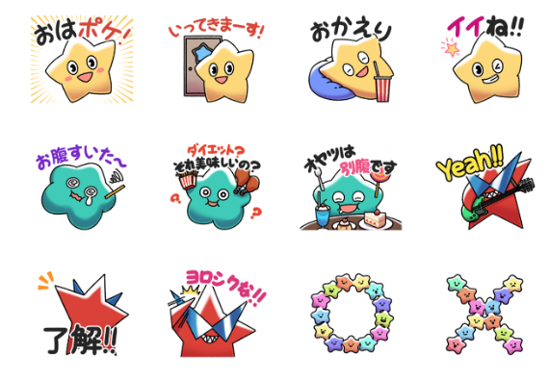  
  
Àwọn nkan isere LINE tuntun yi ni **awọn ẹkun ilẹ̀ ilẹ̀ 32 ẹlẹwà** lati ọdọ Pokemy!

* O ni awọn gbolohun ọrọ Japanese tí ó wúlò fún ìlò ojoojumọ́
* Àwọn àpẹrẹ ẹdáwà fun orisirisi àyáfi
* Àwọn apẹrẹ 32 ti o kun fun ifaya Pokemy

Gba lati ibi ▼

# Tani Pokemy?

Fún awon ti kò mọ̀ ẹni ti àmi náà jẹ́, èyi ni ìmọ̀lẹ̀ ìmọ̀lẹ̀!

## Pokemy

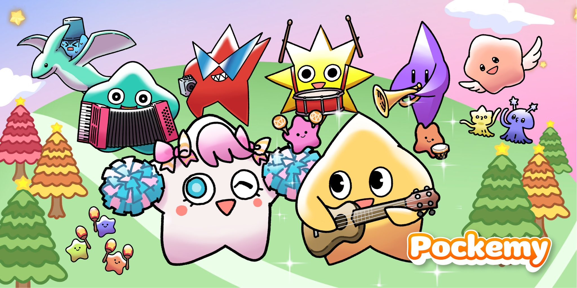

# Akopọ

Àmi ìṣòwò olokiki Smart Pocket, "Pokemy", ti ṣe ifilọlẹ awọn nkan isere LINE osise rẹ́! Pẹ̀lú awọn nkan isere 32 ti o wuyi fún ìbánisọrọ ojoojumọ́, ìbánisọrọ rẹ lori LINE yóò dára sí!

## 📢 Gba awọn imudojuiwọn tuntun níbí:

* Oju opo wẹẹbu osise Smart Pocket: [https://smapocke.com/](https://smapocke.com/)
* Discord osise Smart Pocket: [https://discord.com/invite/smartpocket](https://discord.com/invite/smartpocket)
* Oju opo wẹẹbu osise JAPAN DAO: [https://japandao.jp/](https://japandao.jp/)
* Discord osise JAPAN DAO: [https://discord.com/invite/japandao](https://discord.com/invite/japandao)
* Akọọlẹ X osise Pokemy: [https://x.com/pockemys](https://x.com/pockemys)