

**Titun Animation Holy 'Holy CM' ti tujade! 🎉**

**Awọn onijakidijagan Holy, a dupẹ fun suuru yin!**

**Awọn apanilerin tuntun ti o kun fun ẹwa Holy ti tujade.**

**Iṣẹ yii kun fun ohun ti o dun ati itọju ti yoo ni idaniloju lati mu ọkàn rẹ ni oorun.**

# Awọn aaye pataki ti 'Holy CM'

1. 1. Ayé aláyò àti àlàáfíà ti Holy.
2. 2. Ẹ̀rẹ̀kẹ̀ Holy tó pọ̀.
3. 3. Awọn iduro aladun ti o mu ki ẹnikẹni rẹrin.

# Idije pataki ninu App Smappoke!

Lati ṣe ayẹyẹ itusilẹ awọn apanilerin tuntun 'Holy CM', iṣẹ akanṣe pataki kan nlọ lọwọ ninu app Smappoke!

🔗 Ọna asopọ iṣẹ: [https://www.smapocke.app/list/open_event](https://www.smapocke.app/list/open_event)

⏰ Akoko ipari: Oṣu Kẹsan 30, 2024

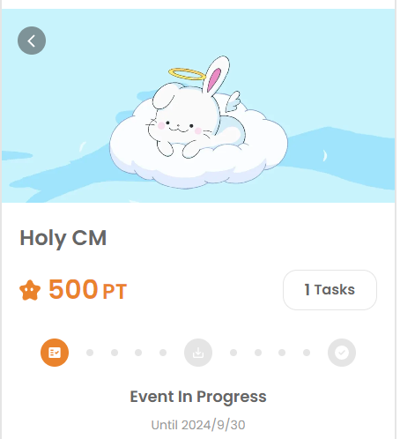

# Akoko lati gba Holy NFT ti bẹrẹ!

Pẹ̀lú èyí, akoko gbigba Holy NFT ti bẹrẹ! Awọn ti o pari iforukọsilẹ ni PREMINT ati pe a yan ni bayi le gba awọn NFTs wọn.

🔗 Alaye alaye lori gbigba Holy NFT: [https://note.com/japan_dao/n/n65c9e48aff43](https://note.com/japan_dao/n/n65c9e48aff43)

# Maṣe padanu awọn imudojuiwọn tuntun lati Holy! 🎨

Ẹgbẹ Holy ni ọpọlọpọ awọn idagbasoke ti a gbero fun ọjọ iwaju. Pẹ̀lú èyí, Holy NFT yii yoo ṣiṣẹ bi ẹri pe o jẹ ọkan ninu awọn olumulo ibẹrẹ ti Holy, nitorinaa maṣe gbagbe lati gba rẹ!

📢 Gba awọn imudojuiwọn tuntun nibi

Akọọlẹ X osise Holy: [https://x.com/holysinfo](https://x.com/holysinfo)

Akọọlẹ X osise JAPAN DAO: [https://twitter.com/japandaojp](https://twitter.com/japandaojp)

Akọọlẹ Discord osise JAPAN DAO: [https://discord.com/invite/japandao](https://discord.com/invite/japandao)