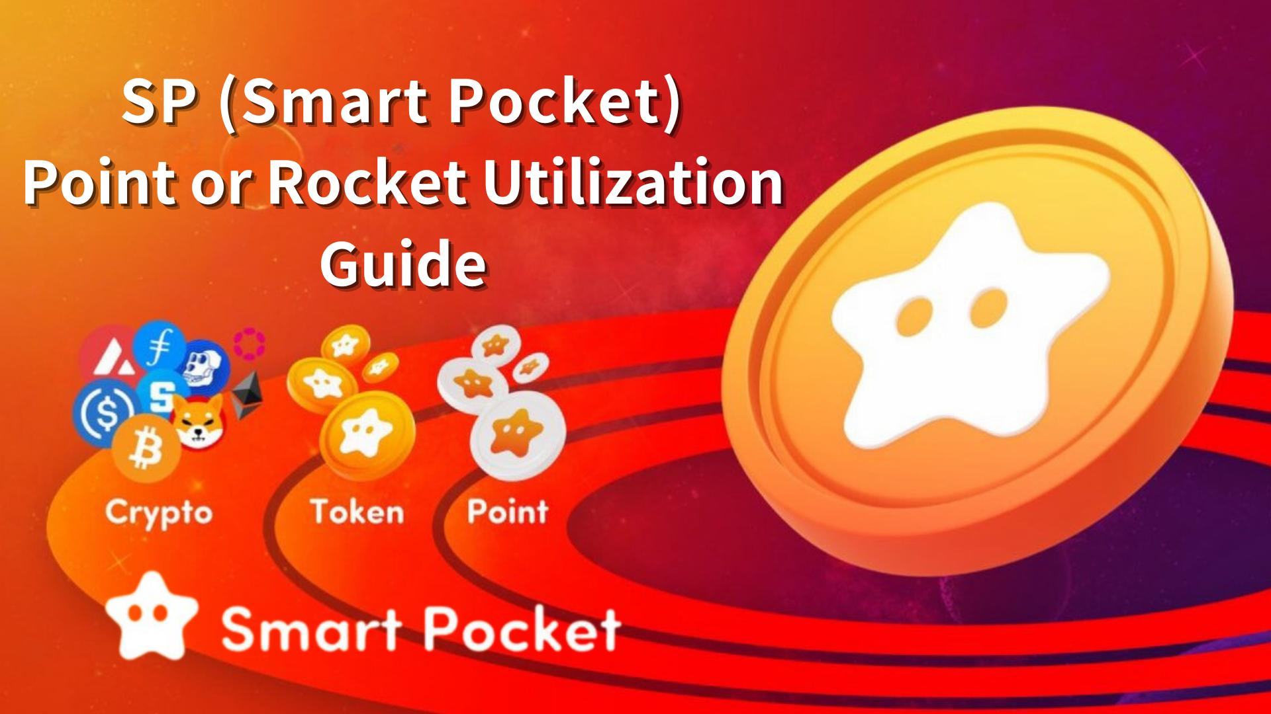

**Itọsọna Lilo Awọn Pointi SP (Smart Pocket) ati Rocket – Igbesẹ akọkọ si Gbigba Token**

**Ẹ ku ọjọ SP Ẹbi!  
  
Loni, a yoo ṣalaye ni kedere nipa Awọn Pointi SP (Smart Pocket) ati Rocket.  
  
Itọsọna yii yoo ṣalaye bi o ṣe le gba awọn pointi SP nipasẹ app Smart Pocket ati awọn iṣẹlẹ Discord, bi o ṣe le ra Rocket lati Ile itaja, ati bi o ṣe le lo wọn daradara.**

# Akoonu

* Ifihan  
  Bii o ṣe le Gba Awọn Pointi SP  
  1. Ere Gbigba akọkọ  
  2. Awọn iṣẹ-ṣiṣe  
  3. Iṣẹ Imọran  
  4. Awọn iṣẹlẹ Q&A (Discord)  
  5. Awọn iṣẹlẹ Rumble (Discord)  
  6. Awọn iṣẹlẹ Mii  
  Bii o ṣe le Ra Rocket  
  ① Rira nipasẹ Telegram Stars (Ti ṣe iṣeduro & Rọrun!)  
  ② Rira pẹlu owo TON (Fun Awọn olumulo To ti ni Iriri)  
  Lilo Awọn Pointi SP ati Rocket  
  🎯 Lilo ni Gacha  
  🧩 Awọn jara PFP lọwọlọwọ  
  📊 Ifarahan lori Ipo  
  Ipari

# Ifihan

Awọn pointi SP jẹ eto aaye agbaye. Lẹ́yìn tí o wọlé sí app Smart Pocket fun igba akọkọ, o le bẹrẹ gbigba awọn pointi — ọfẹ patapata!  
  
O gba 1000 pointi gẹgẹ bi ẹbun iforukọsilẹ akọkọ, ati pe o le gba diẹ sii nipasẹ ṣiṣe awọn iṣẹ ni app ati ṣiṣe alabapin ninu awọn iṣẹlẹ Discord.  
  
O tun le ra Rocket (1 Rocket = 1000 pointi) lati Ile itaja lati faagun awọn ọna lilo.

# Bii o ṣe le Gba Awọn Pointi SP

## 1. Ere Gbigba akọkọ

Forukọsilẹ ki o wọle si app Smart Pocket fun igba akọkọ lati gba 1000 pointi.  
  
Itọsọna forukọsilẹ: https://note.com/japan_dao/n/n41015b5af06a

## 2. Awọn iṣẹ-ṣiṣe

Iṣẹ tuntun ni app n jẹ ki o rọrun lati gba pointi.  
  
【Igbesẹ】  
- Ṣii taabu Earn  
- Yan iṣẹ Daily tabi Earn  
- Tẹ “Start”  
- Pari iṣẹ naa  
- Tẹ “Claim” lati gba awọn pointi  
  
Alaye: https://note.com/japan_dao/n/nfa9879331899

Maṣe gbagbe lati tẹ bọtini “Claim” ni apakan “Complete Task” ni iboju Ile lẹhin pari gbogbo awọn iṣẹ!  
  
Alaye: https://note.com/japan_dao/n/n08363fd3c288

## 3. Iṣẹ Imọran

Pin koodu ifiwepe rẹ lati pe awọn miiran ati gba pointi.  
  
【Igbesẹ】  
- Wọle si app  
- Pin koodu ifiwepe  
- Ẹnikan lo koodu naa  
- Ṣayẹwo ati gba awọn pointi rẹ  
  
Alaye: https://note.com/japan_dao/n/n1922dcba923c

## 4. Awọn iṣẹlẹ Q&A (Discord)

Ni gbogbo ọjọ Ẹtì ni 23:00. Dahun awọn ibeere lati gba pointi SP, USDT ati irawọ ✅Intelligence🌟.  
  
Alaye: https://note.com/japan_dao/n/nf78c58c19093

## 5. Awọn iṣẹlẹ Rumble (Discord)

Ni gbogbo Satidee ati Sunde ni 23:00. Ṣe idije ni awọn ere kekere lati gba pointi SP, USDT ati irawọ ✅Battle🌟.  
  
Alaye: https://note.com/japan_dao/n/nc2d3ae603c8b

## 6. Awọn iṣẹlẹ Mii

Kopa ninu awọn idije meme, awọn iṣẹlẹ tuntun lori Discord, ati awọn iṣẹlẹ pataki fun awọn ti o ni ipa Supernova.  
  
【Bii o ṣe le gba ✅Supernova🌟】  
Gba ✅Twinkle🌟, ✅Intelligence🌟 ati ✅Battle🌟 papọ.

# Bii o ṣe le Ra Rocket

## ① Rira nipasẹ Telegram Stars

Ra ni irọrun pẹlu kaadi kirẹditi tabi isanwo foonu.  
  
O dara fun awọn tuntun.

## ② Rira pẹlu owo TON

Ra TON lori CEX, fi ranṣẹ si apamọwọ Tonkeeper, ki o sanwo.  
  
O dara fun awọn ti o ni iriri pẹlu cryptocurrency.  
  
Alaye: https://note.com/japan_dao/n/nee8e860a6e5a  
https://note.com/japan_dao/n/nce61e2ee9292

# Lilo Awọn Pointi SP ati Rocket

## 🎯 Lilo ni Gacha

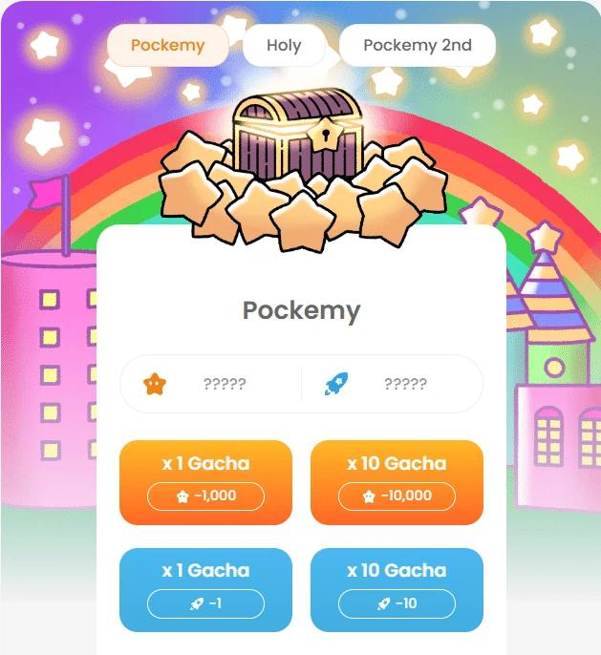  
  
1000 pointi tabi 1 Rocket = 1 yiyi  
10000 pointi tabi 10 Rocket = yiyi 10  
  
PFP ti o gba le ṣee ṣe igbasilẹ ati lo bi aami app tabi aworan profaili lori SNS.

## 🧩 Awọn jara PFP lọwọlọwọ

🟠 Pockemy PFP: jara akọkọ. Ere fun gbigba gbogbo (300 iru)  
🟡 Holy PFP: kekere ati fun ikojọpọ (10 iru)  
🔷 Pockemy 2nd PFP: pẹlu iyatọ, ni ipa julọ lori ipo (10,000 iru)  
  
Ti o ba fẹ ipo giga, dojukọ lori Pockemy 2nd PFP.

## 📊 Ifarahan lori Ipo

Diẹ sii PFP = ipo to gaju  
PFP ti o ṣọwọn ni ipa to lagbara  
  
O le ni ipa lori awọn airdrop ni ọjọ iwaju  
  
Alaye: https://note.com/japan_dao/n/n521a5818be74  
https://note.com/japan_dao/n/n49750a2f46a5  
https://note.com/japan_dao/n/nc9e036af5369

# Ipari

Gba awọn pointi fun ọfẹ nipasẹ awọn iṣẹ ni app tabi awọn iṣẹlẹ Discord, tabi ra Rocket ni ile itaja. Lo wọn fun gacha ati awọn iṣẹ miiran.  
  
Rira Rocket kii ṣe dandan — lo ni ibamu pẹlu ipo rẹ.  
  
Awọn jara PFP tuntun n bọ laipẹ. Duro de awọn ikede osise!  
  
Tẹle “Smapoke Magazine” ati akọọlẹ X osise wa:  
https://twitter.com/smapocke  
  
Discord osise:  
https://discord.com/invite/smartpocket