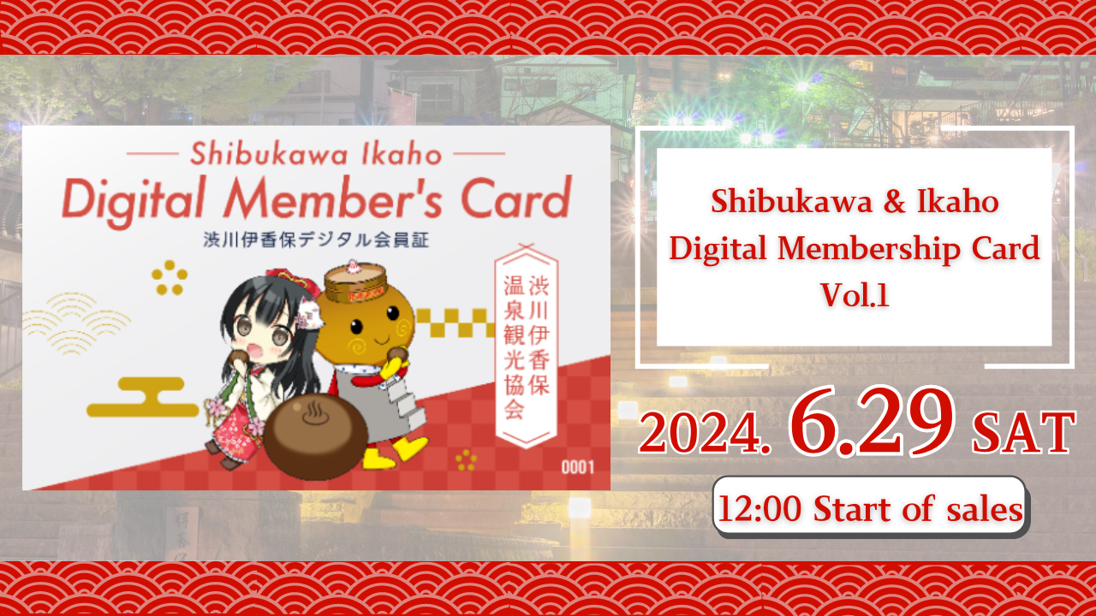
"Shibukawa / Ikaho Digital Comblode Kao VEL.1 yoo ta ni Oṣu Karun 29, 2024!
Kaabo, idile Dayo Japan yii!
Ni akoko yii a yoo fi awọn irohin nla pataki fun ọ.
Shibukawa ikaho lori igbẹkẹle irin ajo ati apejọpọ Co., Ltd. yoo kopa ninu aye ti agbegbe naa, agbaye yoo wa ni atapa si agbaye si ipo ti Ikaho ti Ikiho lori rẹ, Igbimọ Ẹyọ.
Gẹgẹbi apakan ti iyẹn, "Shibukawa / Shibikawado / NFAHO Forukọsilẹ" Nft yoo han! Japan Dao wa ni idiyele ti apẹrẹ ohun kikọ nft nft.
isọniṣoki
"Shibikawa / Ikaho Digital Command Vol. 1" Nbo le gba awọn anfani pupọ gẹgẹbi awọn ẹdinwo ti o ṣii ki o ṣafihan ni awọn ile-ajo irin-ajo ati awọn ounjẹ ni Ikaho lori.
Laini atẹle "Dosi" yoo ta.
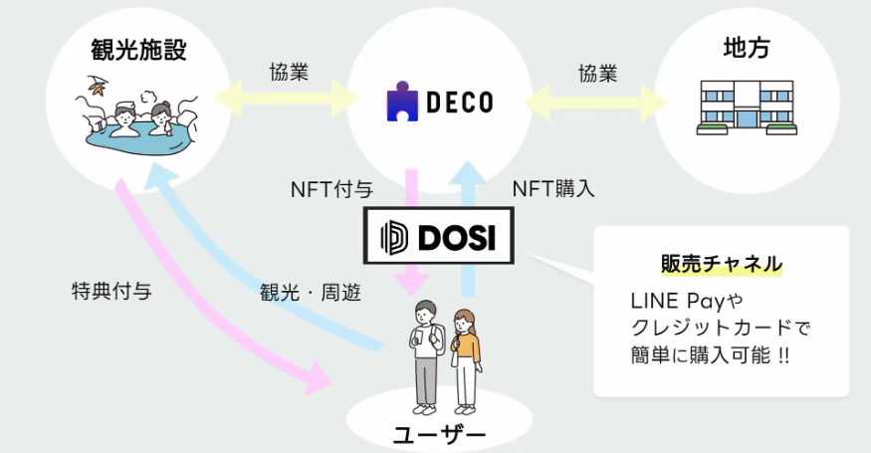
Ni afikun, apẹrẹ ti ohun kikọ ba awọn ohun kikọ mẹta ti o han ni awọn olokiki Japan Daa Project "Kagura".
Ti o ba fẹ mọ diẹ sii nipa Kagura tabi fun igba akọkọ, jọwọ wo nkan yii.
https://note.com/japandaosolution/n/na2004b0b81ab
https://note.com/japandaosolution/n/n14402a810a8e
Lẹhin ti ifowosowopo pẹlu ikaho lori ẹgbẹ irin ajo irin ajo
Ikaho Onsen jẹ ọkan ninu awọn aaye iwoye ti Japan pẹlu iraye to dara lati Ilu Iyipada oni-nọmba (DX), ati pe o dara fun igbega Wẹwa fun lilo nft.
Japan Dao ṣiṣẹ pẹlu Ikaho ti o wa lori irin-ajo irin ajo lati sọji agbegbe lati mu afilọ ti agbegbe naa pọsi.
Tẹ ibi fun iroyin X ti osise ti Shibkawa ikah lori ẹgbẹ irin ajo
https://twitter.com/ikahoonnsenn
Nipa Shibikawa / Ikaho Digital kaadi titari
Ibẹrẹ Tita: Satidee, Okudu 29, 2024 12:00
Ipari Tia: 12:00 Ọjọ Aarọ, Oṣu Kẹsan Ọjọ 30, 2024
Iye: $ 12 (nipa 1,900 yen)
Ikọkọ tita: Oja oniyi "dosi"
Awọn tita: Awọn ege 300 lopin
Apẹrẹ: Laigba ti a ta lati awọn oriṣi 3 ti awọn apẹẹrẹ (aaye kan pẹlu nọmba tẹlentẹle)
Tẹ ibi fun ọna asopọ ti oju-iwe rira
https://market.store.dosi.world/ja-JP/1st_sale/sales/40318/
Awọn ohun elo alabaṣepọ ati awọn anfani
Nipa fifihan awọn "Shibikawa Kaadi ẹgbẹ Digital", o le gba awọn anfani ni ọpọlọpọ awọn ohun elo ni agbegbe awọn idiyele, awọn ẹdinwo lori awọn idiyele gbigba, awọn ẹdinwo ati awọn ẹbun ni awọn ounjẹ.
Awọn ohun elo ajọṣepọ pẹlu Ikaho ryoko, yohji foripe free iranti, hara musiọmu arc, kafe, Ile itaja Gbogbogbo, ati awọn ohun elo iwẹ.
O le ṣayẹwo awọn alaye ti awọn anfani ati atokọ ti awọn ohun elo ajọṣepọ lati ọna asopọ ni isalẹ.
https://www.google.com/maps/d/edit?mid=1LINMrLa6cHlL1hEaEbnnWYt5NvWhCQo&usp=sharing
* Awọn anfani jẹ koko ọrọ si iyipada laisi akiyesi.
* Akoko lilo anfani ni a ṣeto fun Oṣu Keje ọjọ 15, 2024 si Oṣu kejila ọjọ 31, 2024.ne yoo fun ni lẹhin 2025.
* Awọn anfani le ṣee lo lẹẹkan fun apo kan lakoko akoko loke. Ohun kanna jẹ otitọ ti o ba ni awọn kaadi ẹgbẹ pupọ.
Bii o ṣe le lo "shibikawa / Ikaho ijẹrisi"
A ra "Shibikawa / Ikaho Ẹgbẹ ẹgbẹ ẹgbẹ" ni Dosi.
Ka koodu QR naa ti o fi sinu ile-iṣọpọ pẹlu foonu alagbeka rẹ.
Fipamọ iboju iboju foonu si oṣiṣẹ ohun elo.
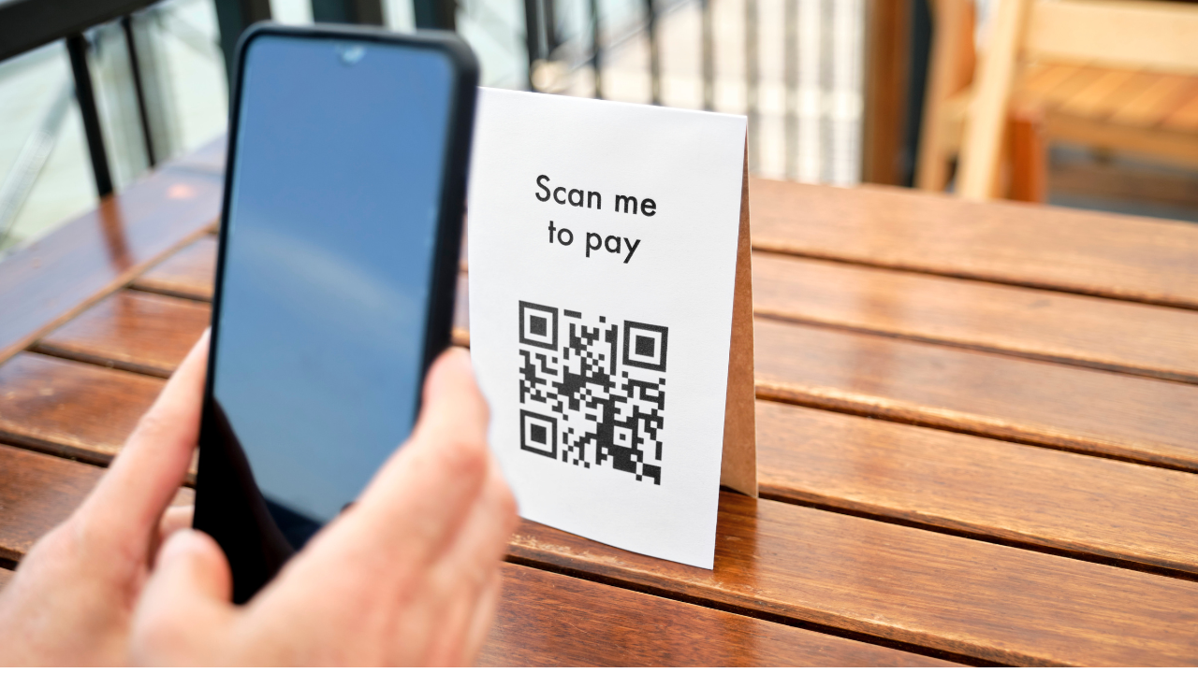
O le ni rọọrun gba awọn anfani!
Kini Prosi?
Dosi jẹ ọja ọjà agbaye ti o le ni irọrun iṣowo awọn ohun oni-nọmba to niyelori.
Rọrun lati wọle pẹlu akọọlẹ laini tabi akọọlẹ SNS
O le ra awọn ohun kan nipa lilo kaadi kirẹditi tabi isanwo laini
O le ṣe iṣowo kii ṣe ni Japan nikan ṣugbọn fun awọn burandi agbaye
Bi o ṣe le ṣii "Dosi"
https://dosi-jp.landpress.line.me/userguide_account
Bawo ni lati Ra NF
https://dosi-jp.landpress.line.me/userguide_purchase
New development of Amakomi (manga)
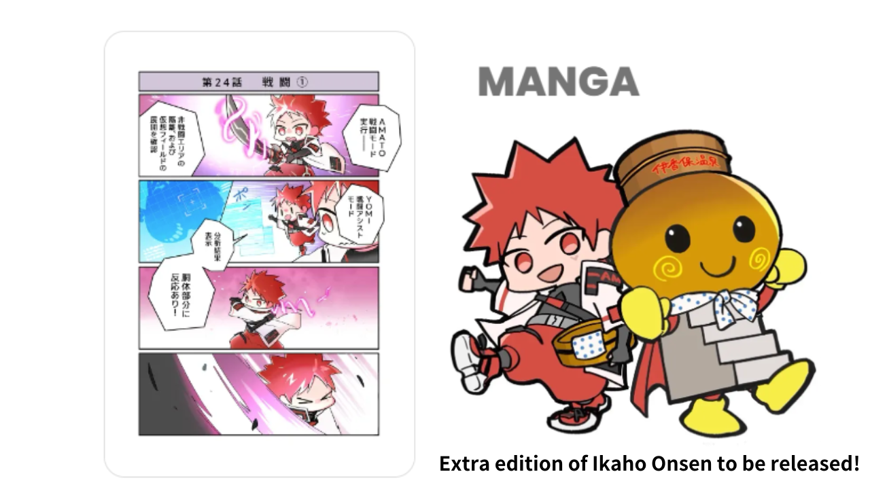
"IKAHO Onsen Onsen" yoo tu silẹ si Amakomi ninu lẹsẹsẹ!
"Amakomi" is a very popular four -frame manga series in June 2024, and has been serialized until Episode 26.
Ni Ikaho lori afikun ẹda, iwoye kan nibiti o le gbadun awọn erekusu Ilu ati awọn ohun elo orisun omi gbona yoo fa.
Manga ni akosile le wa ni ka fun ọfẹ lati ibi.
https://amato-official.com/manga
isọniṣoki
"Orile-ede Shibukawa / Ikaho oni-nọmba Voi. 1" NFA gba awọn anfani nikan ni awọn ohun elo arinrin-ajo ati tun gbadun apẹrẹ ẹda ti Japan Dao.
Ti ṣeto awọn tita lati bẹrẹ ni Oṣu Kẹsan Ọjọ 29, 2024, nitorinaa ṣayẹwo.
Ti o ba nifẹ si Japan Dao, jọwọ tẹle ati Ski fun "Kamana Kupan Dao".
AKIYESI X: https: //twitter.com/japonnfmuseum
Didflard osise: https://dissoft.com/invite/japondao

