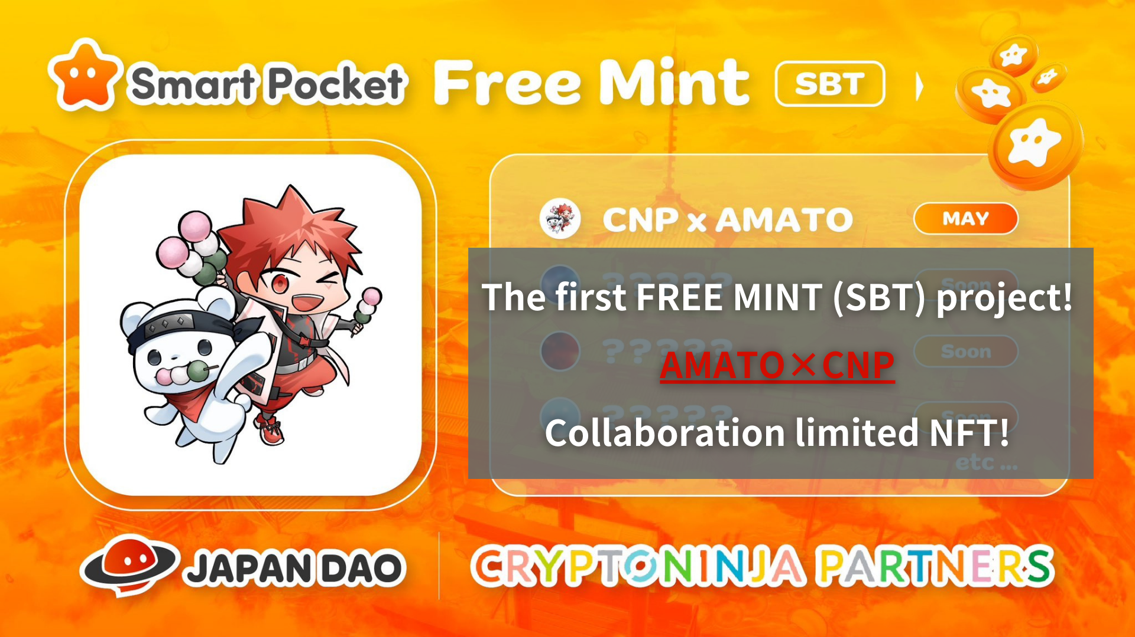
Mint Mint (SBT) iṣẹ akọkọ! Amato X CNP ifowosowopọ NFẸ NFẸ !! (Asọ nkan 5/19 23:59)
Kaabo, idile Dayo Japan yii!
O le ti rii tẹlẹ, ṣugbọn SBT ni akọkọ ti a ti kede.
Awọn ọna pupọ lo wa lati gba ẹrọ ifowosowopo lopin ati alaye ikoko ju apakan ojutu naa lọ.
Jọwọ ka nkan yii titi di opin ki o maṣe padanu gbogbo alaye!
Tẹ Tẹ ibi fun Awọn iroyin Big
Ile-iṣẹ Jamba NFA Japan yoo jẹ onigbọwọ osise ti Japan Change log_! Bẹrẹ ifowosowopo ti o lopin
https://twitter.com/japandaojp/status/1788083040377536639
Awọn akoko ph
https://prtimes.jp/main/html/rd/p/000000006.000134601.html
isọniṣoki
Awọn iroyin yii jẹ nipa Olumulo NFT ti Iṣẹ akanṣe NF "CNP (Cryptoninja Alafẹfẹ)" Ṣiṣẹ nipasẹ Gussisocional Ona, Amamo ati CNP Lopin Ijumọsọrọ pẹlu Iṣàn (Ọfẹ).
Pẹlupẹlu, ajọṣepọ yii ko ni opin si ifowosowopo, ati Japan Dao ti ṣiṣẹ pọ pẹlu CNP ati awọn aṣa oṣuwọn ti aṣa ti "aṣa Digital ti aṣa Japanese". A gbero.
Nipa CNP
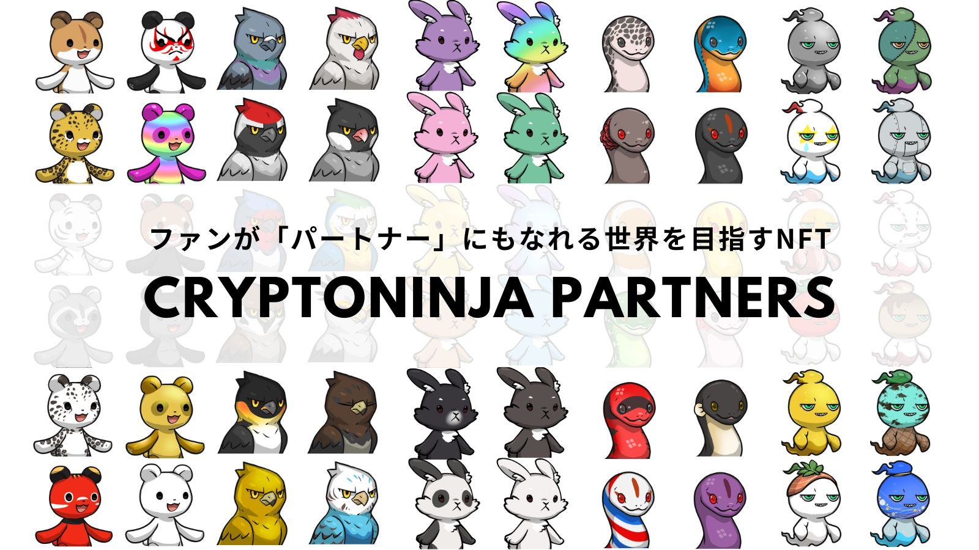
CNP (Cryptoninja) jẹ iṣẹ akanṣe ẹda pataki ti Cryptonja, ami ohun kikọ kan pẹlu ọdun 22,22, ati diẹ sii ju 5,300 ti ara CNP ti ara CNP.
CNP nfunni ni adehun igbeyawo si jinna nipasẹ "mọ, fọwọkan, ati iriri" ti isanwo owo-ori The Nettown ",Ati idagbasoke awọn oniwun NFT.
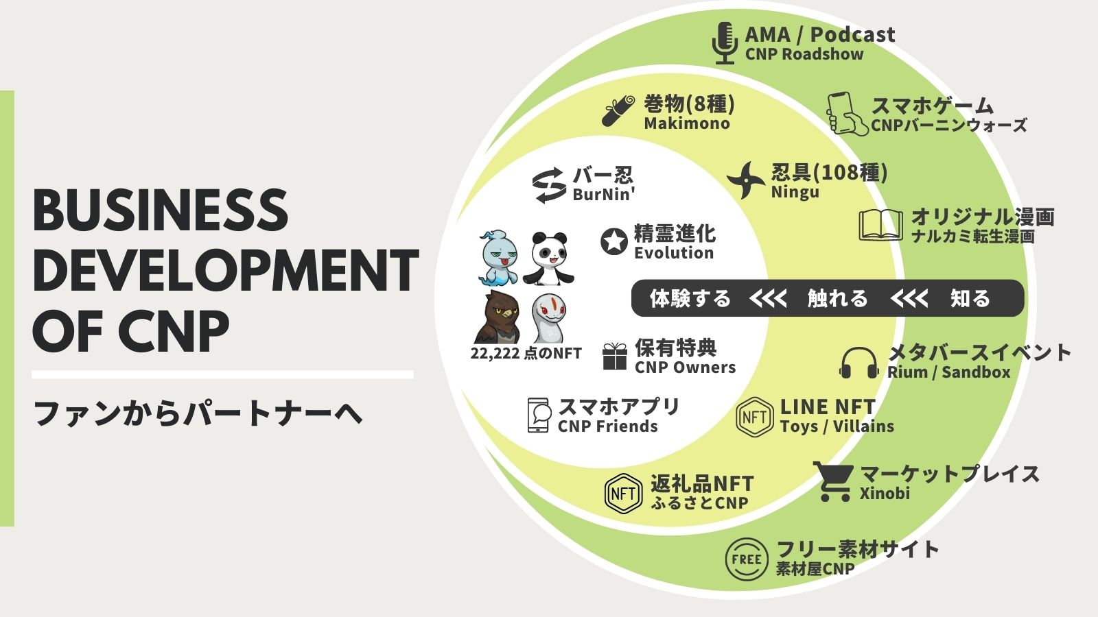
Oju opo wẹẹbu CNP
https://www.cryptoninja-partners.xyz/
Nipa Amamo
"Amamo" jẹ ami-kikọ ti ohun kikọ akọkọ ti Japan Dao ti Ilu Japan, ati pe o jẹ iṣẹ NFT lori akori nikanpupa ati funfun ti asia ti Japanese ti awọn asia ara ilu Japanese jẹ awọ nibi gbogbo, "paapaa fun apakan apakan," eyiti o jẹ ohun ija nlaDumplings, elegede, ọṣẹ awọn eekanna, ati wuyi.
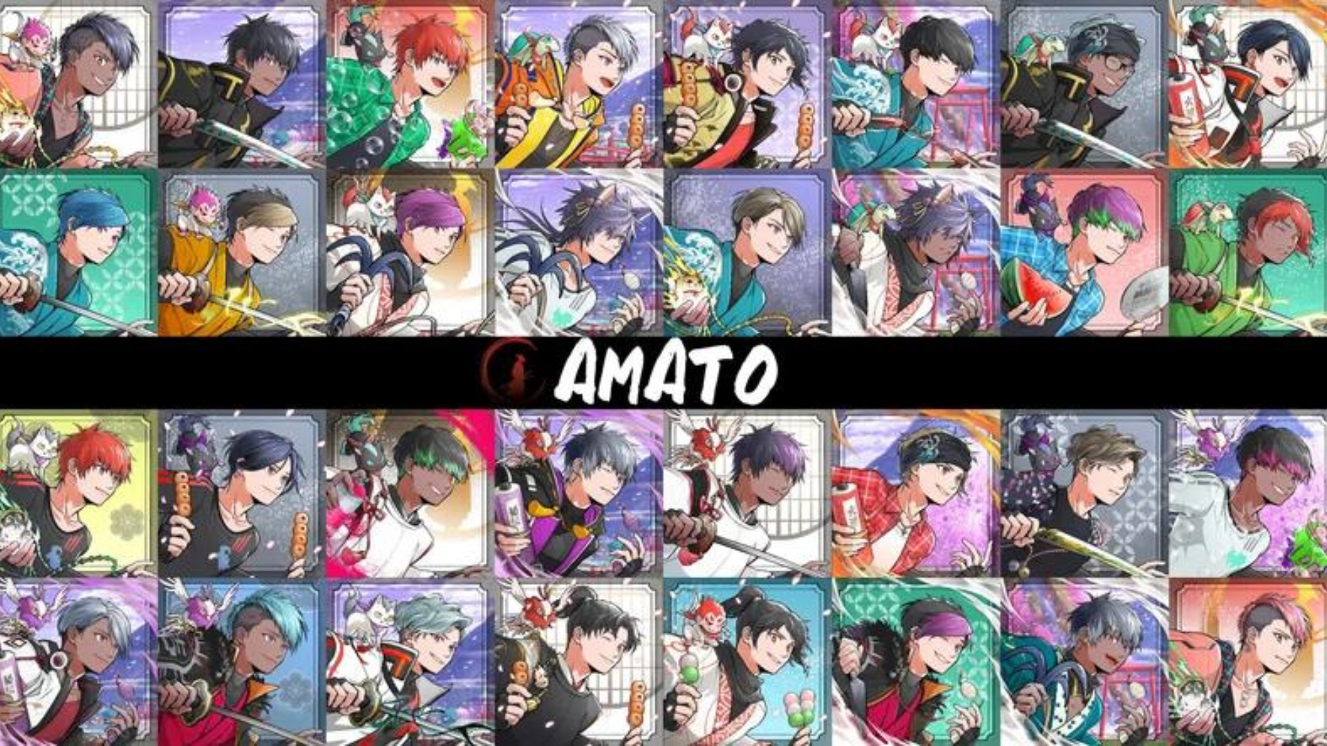
* Ti o ba fẹ mọ alaye diẹ sii nipa Amamo, jọwọ wo nkan alaye ti o pese nipasẹ Japan Dao.
Voll.1 "bibi Amanaa"
https://note.com/japandaosolution/n/n90351d7bb368
Vol.2 "Amaso lọwọlọwọ ati ọjọ iwaju"
https://note.com/japandaosolution/n/n02ce3453e5ba
Alaye NFT NFT
Akoko Igbanisiṣẹ (akoko ohun elo Preint)
2024/05/08 si 2024/05/19 23:59
Ọjọ Mint
Seto le 25, 2024
idiyele
Mint (ọfẹ)
ẹwọn
Polygon (SBB)
* SBT: Kò fi ben NFT ko le ta tabi gbe
Gaasi owo
ṣ'ofo
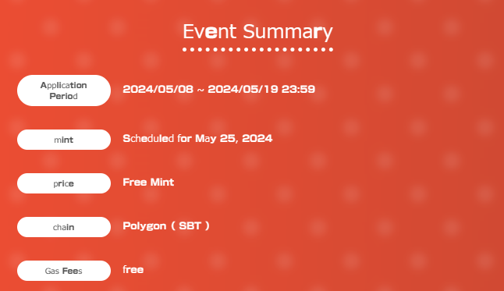
Ọna Ohun elo
1.Achices si aaye pataki
Aaye pataki naa jẹ lati ibi rẹ
https://japandao.jp/amato-cnp
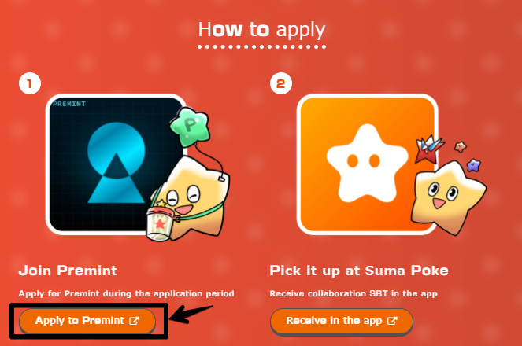
2.PREMINT ohun elo
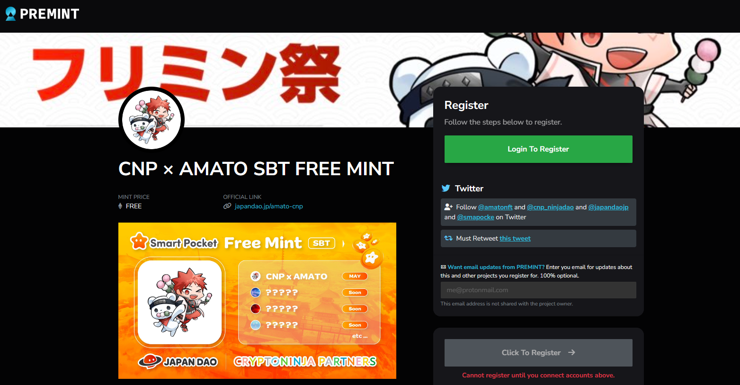
Ti o ko ba mọ bi o ṣe le lo fun akọmilẹ, jọwọ lo ọna asopọ ti o wa ni isalẹ, nitorinaa jọwọ lo.
https://note.com/japandaosolution/n/nd3b194382857
Alaye ikọkọ ti o wa lati apakan ojutu ❗
1. Gba gbogbo iru SBT ati pe o ni nkan ti o dara fun eniyan ??
Gẹgẹbi Pomu lati Daruman (@daruman_jp), o dabi pe o jẹ nkan pataki fun awọn ti o gba gbogbo ifowosowopo SBT.AT yoo tu awọn iṣẹ Mẹrin silẹ, gbogbo eyiti o le gbaOhun gbogbo!
https://t.co/UTUjvyMpES
2. Itan ifowosowopo iṣelọpọ
Awọn SBTIg n ṣe afihan lily Lily pẹlu STFIT Ninja lati "NAFT" CNP "ti ko ni idiIhuwasi ni CNP, ati pe o baamu pupọ pẹlu Amana-kuni, ti o wọ nilna.
Ni akoko yii, Ogbet Akitsu (@ Akitu08), ti o ṣiṣẹ lori "Amamo", wa ni idiyele.mr.Akitpu jẹ iṣẹ ifowosowopo iyanu laisi imọ ti concuggruty, mu iwa ti CNP sinu wiwo agbaye ti Amato pẹlu awọn ọgbọn giga giga rẹ.
Ni afikun, itan kan wa ti AkitU fẹran awọn ohun elo dumpling fun lilo awọn dumplings fun lilo awọn dumplings fun awọn apakan ni CNP ati awọn ikojọpọ NFT NFT.
isọniṣoki
Ninu nkan yii, a ṣafihan iṣẹ Mint Nint Nft Lopin nipasẹ Amana ati CNP, eyiti yoo waye lati ni iranti Japan Japan bi olutaja osise ti "CNP (Awọn alabaṣiṣẹpọ CRP (CRPRETNJA)".
O tun pẹlu Akopọ ti iṣẹlẹ naa, bawo ni lati ṣe alabapin, ati alaye pataki.St wa fun ọfẹ, nitorinaa rii daju lati gba gbogbo awọn oriṣi lori iṣẹlẹ yii.
Ti o ba ni awọn ibeere eyikeyi, jọwọ lero ọfẹ lati kan si wa lori ọrọìwòye tabi lori ikanni Japan dao.
Ti o ba nifẹ si Japan Dao, jọwọ tẹle ati Ski fun "Kamana Kupan Dao".
AKIYESI X: https: //twitter.com/japonnfmuseum
Didflard osise: https://dissoft.com/invite/japondao
Instagram osise: HTTPS: //www.instagram.com/japannkmuseum/

