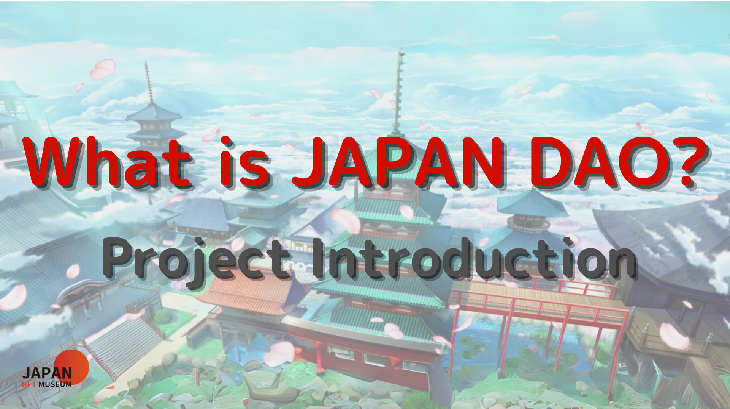
ENLE o gbogbo eniyan!
Kaabọ si iwe irohin Jer Japan.
Ninu nkan ti tẹlẹ, a ṣafihan imuṣiṣẹ metava ti Japan dao.Ti o ko ba ka o sibẹsibẹ, jọwọ gbadun isele 3rd
Nkan yii jẹ apakan kẹrin ti jara mẹrin -Part kan lati jinle agbaye Daa.Nibi, a ṣafihan iṣẹ-iṣẹ kọọkan ti Japan Dao.
Aaye ile-iṣẹ Japan Dao Rẹ VTPSPS://jappandao.jp/hp
Ifihan ti iṣẹ kọọkan
Japandao ni orisirisi ti awọn iṣẹ akanṣe, gẹgẹ bi "Amamo", eyiti o jẹ ero ti Sumrai ati "Nijii" ti o sọ aṣa ilu Japanese Akori aye. n dagbasoke.Ni afikun si awọn wọnyi, awọn iṣẹ-rere ti o wuyi wa, ọkọọkan eyiti o ni oju-iwe tirẹ ti ara rẹ nipasẹ iwara, manga, orin ati awọn ere ati awọn ere.
Lati akoko yii, a yoo ṣafihan awọn iṣẹ wọnyi ati awọn ipilẹṣẹ akiyesi miiran.
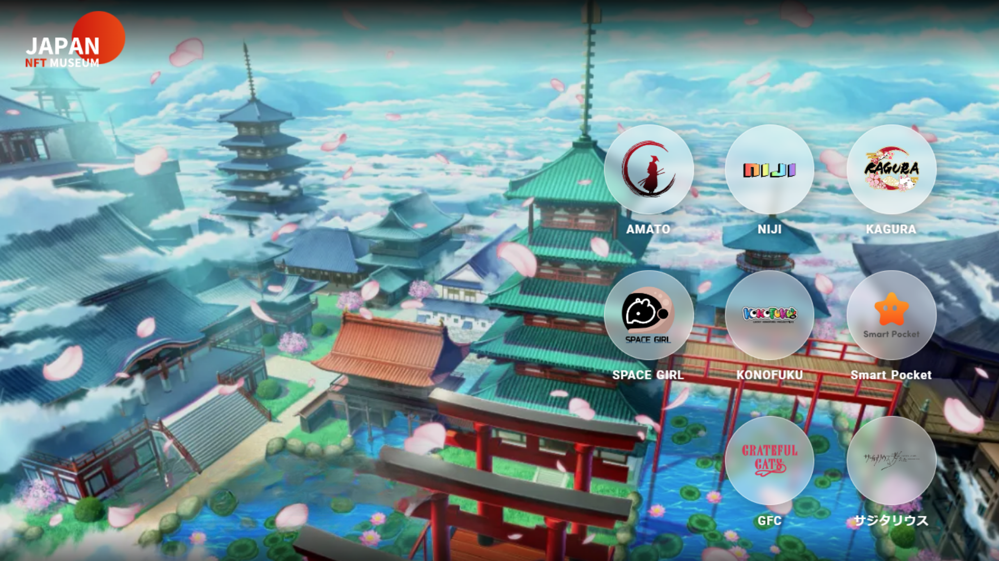
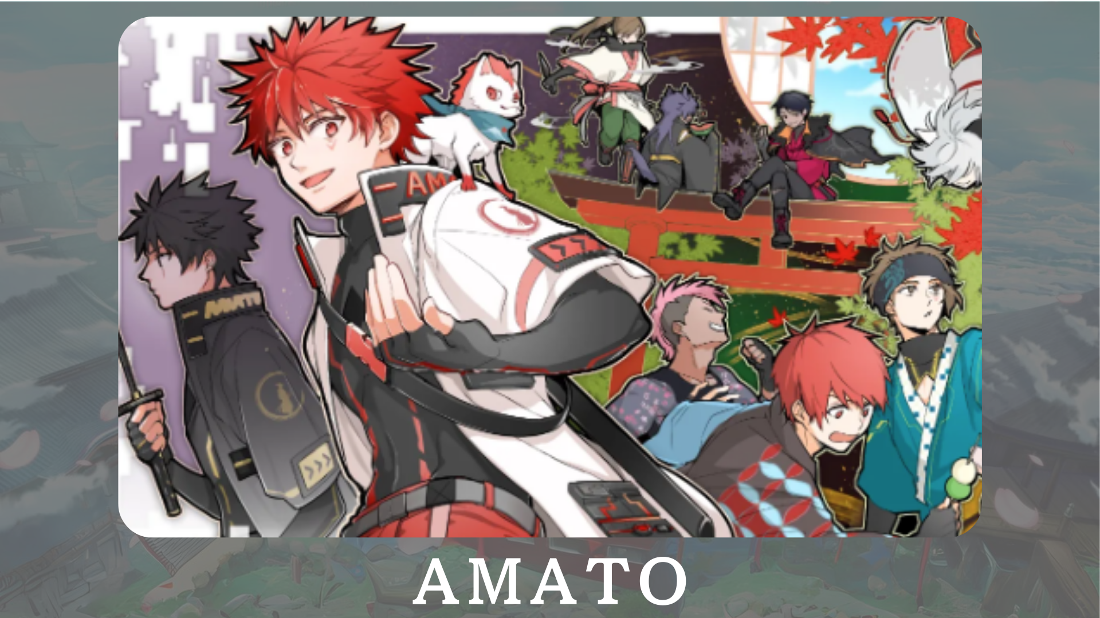
"Amato" jẹ ohun kikọ Japano ti o da lori Samurai.O ṣepọ pupa ati funfun, awọ Japanese ibile, si agbaye ni ifaya ti aṣa Japanese.Labẹ idagbasoke ninu manga "Amakomi".Ni afikun, idagbasoke ti awọn ere ori ayelujara ti a pe ni "Amamo ni Fortnite" ti wa ni Amẹrika, ni ero lati faagun awọn alaifẹfẹ fẹ.
Oju opo osise: HTTPS: //amato-official.com/
Account X ti Osise: HTTPS: //twitter.com/amadonft
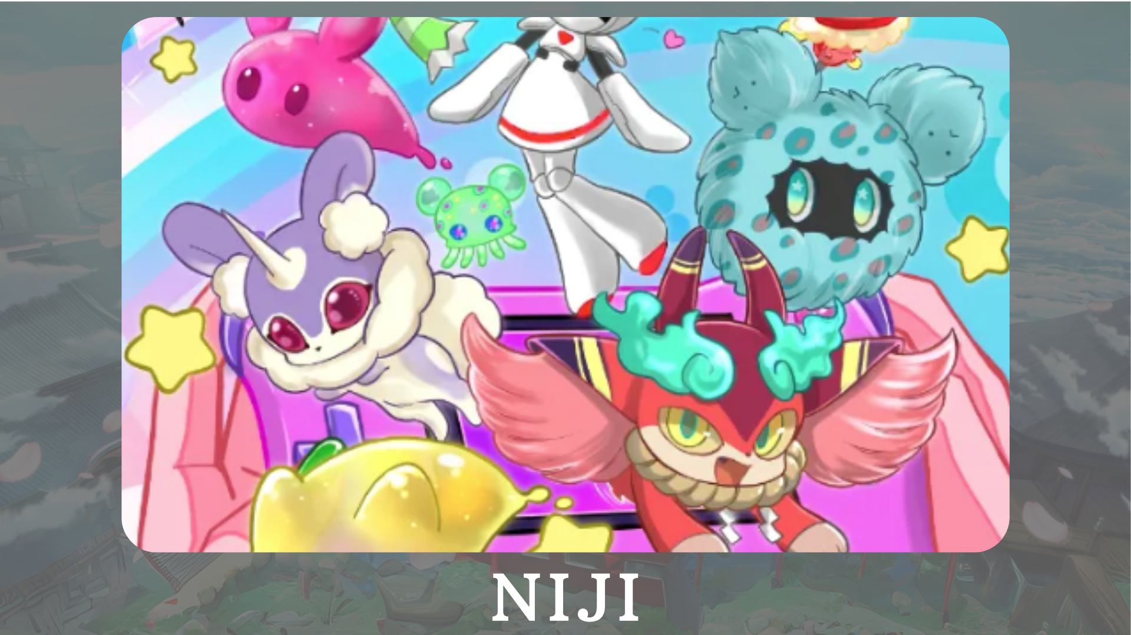
"Nijie" jẹ iṣẹ akanṣe lori akori ti kikun agbaye pẹlu ọpọlọpọ awọn awọ.Awọn ifihan awọn ohun kikọ silẹ ninu manga "Ni ajikomi" ati "awọn ọrẹ Awọn ọrẹ Awọn ọrẹ Awọn ọrẹ", ati awọn ọrẹ ti awọn ọrẹ ", eyiti o ṣe awọn ohun kikọ silẹ, ti nlọ lọwọ.
Oju opo osise: HTTPS: //japfmuseum.com/niji
Account X ti Osise: HTTPS: //twitter.com/nijafrist
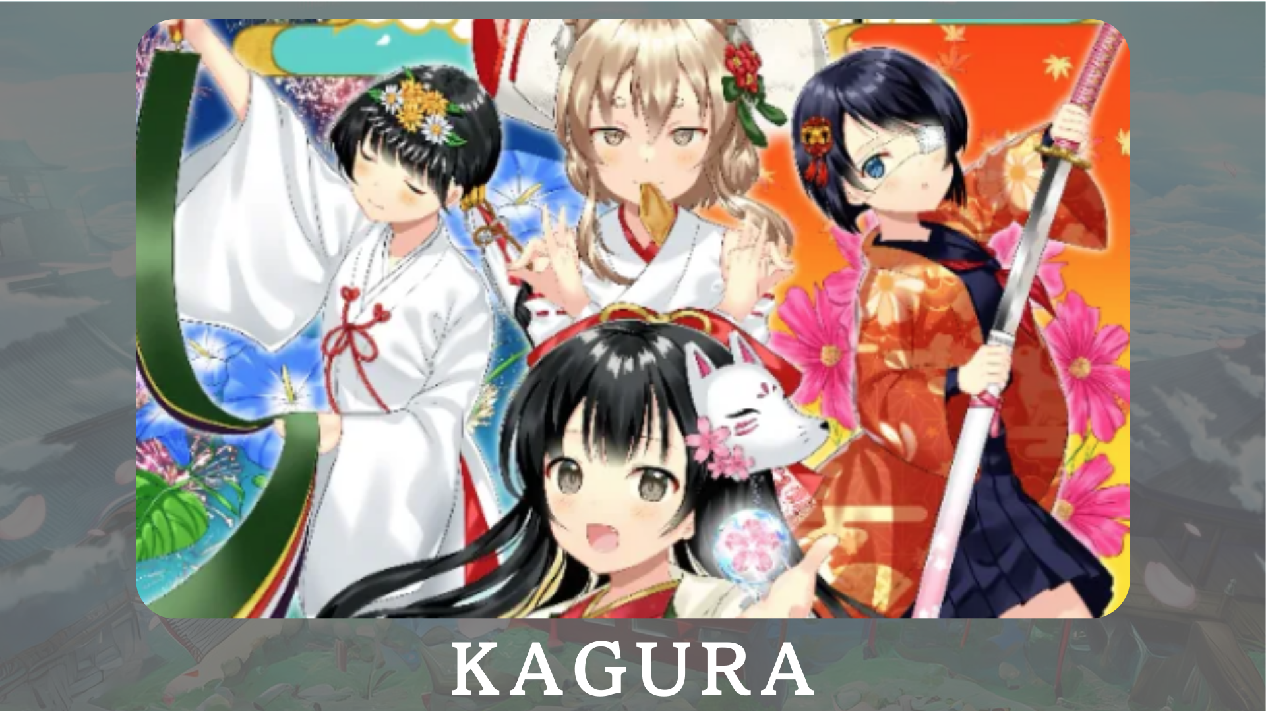
"Kagura" ni Ile-iṣẹ Alakoso Japanese ti Japandao ni ero ni sisọ aṣa Japanese si agbaye.Nipasẹ nadshilo gakuen ti "kọ ẹkọ Club Japanese Club", a n ṣafihan Karatigiri kagba Koringkomi, Manga ṣafihan aṣa ara ilu Jade Jade Jages.
Oju opo osise: HTTPS: //japannfmuseum.com/kagura
AKIYESI X: https: //twitter.com/kagurajpn
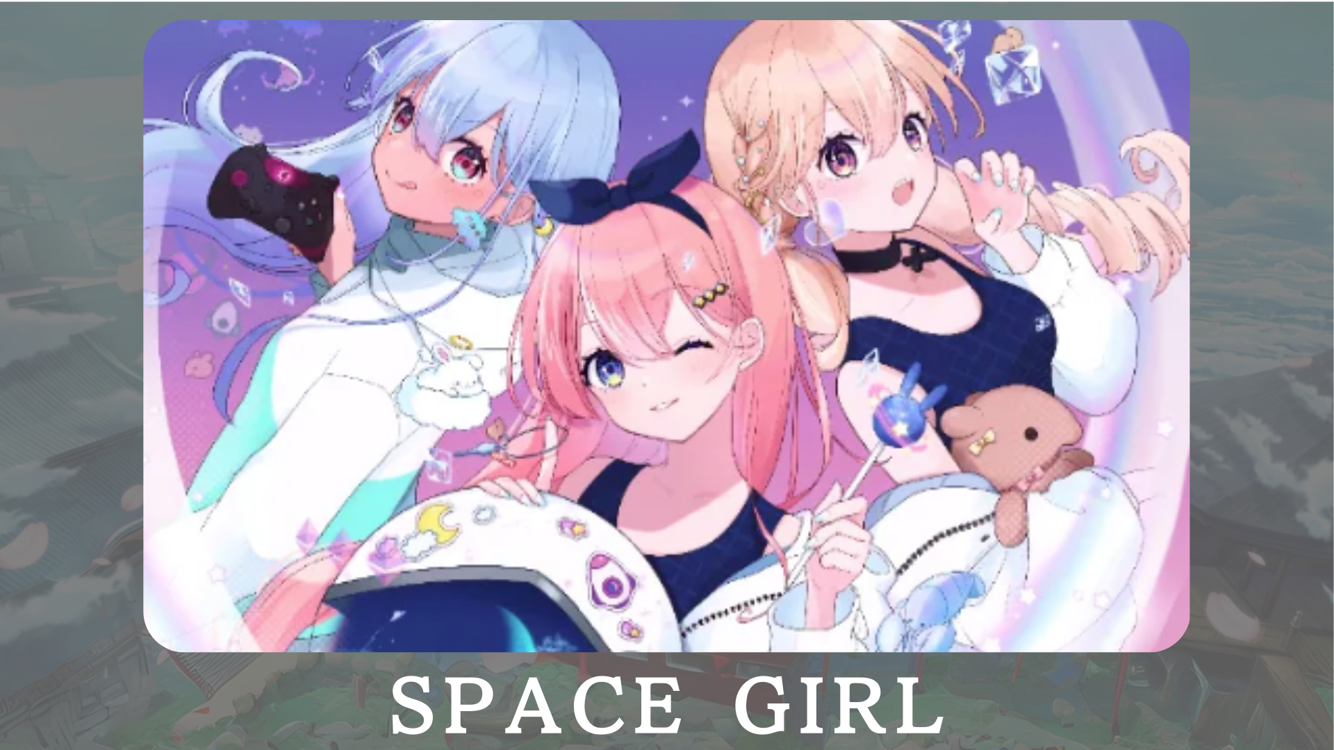
"Ọmọbinrin aaye" jẹ iṣẹ-ṣiṣe ti awọn aaye-aye, ati Eleda "Kin ko ni fifi ifẹ jinlẹ ti Agbaye nipasẹ NFF.Idi naa ni lati pin ife gidigidi fun Agbaye ki o pin pẹlu ọpọlọpọ eniyan.Ni ọjọ iwaju, a gbero lati pese awọn ohun kikọ si Vtuber ati awọn ere, eyiti yoo faagun afilọ siwajuọ siwaju sii.
Oju opo osise: HTTPS: //japannfmuseum.com/spacegil
AKIYESI X: HTTPS: //twitter.com/spacegilb
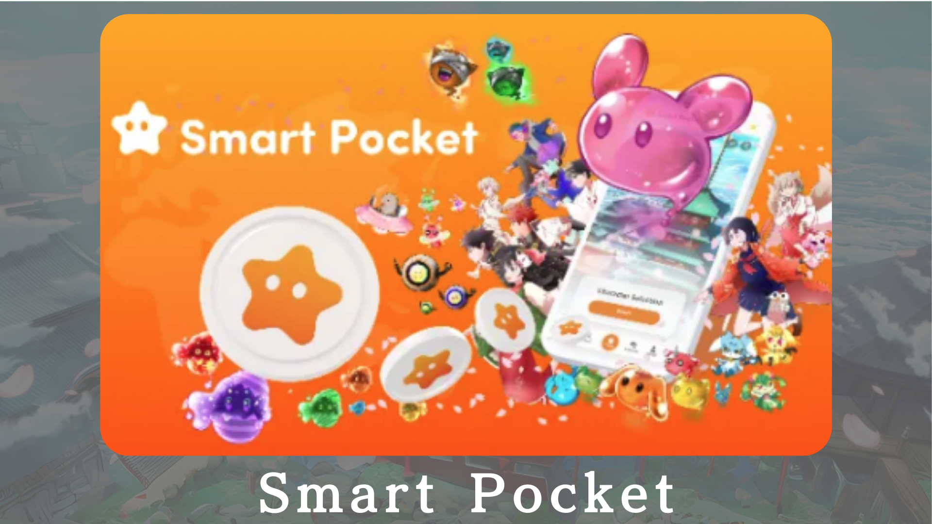
"Apoti Smart" jẹ ipin-kan ipo-si -Ar-ba fun awọn olumulo laaye lati jo'gun awọn aaye nipasẹ awọn iṣẹlẹ nft nft.Ojuami wọnyi le paarọ fun SMIMO OJU SAM, ati pe o le gba awọn àmi nipa didimu ibi-afẹde.Ni afikun, o jẹ eto iṣọtẹ ti o fun ọ laaye lati mu awọn aaye pọ nipasẹ kopa ninu awọn iṣẹlẹ iṣẹ-ṣiṣe ati rira ati ta nft.
Oju opo osise: HTTPS: //Smapacket.com/jp
Account X ti Osise: HTTPS: //twitter.com/scapottacket
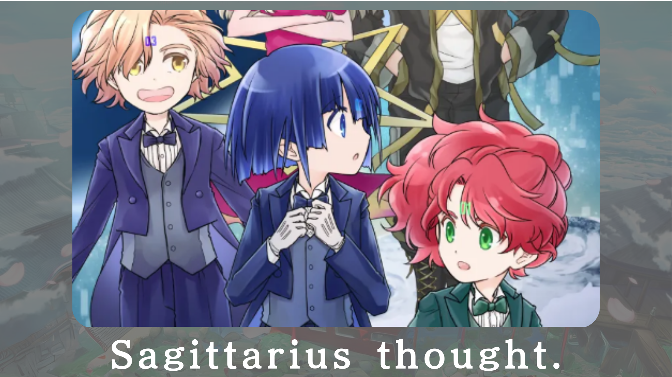
"Mo ro ti sagarius-" jẹ iṣẹ itan imọ-jinlẹ imọ-jinlẹ ti o ṣafihan awọn ọjọ fifa lori ọkọ ofurufu-ilẹ nla, ọjọ iwaju ti o jinna.Ni ọjọ iwaju, awọn kikọ yoo ta bi nft.
Oju opo osise: HTTPS: //sagitracuusthouthout.com/
AKIYESI X: HTTPS: //twitter.com/sagittariuip? S = 21
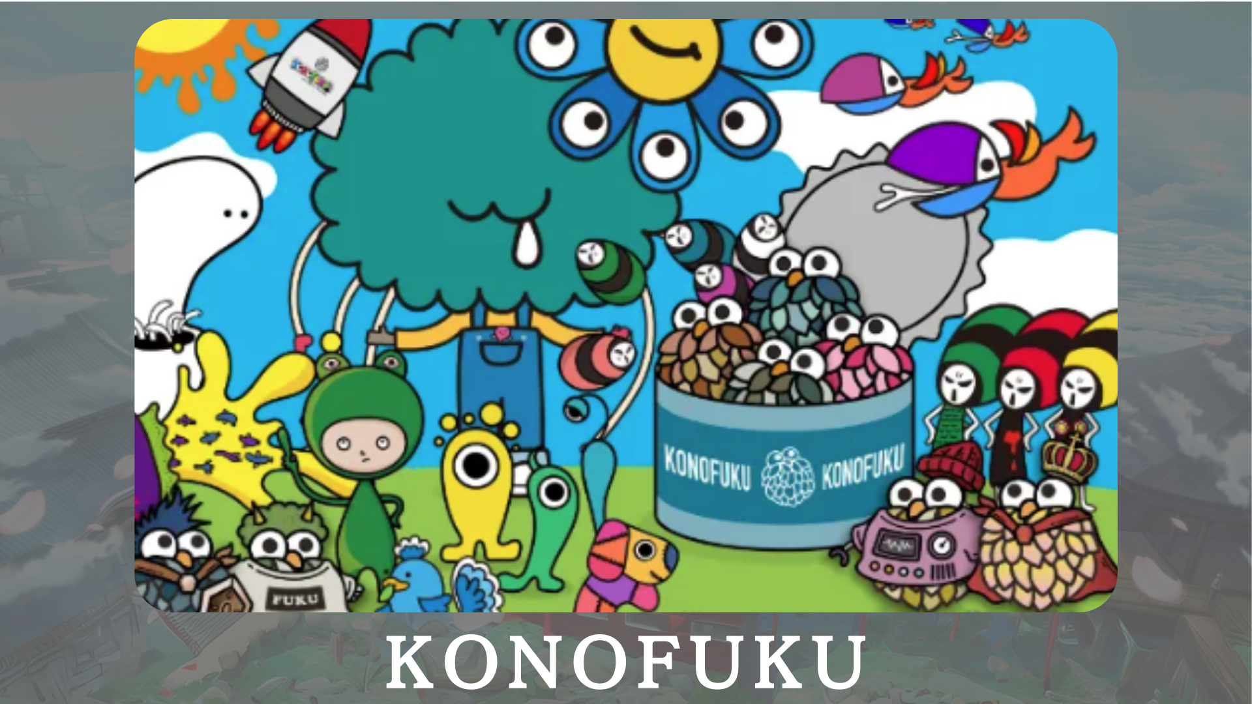
"Konofuko" ni idagbasoke nipataki lori awọn ohun kikọ ti o dara ti o gbe orire to dara.Awọn olumulo le yan awọ imularada ti o baamu fun ọ.Awọn ohun kikọ ti ara ẹni firanṣẹ ayọ lori ipilẹ ojoojumọ.
Oju opo osise: HTTPS: //lucky-art.net/
AKIYESI X: https: //twitter.com/lucky_Sunrise8
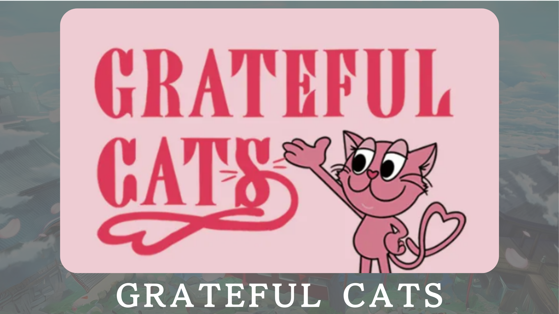
"Awọn ologbo nla" jẹ iṣẹ akanṣe ti o nlo imọ-ẹrọ ar lojojumọ.Awọn ohun kikọ nigbagbogbo n rẹrin musẹ nigbagbogbo ati kọ ẹkọ pataki ti o ni idiyele idunnu kekere.Pẹlú pẹlu awọn ologbo ọpẹ, o ṣeun fun ayọ ti o lero ninu igbesi aye rẹ ojoojumọ ki o pin awọn ikunsinu rẹ.
Oju opo osise: HTTPS: //japondao.jp/gfc
Account X ti Osise: HTTPS: //twitter.com/Gorvecatpats
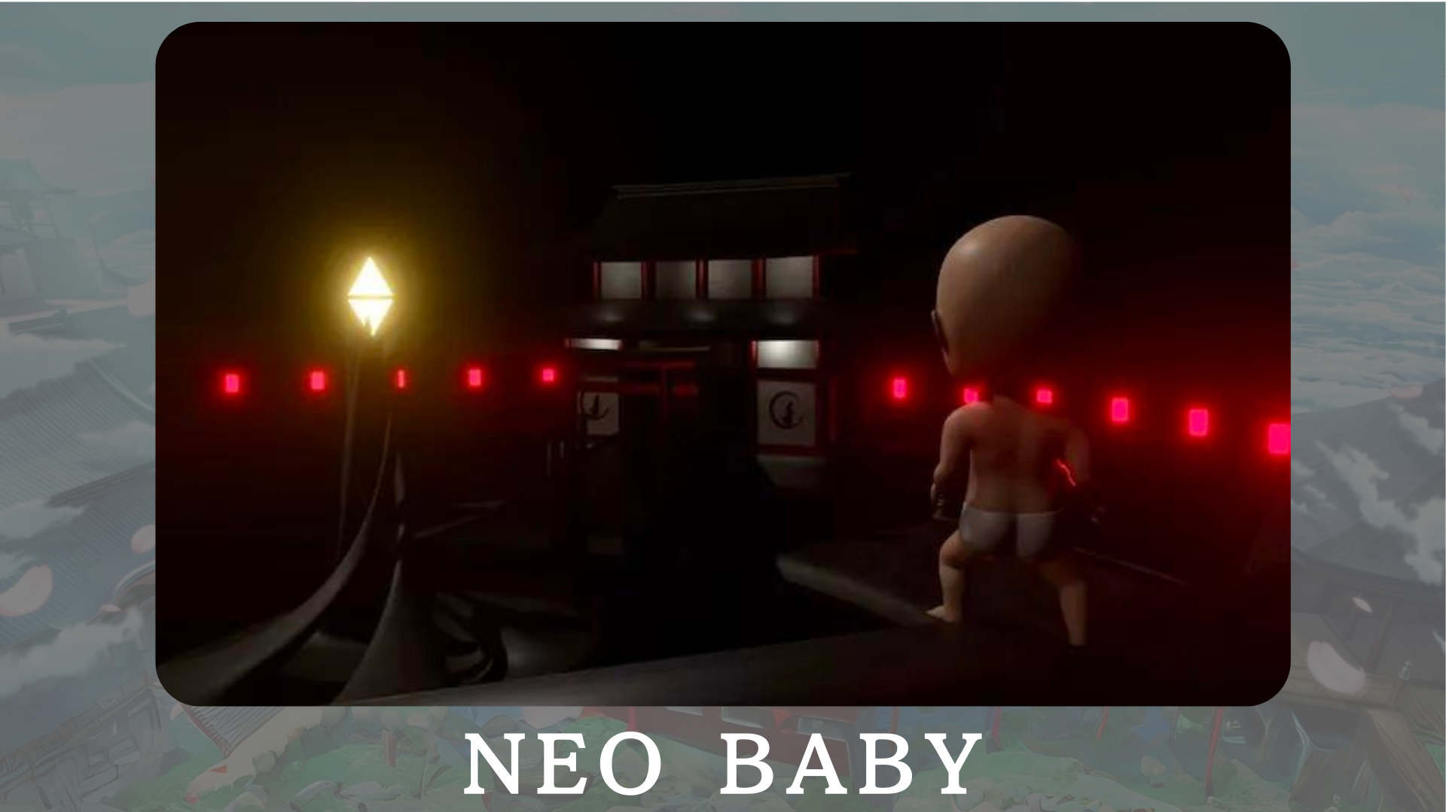
"Neo ọmọ" ni gbigba 3DNICTOT TOWỌ pẹlu akori ti awọn ọmọ-ọwọ lati akoko tuntun.Labẹ awọn Slogan ti "seese ni ailopin," A ṣe ifọkansi lati gba agbara ati igboya si agbaye.
Oju opo osise: HTTPS: //japannfmuseum.com/neobaby
Account X ti Osise: HTTPS: //twitter.com/neoBabyby
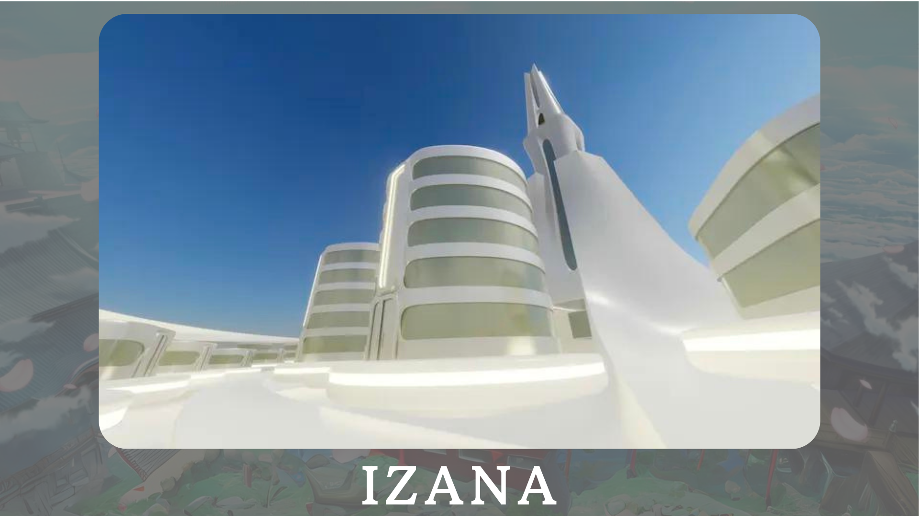
"Izana" ti gbero bi ilu nibiti ọpọlọpọ awọn ilu nft, ati awọn ile-iṣẹ NF, ati awọn ọfiisi NFT pe, nipataki ni Ile-iṣọ JAA.Ni afikun, awọn iṣẹlẹ ati awọn ifihan ti o faagun agbara awọn metaveers ti wa ni ngbero.
Oju opo osise: HTTPS: //japonanfmuseum.com/zana
isọniṣoki
Ni iwe irohin Japandao yii, a ṣafihan ọpọlọpọ awọn iṣẹ idagbasoke nipasẹ Japan dao.Ni iṣẹlẹ yii, Emi yoo fẹ ki o ṣe igbesẹ sinu ọkan ninu awọn iṣẹ-ṣiṣe Dao ti Japan ati iriri ifaya taara.Awọn awari tuntun n duro de ọ nipasẹ iwara, mango, orin, ati awọn ere.
Iwe irohin Japan Dao yoo ṣafihan alaye titun lori Japan Dao ati alaye alaye lori awọn iṣẹ akanṣe.Ti o ba nifẹ si Japan Dao, jọwọ tẹle akọọlẹ X osise pẹlu "Magnazine ti Japan".
AKIYESI X: https: //twitter.com/japonnfmuseum
Didflard osise: https://dissoft.com/invite/japondao
Instagram osise: HTTPS: //www.instagram.com/japannkmuseum/

