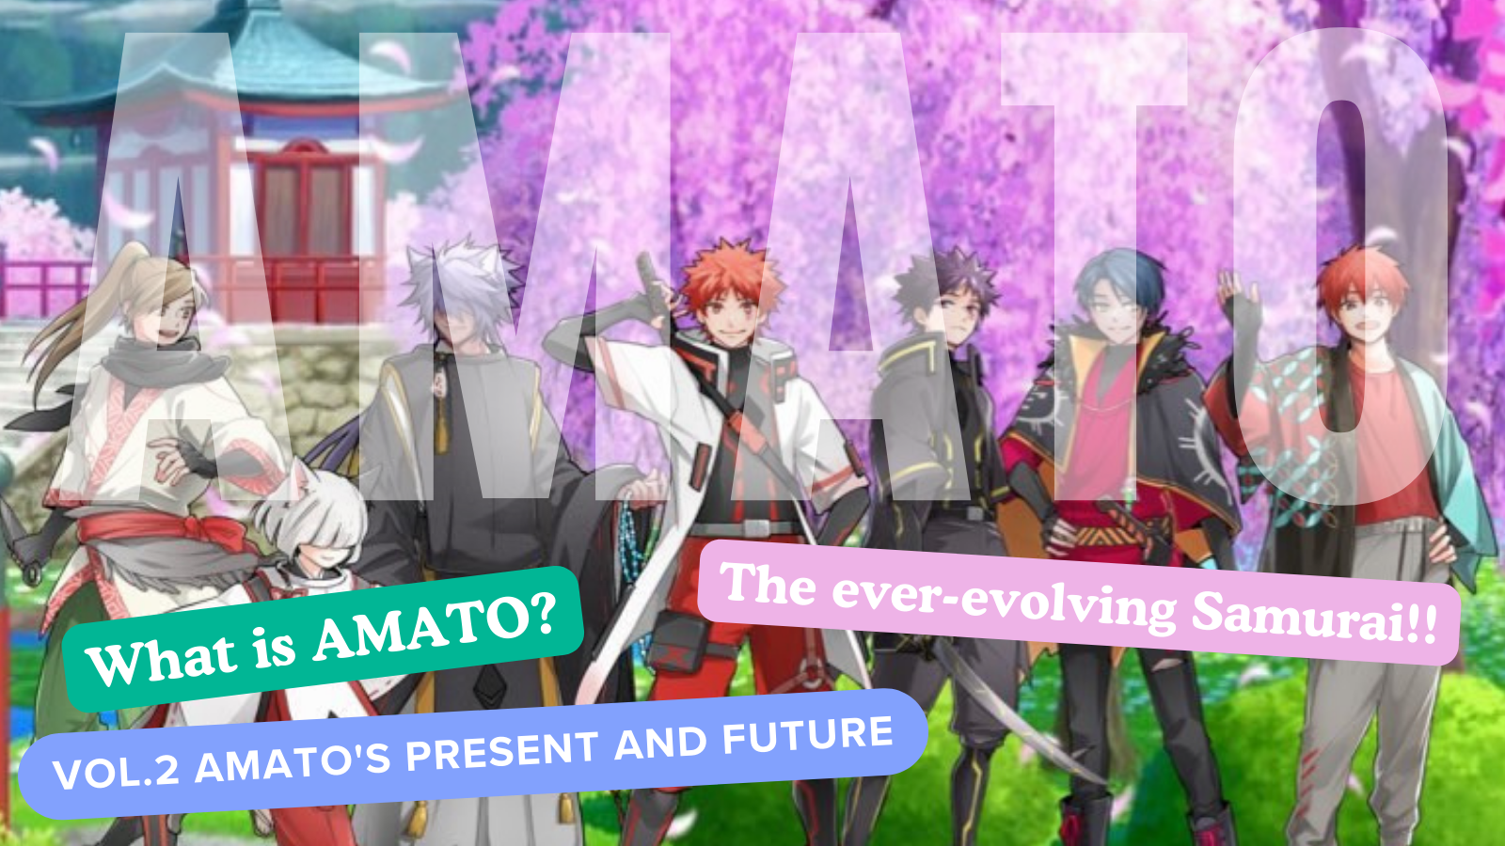
Kini amato?Vol.2 "Amaso lọwọlọwọ ati ọjọ iwaju"
Hello idile Japan dao ☆
Ninu nkan yii, tẹle ibimọ Amato nft, ipo lọwọlọwọ ti "Amava", eyiti o ti wa sinu akoonu pupọ, gẹgẹ bi "manga", "awọn ere", " , ati IP siwaju siwaju. Emi yoo tun ka ojo iwaju ti "Amamo" ibiti mo ti tẹsiwaju.
Jọwọ ya wo si opin!
* "Kini amato?Ti o ko ba ka ibi ti Vol.1 Amamo, Emi yoo dupe ti o ba le rii lati ọna asopọ ni isalẹ.
Ọna asopọ irohin Jer Japan
"Kini amato?Vol. Ibibi Amato "
aaye osise
https://amato-official.com/
Ṣii okun
https://opensea.io/collection/amato-official
X (Twitter)
https://twitter.com/amatonft
Manga (apanilerin)
Manga mẹrin -Frame "Amakomi" pẹlu ori ti Ẹka Oloona nmọlẹ
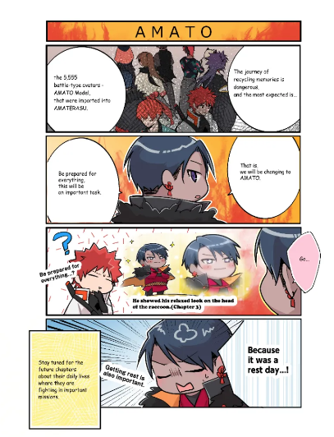
Ọkan ninu akoonu pataki julọ ti ise agbese Amato ni manga "Amakomi".
Awọn jara ti awọn ẹgbin mẹrin-sificme, eyiti o bẹrẹ X (Twitter) ni Oṣu Kẹwa 2022, ti jẹ sealized titi di Oṣu Kẹrin 2024 ati titi di Episode 2024 ati titi di Episode 2024 ati titi di Episode 2024 ati titi di Episode Ọjọ 2224 ati titi di Episode 2024 ati titi di Episode Ọjọ 2224 ati titi di Episode 2024 ati titi di Episode 2024 ati titi di Episode 2024 ati titi di Ede
Awọn iwe osise ti ni iriri n ṣe iṣelọpọ pẹlu gbogbo awọn agbara wọn, nipataki nipasẹ olootu -in -CH -Nikọ ti omi-omi -, ni Ẹka Kristian Ilu Java.
Awọn akoonu ti wa ni satunkọ ni abẹlẹ ti itan "Itan Amara" ṣẹda ni iru ikopa ti agbegbe, ati pe o jẹ iṣẹ ọlọ ati igbadun pẹlu aaye ti itan naa.
O ti ni imudojuiwọn lẹẹkan tabi lẹmeji oṣu kan lẹẹkọọkan pẹlu ohun kikọ ti ohun kikọ miiran ti ohun ẹda (imudojuiwọn Tuesday).
Lati ọna asopọ ni isalẹ, o le ka gbogbo awọn itan papọ, nitorinaa jọwọ wo ♪
https://twitter.com/amatonft/status/1584864119383281665?ref_src=twsrc%5Etfw%7Ctwcamp%5Etweetembed%7Ctwterm%5E1584864119383281665%7Ctwgr%5Ec3f5998cec022928a3538af58bcae928245143c9%7Ctwcon%5Es1_&ref_url=https%3A%2F%2Fnote.com%2Fpreview%2Fnae2486489acd%3Fprev_access_key%3D88099127a8c630e0627bfeada77f60f9
Amassomi
https://amato-official.com/manga
Orin (orin)
A bi Fi orin akọkọ AMATO ni a bi!!Orukọ naa "Amava"
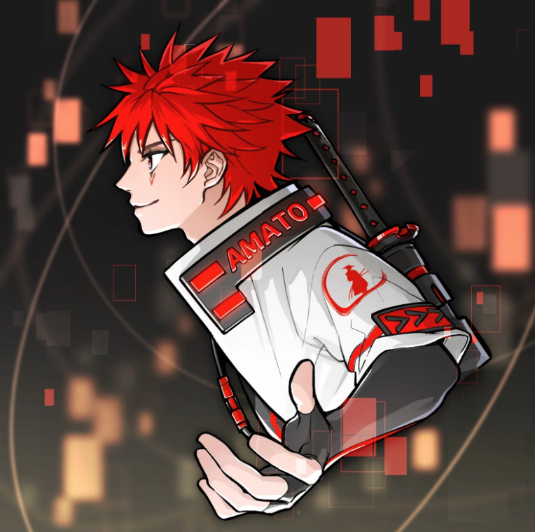
Nomaku (@Nomakugo)
Orin Akori Amamo "Amaro" amato "ni a kede tẹlẹ pe idasilẹ Amamo (nft), ati pe o ti wa ni ibamu lati ọjọ yii.
Iṣelọpọ ati orin awọn orin wa ni idiyele Noomakuun (Orukọ olorin: Sho -go), Ile-ọwẹ ti Ile-iṣẹ ti Ile ọnọ NF.Ni afikun si iṣelọpọ ati iṣẹ ti gbigba NFF atilẹba, o jẹ Ẹlẹda ti o dara julọ ti o ti n n ṣiṣẹ lori awọn ere, iṣelọpọ Orin, ati awọn akọrin.
A ti pin aaye Akori "Amato" lori ọpọlọpọ awọn iru ẹrọ orin, pẹlu orin Apple, ati pe o ti fa iyin giga ati akiyesi.Lati inu omi ti o dara ti itọwo Japanese, rilara ti sprinting ati agbara ti o ni imọlara ati pe o jẹ orin ti o ni itura pupọ.Lati ọpọlọpọ awọn ifihan Japanese ti o lẹwa ti o le fojuinu SAMURARIYU, ati pe o le lero wiwo agbaye ni kikun ti Amamo.
Lati ọna asopọ ni isalẹ, o le tẹtisi "Amamo" lori orin Apple, nitorinaa jọwọ gbọ tirẹ ♪
https://twitter.com/amatonft/status/1542814937944170497?ref_src=twsrc%5Etfw%7Ctwcamp%5Etweetembed%7Ctwterm%5E1542814937944170497%7Ctwgr%5Ec3f5998cec022928a3538af58bcae928245143c9%7Ctwcon%5Es1_&ref_url=https%3A%2F%2Fnote.com%2Fpreview%2Fnae2486489acd%3Fprev_access_key%3D88099127a8c630e0627bfeada77f60f9
Ọna asopọ orin Apple
https://music.apple.com/jp/album/amato-single/1633233894
Gbigba ọna asopọ asopọ nomakuku
https://t.co/fml5dbjbby2u
Ere
"Amato" kopa ninu Fortnite Tani o fẹran gbogbo eniyan.
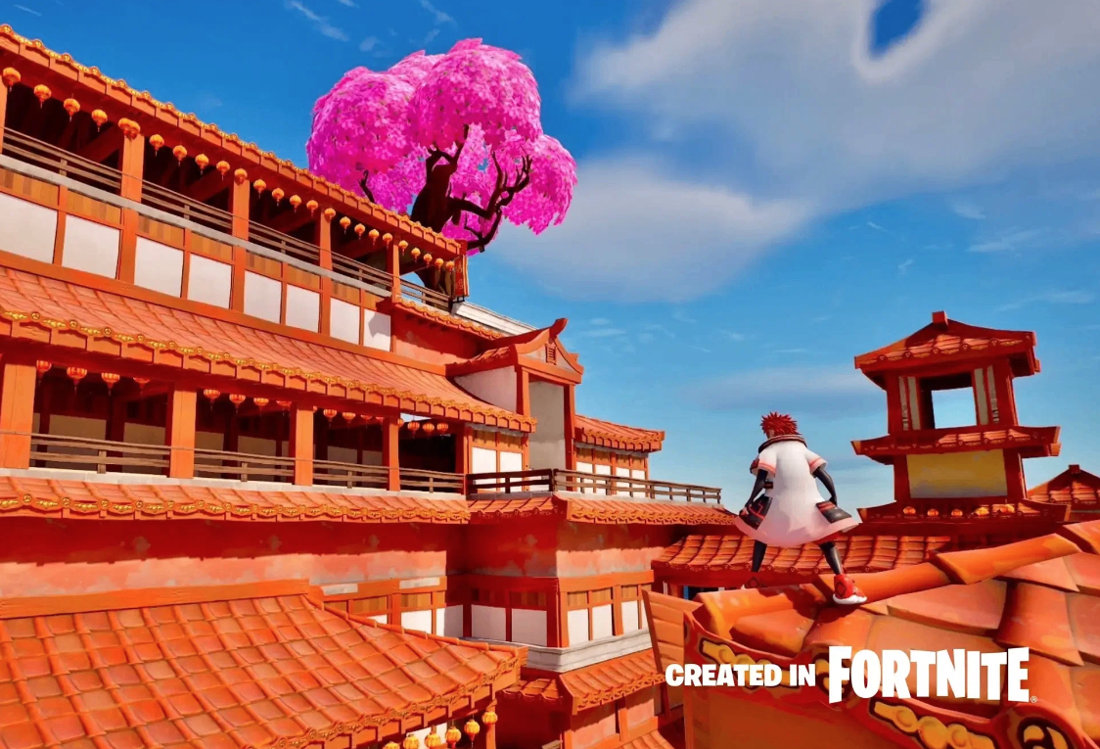
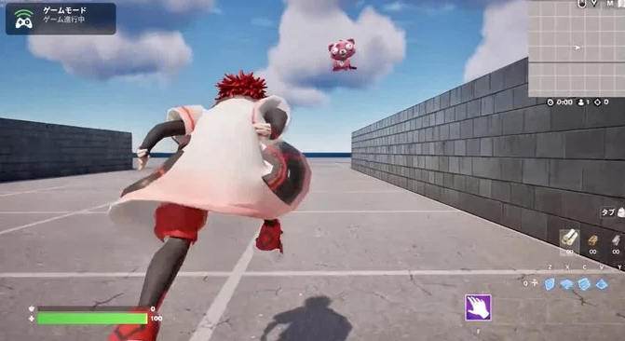
Tialeselealaini lati sọ, "Fortnite" ni ere ori ayelujara ti o tobi julọ ni agbaye pẹlu diẹ sii ju awọn olumulo 500 milionu ni agbaye.Ni afikun si awọn kọmputa ti ara ẹni, o ṣe atilẹyin ọpọlọpọ awọn iwọn ere ere ti ile bii yipada Nintendo, fifa awọn iran.
Ni Oṣu Kẹjọ Ọjọ 31, Idajirun diẹ sii lati PR akoko (atẹjade), ati ni apapọ pẹlu itusilẹ aworan ti o ", Ere-ọrọ" Awọn ere Demorio "Japan . Ati pe ikede iyalẹnu ti idagbasoke ti idagbasoke ere ori ayelujara.Inu won ni inudidun nipasẹ ikede yii, eyiti a ko nireti.
Ilana jẹ bi atẹle
Ona abatar ti "Amamo" ni "Fortnite".Awọn ohun kikọ IP alailẹgbẹ ti wọ ere ere ori ayelujara ti o tobi julọ ni agbaye.
Ni afikun si awọn kọnputa ti ara ẹni, o tun le ṣe atilẹyin gbogbo awọn iwọn ere ile bii PS5, yipada Nintendo, ati Xbox.
. Nipa ifowosowo pọ pẹlu awọn olupilẹṣẹ nipa lilo IP ti ara rẹ, iyara iyara agbaye ti ẹda Japanese.
Fi idi mulẹ musiọmu NFA Japan ninu ere ere ayelujara ti o dara julọ ni agbaye ati fi iṣẹ ti awọn oju-iwe arabinrin Japanese si agbaye.
Wo ọna asopọ ti awọn akoko pr ni isalẹ fun awọn alaye.
Biotilẹjẹpe o tun wa ni idagbasoke ati ọpọlọpọ awọn aaye aimọ o wa, eyiti o jẹ ohun ti o wa ni ṣiṣi ati orisun omi Meta ti o tobi julọ, eyiti o sunmọ awọn olumulo bilionu 10 ni ọjọ iwaju.Pataki ti "Amamo" ti nwọle nibẹ ni ifarahan.O jẹ idanimọ bi iP agbaye, bii "nkan kan" ati "Ball Ball Ball", ati fojuinu ọla ti o nifẹ si agbaye.
https://twitter.com/yudajapandao/status/1697027208802615597?ref_src=twsrc%5Etfw%7Ctwcamp%5Etweetembed%7Ctwterm%5E1697027208802615597%7Ctwgr%5Ec3f5998cec022928a3538af58bcae928245143c9%7Ctwcon%5Es1_&ref_url=https%3A%2F%2Fnote.com%2Fpreview%2Fnae2486489acd%3Fprev_access_key%3D88099127a8c630e0627bfeada77f60f9
Awọn akoko ph
https://prtimes.jp/main/html/rd/p/000000003.000127669.html
Ọna asopọ Fortnite
https://www.fortnite.com/
Ohun idaraya
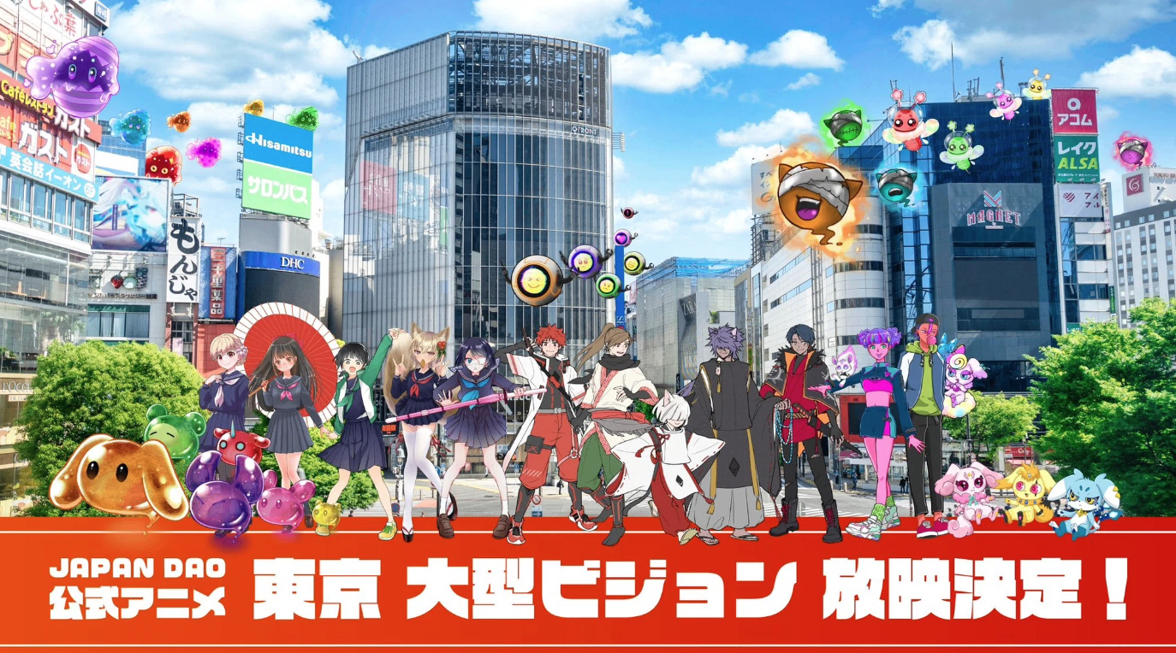
O ti wa nireti pe iwara yoo ni ilọsiwaju nikan "Amava" ati tun ni gbogbo awọn burandi ohun kikọ ti "Japan dao" ni.
Ni pataki, "Amato" ni awọn abuda ti ọdọ ati arugbo, "awọn akọni awọn ọta bii awọn ọmọ ilu bii awọn ọmọ ilu bii awọn ọmọ ilu bii awọn ọmọ ilu bii awọn ọmọ ilu bii awọn ọmọ ilu bii awọn ọmọ ilu bii awọn ọmọ ilu bii awọn ọmọ ilu bii awọn ọmọ ilu bii awọn ọmọ ilu bii awọn ọmọ ilu bii awọn ọmọ ilu bii awọn ọmọ ilu bii awọn ọmọ ilu bii awọn ọmọ ilu bii agbegbe ti yoo ni idaniloju pe yoo ṣaṣeyọri pupọ.
O jẹ ohun iwuri lati fojuinu ọjọ iwaju nibiti awọn ọmọde sọrọ nipa Amamo ni ile-iwe.
A ti bẹrẹ iṣẹmọ osise ti bẹrẹ ni iran nla ti Tokyo (Shinjuku, Ikejukuro, Roppongo), ati ilọsiwaju ti ami iyasọtọ kọọkan ni ọjọ iwaju jẹ adehun nla!
https://twitter.com/amatonft/status/1742431758753439985?ref_src=twsrc%5Etfw%7Ctwcamp%5Etweetembed%7Ctwterm%5E1742431758753439985%7Ctwgr%5Ec3f5998cec022928a3538af58bcae928245143c9%7Ctwcon%5Es1_&ref_url=https%3A%2F%2Fnote.com%2Fpreview%2Fnae2486489acd%3Fprev_access_key%3D88099127a8c630e0627bfeada77f60f9
Ọja ile-iwe (Gakuchichi) News
https://gakuichi.com/blogs/gakuichi-news/%E4%B8%96%E7%95%8C%E6%9C%80%E5%A4%A7%E7%B4%9A%E3%81%AE%E3%83%A1%E3%82%BF%E3%83%90%E3%83%BC%E3%82%B9%E7%BE%8E%E8%A1%93%E9%A4%A8-%E6%97%A5%E6%9C%ACnft%E7%BE%8E%E8%A1%93%E9%A4%A8-%E3%81%8C%E6%9D%B1%E4%BA%AC4%E3%83%B6%E6%89%80%E3%81%AE%E5%A4%A7%E5%9E%8B%E3%83%93%E3%82%B8%E3%83%A7%E3%83%B3%E3%81%AB%E3%81%A612%E3%83%B6%E6%9C%88%E9%80%A3%E7%B6%9A%E3%81%A7%E5%85%AC%E5%BC%8F%E3%82%A2%E3%83%8B%E3%83%A1%E3%83%BC%E3%82%B7%E3%83%A7%E3%83%B3%E3%81%AE%E6%94%BE%E6%98%A0%E3%81%8C%E6%B1%BA%E5%AE%9A-%E6%B8%8B%E8%B0%B7-%E6%96%B0%E5%AE%BF-%E6%B1%A0%E8%A2%8B-%E5%85%AD%E6%9C%AC%E6%9C%A8%E3%81%AE%E5%85%A8%EF%BC%94%E3%83%B6%E6%89%80%E3%81%A7%E6%94%BE%E6%98%A0
Awọn ẹru (itaja wẹẹbu)
Njẹ Ile itaja osise ti Titari "Amava"?
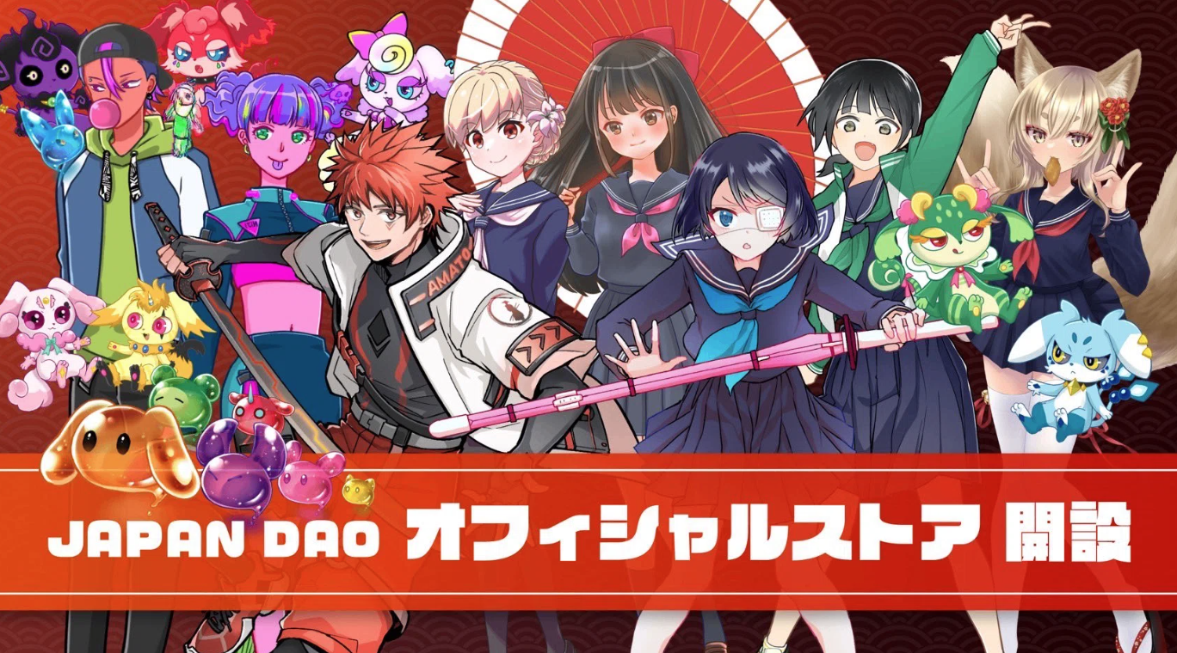
Ni afikun si awọn tita ọja ni gbigba NFT (ti a mọ bi n Kore) waye ni Osaka ati awọn aaye pupọ, Ile itaja Oju opo wẹẹbu Japan osise ni o ṣii ni igba ooru ọdun 2023.Paapaa awọn ti ko ba le lọ si n Kore le awọn irọrun rira awọn ẹru.
Oṣuwọn igbanisiṣẹ ti Amamo, eyiti o ṣe iroyin fun awọn ẹru bii apa kan, awọn ẹya ẹrọ, ni o le sọ pe o fẹran pupọ nipasẹ awọn olumulo.
Awọn egeb onijakidijagan wa, gẹgẹbi t -shitts pẹlu apẹrẹ aṣa ti o tutu ati tutu paapaa fun lilo lojojumọ.
Jọwọ wo lati ọna asopọ ni isalẹ.
https://twitter.com/japannftmuseum/status/1629058295901360130?ref_src=twsrc%5Etfw%7Ctwcamp%5Etweetembed%7Ctwterm%5E1629058295901360130%7Ctwgr%5Ec3f5998cec022928a3538af58bcae928245143c9%7Ctwcon%5Es1_&ref_url=https%3A%2F%2Fnote.com%2Fpreview%2Fnae2486489acd%3Fprev_access_key%3D88099127a8c630e0627bfeada77f60f9
https://twitter.com/Rain_NFT/status/1693469819159679104?ref_src=twsrc%5Etfw%7Ctwcamp%5Etweetembed%7Ctwterm%5E1693469819159679104%7Ctwgr%5Ec3f5998cec022928a3538af58bcae928245143c9%7Ctwcon%5Es1_&ref_url=https%3A%2F%2Fnote.com%2Fpreview%2Fnae2486489acd%3Fprev_access_key%3D88099127a8c630e0627bfeada77f60f9
Ọna asopọ Oju-itaja Oju opo wẹẹbu Osise
https://japandao.jp/ec
isọniṣoki
Ni iwe irohin Japanda yii, "Kini Amato?Ni atẹle ibikibi ti Voe.1 Amamo, a ti ṣafihan awọn oriṣiriṣi akoonu ti yoo awọ gbooro "Amaro".
Emi yoo dun ti o ba bi ọpọlọpọ eniyan ti o ba ṣee ṣe lẹhin kika nkan naa jẹ ẹwa si "Amamo" ati pe yiya nipa ọjọ iwaju.
Nipa nrin pẹlu "Samarai lati koju", iwọ yoo ni iriri iyanu ♪
Jẹ ki a gbadun agbaye wo papọ pẹlu Amata (NFT)!!
Iwe irohin Japan Dao yoo ṣafihan alaye titun lori Japan Dao ati alaye alaye lori awọn iṣẹ akanṣe.
Ti o ba nifẹ si Japan Dao, jọwọ tẹle akọọlẹ X osise pẹlu "Magnazine ti Japan".
AKIYESI X: https: //twitter.com/japonnfmuseum
Didflard osise: https://dissoft.com/invite/japondao
Instagram osise: HTTPS: //www.instagram.com/japannkmuseum/

